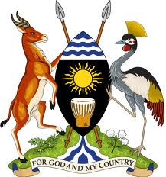

**UGANDA NATIONAL ACTION PLANTO IMPLEMENT THE GLOBAL COMPACT ON REFUGEES AND**

**ITS COMPREHENSIVE REFUGEE RESPONSE FRAMEWORK (CRRF)**

* **Uganda’s revised CRRF Road Map –**

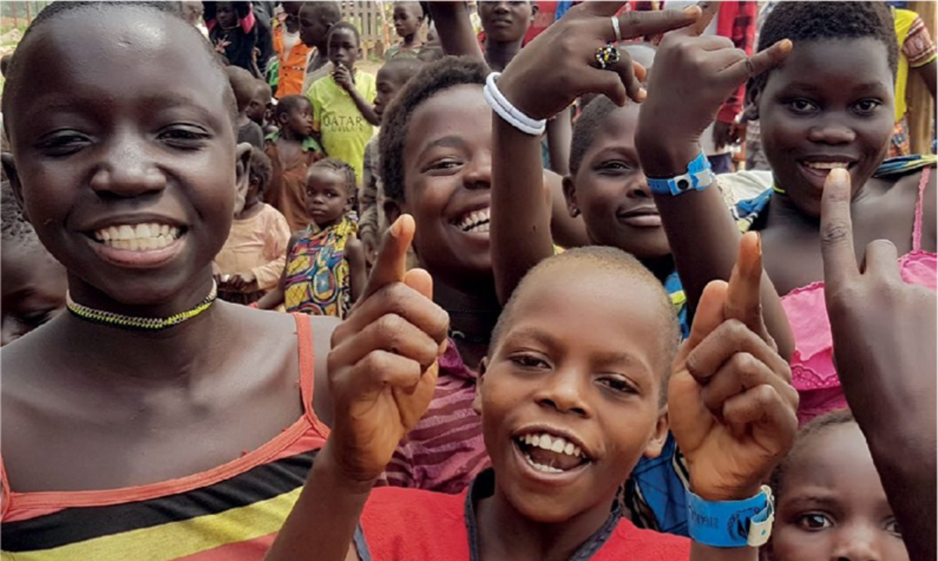**2018-2020**

© UNHCR/Duniya Aslam Khan

**Table of Contents**

**1.** **CONTEXT** 6

**1.1.** **Rationale for the Comprehensive Refugee Response in Uganda** 9

**1.2.** **CRRF Pillars of Engagement in Uganda** 10

**1.3.** **National and International Frameworks: A Long History of Self Reliance** 11

**2.** **CRRF ACHIEVEMENTS AND PROGRESS 2017-2018** 13

**2.1.** **Meeting the needs of refugees and host communities and easing pressure on refugee-hosting districts** 13

**2.2.** **National arrangements for greater burden- and responsibility-sharing - An unprecedented, novel common platform** 15

**3.** **STAKEHOLDERS AND PARTNERSHIPS** 16

**3.1.** **Government** 16

**3.2.** **The United Nations** 19

**3.3.** **Bilateral and Multilateral Partners and International Financial Institutions** 19

**3.4.** **National and International NGOs** 20

**3.5.** **Refugees** 20

**3.6.** **Host Communities** 20

**3.7.** **Private Sector** 21

**3.8.** **Academia** 21

**3.9.** **Regional Partnerships** 21

**4.** **COORDINATION** 21

**4.1.** **Key Existing Coordination Mechanisms for CRRF** 22

**4.2.** **Steering Group for Comprehensive Refugee Response in Uganda** 26

**4.3.** **Secretariat for Comprehensive Refugee Response in Uganda (OPM)** 28

**5.** **PRACTICAL APPLICATION OF THE COMPREHENSIVE REFUGEE RESPONSE FRAMEWORK** 30

**5.1.** **Principles of Implementation** 31

**5.2.** **Common messages for engagement and cooperation between CRRF Stakeholders** 33

**5.3.** **Expected Results of Uganda’s Plan of Action in 2018-2020** 33

**5.4.** **Reasoning behind the Expected Results** 36

**5.5.** **Milestones Toward Achieving Comprehensive Approaches** 38

**6.** **APPLICATION METHODOLOGY** 51

**6.1.** **Monitoring and Evaluation** 51

Annex 1 – Terms of Reference - Steering Group 52

Annex 2 – Terms of Reference – Secretariat 55

**LIST OF ACRONYMS**

CRRF - Comprehensive Refugee Response Framework

DfID - Department for International Development

DLG - District Local Government

DPG - Development Partners Group

DRC - Democratic Republic of Congo

DRDIP - Development Response to Displacement Impacts Project

ECW - Education Cannot Wait

JLOS - Justice Law and Order Sector

LDPG - Local Development Partners Group

LG - Local Government

LGDP - Local Government Development Plan

MDAs - Ministries, Departments and Agencies

MoES - Ministry of Education and Sports

MoGL&SD - Ministry of Gender, Labour and Social Development

MoH - Ministry of Health

MoLG - Ministry of Local Government

MWE - Ministry of Water and Environment

NDP - National Development Plan

NFI - Non-food items

NPA - National Planning Authority

PS - Permanent Secretary

RCM - Refugee Coordination Model

RWL - Refugee Welfare Leaders

SDG - Sustainable Development Goals

TOR - Terms of Reference

UBOS - Uganda Bureau of Statistics

UN - United Nations

UNDAP - United Nations Development Assistance Plan

UNHCR - United Nations High Commissioner for Refugees

UNRC - UN Resident Coordinator

WASH - Water, Sanitation and Hygiene

**EXECUTIVE SUMMARY**

In recent years, refugee situations around the globe have increased in scope, scale and complexity. Today, over 68.5 million people worldwide have been forced to flee, including more than 25.4 million people who have crossed borders to become refugees. Many of them live in protracted situations, often in low- and middle-income countries facing their own economic and development challenges, and the average length of stay has continued to grow.

In response, in December 2018, the international community agreed on a “new deal” to forge a stronger, fairer response to large refugee movements known as the **Global Compact on Refugees**[1] to provide greater support for those fleeing their homelands and for countries that take them in, which are often among the poorest in the world[2]. The Global Compact on Refugees is a new commitment to burden- and responsibility-sharing, designed to provide a robust and systematic model to improve the lives of refugees and their host communities.

Prompted by the historic **2016 New York Declaration for Refugees and Migrants[3]** (hereinafter NY Declaration), the Global Compact builds on the experience of countries who have been implementing aspects of the **Comprehensive Refugee Response Framework (CRRF)** over the past year – including Uganda, which was the first country to implement aspects of the CRRF and whose progressive refugee model has shaped the formulation of the NY Declaration and its CRRF. Against this background, the Global Compact contains four parts:

1. An introduction setting out the background, guiding principles and objectives.
2. The Comprehensive Refugee Response Framework (CRRF), as agreed to by Member States in Annex I of the New York Declaration.
3. A Programme of Action including arrangements to share burdens and responsibilities through a Global Refugee Forum; national and regional arrangements for specific situations; and tools such as funding, partnerships and data gathering and sharing. It also identifies areas in need of support from reception and admission, to meeting needs and supporting communities, to solutions.
4. Arrangements for follow-up and review, which will primarily be conducted through the Global Refugee Forum, an annual high-level meeting, and the High Commissioner’s annual report to the General Assembly.

In Uganda, the adoption of the NY Declaration coincided with what would become Uganda’s single largest refugee influx in its history. Today, following the conclusion of a biometric verification exercise[4], with nearly 1.2 million refugees, Uganda is not only the largest refugee hosting country in Africa, but also among the top three refugee hosting countries in the world. At the same time, Uganda ranks among the least developed countries in the world, with some of its refugee hosting districts being among the poorest in the country.[5]

Despite the tremendous generosity of the Ugandans who are hosting the refugees as well as of donors and the international community, the large number of refugees arriving in Uganda over the past years has placed overwhelming demands on already stretched capacities and resources of the State and of host communities. As a result, the gap between the needs of refugees, their hosts and funding has widened and has made the need for more equitable sharing of the burden and responsibility for hosting and supporting refugees and host communities ever more evident.

As one of the first countries to implement this new approach of responding to refugee situations, Uganda adopted its **CRRF Road Map** in January 2018, setting out the vision to strengthen implementation of a comprehensive approach in its response in order to ease the pressure on host districts and meet the needs of refugees and host communities. Uganda’s CRRF Road Map identifies the CRRF pillars of engagement and priority interventions across the humanitarian-development nexus required to stabilize and recover from the emergency while simultaneously laying the operational foundation for inclusion and longer-term development engagement, including through the development of comprehensive sector plans to address the needs of host communities and incorporate refugees into its national service delivery strategies.

Within the first year of implementation, significant advances were achieved towards implementing Uganda’s CRRF Road Map in line with elements incorporated in the Programme of Action of the Global Compact on Refugees:

* **Setting up / strengthening national arrangements to coordinate and facilitate the efforts of all stakeholders working to achieve a comprehensive response[6];**
* **Meeting the needs of refugees and host communities, including through the development of comprehensive sector plans, articulating clearly where additional support is needed[7]; and**
* **Advancing durable solutions, including third-country solutions (resettlement and complementary pathways)[8] .**

Given Uganda’s progressive refugee model (open borders and non-camp policies) and significant progress made in implementing the CRRF, Uganda serves as a role model globally and has been widely recognised as “*proof of concept*” in terms of being able to apply many of the elements as contemplated in the world’s new refugee deal even in time of significant influx.

Moving forward, continuous coordinated effort and increased burden- and responsibility-sharing as articulated in the Global Compact on Refugees will be critical to yield concrete results at district level benefitting refugees and host communities alike.

Against this background and following a decision made during the **5th CRRF Steering Group** meeting held on 17 October 2018, Uganda’s CRRF Road has been revised in consultation with Uganda’s CRRF stakeholders[9] to

* Address lessons learnt from CRRF implementation in Uganda;
* Allow for wider consultations considering the enlarged membership of the CRRF Steering Group[10];
* Consider necessary milestones to ensure that 2018 deliverables as well as CRRF Steering Group decisions are being followed up and implemented;
* Confirm/update priority issues and update problem statements where necessary; and
* Most importantly, re-define the expected results and milestones for 2019 and beyond to leverage the Global Compact on Refugees and translate this into concrete actions benefiting refugees and their hosts.

As such, this **National Plan of Action** aims to facilitate the further application of comprehensive approaches in support of refugees and the Ugandans who are hosting them. Its success relies on robust and well-functioning arrangements for burden- and responsibility-sharing, and the international community to live up to their commitments in the Convention relating to the Status of Refugees and its Protocol through innovative means and provide concrete contributions to bring these arrangements to life as articulated in the Global Compact on Refugees.

# **CONTEXT**

Uganda, a country with a population of approximately 42 million, has a long history of hosting refugees and asylum seekers. On average, Uganda has hosted over 160,000 refugees per year since 1959, a number which fluctuates proportionally to security conditions in neighbouring countries.

Most recently, throughout 2016-2018, Uganda faced concurrent emergencies from South Sudan, the Democratic Republic of the Congo (DRC), and Burundi. The Office of the Prime Minister (OPM) and UNHCR commenced a large-scale exercise between March 2018 and October 2018, verifying and biometrically enrolling close to 1.1 million refugees.[11] As of March 2019, Uganda hosts more than 1,2 million refugees[12]. With 789,099 refugees from South Sudan, 312,699 from the DRC, 34,981 from Burundi, 23,633 from Somalia and others from elsewhere, Uganda is Africa’s largest refugee hosting country and one of the three largest refugee hosting countries in the world. Indeed, Uganda is ranked among the least developed countries[13], and together with other sub-Saharan African countries is hosting almost one-third of the global total (6.3 million refugees)[14].

*Figure 1: Overview of Refugees in Uganda as of March 2019. Source: OPM/UNHCR, ugandarefugees.org.*

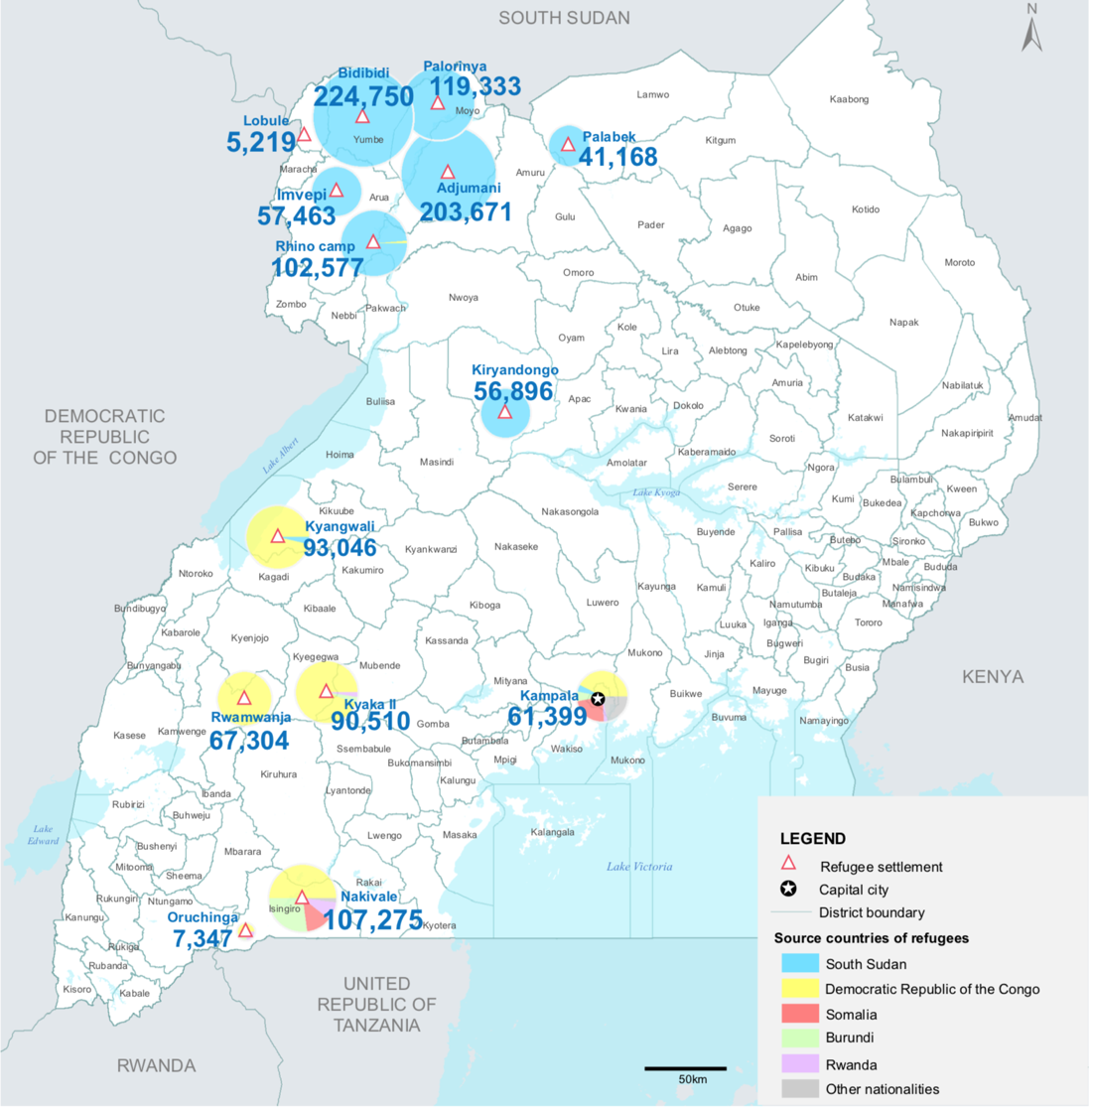

More than 60 percent of Uganda’s refugees are under the age of 18, one of the most visible consequences of conflicts in neighbouring countries – and with clear implications for protection needs and the provision of protection services.

The refugees are mainly hosted in twelve districts. About 92 percent live in settlements alongside the local communities, mainly in Northern Uganda or West Nile (Adjumani, Arua, Koboko, Moyo and Yumbe) or Acholi (Lamwo), with smaller numbers in Western Uganda or Mid-West (Kiryandongo and Kikuube) or South West (Kyegegwa, Kamwenge and Isingiro). Urban centres are home to eight percent of the refugee population, especially Kampala.

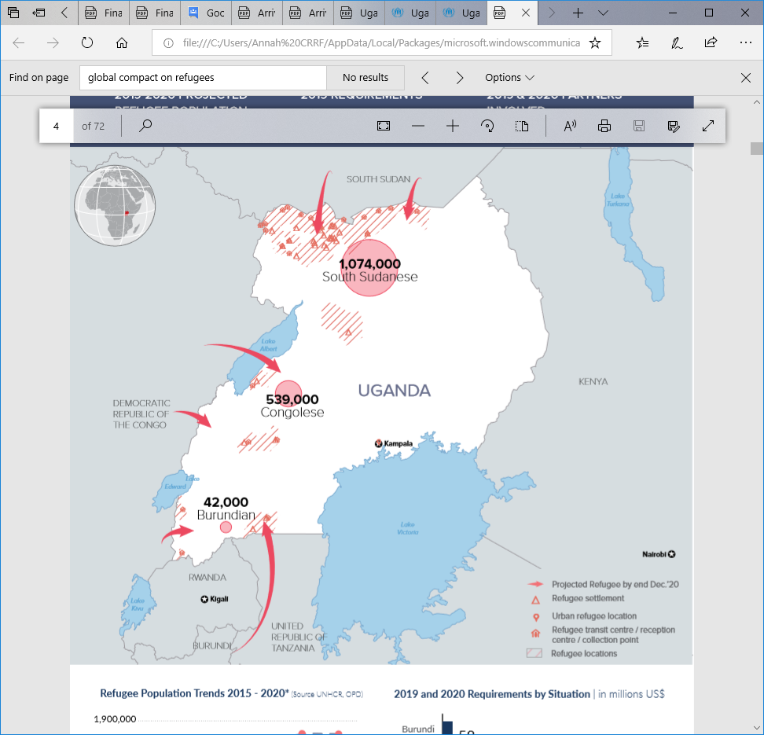The presence of large numbers of refugees has placed inordinate pressure and overwhelming demands on already stretched capacities and resources of the State and of host communities. Yet Uganda has kept its borders open and maintained its settlement approach, with host communities and District Local Governments at the frontline of the country’s refugee response. With expected refugee influxes from the DRC (140,000), South Sudan (70,000) and Burundi (7,000) throughout the period covered by this National Plan of Action, Uganda is likely to host about 1.3 million refugees by the end of 2020.[15]

*Figure 2: Projected Refugees by end of December 2020. Source: Refugee Response Plan 2019-2020.*

These trends have created a perpetual cycle of emergency response to urgent needs as well as a growing protracted refugee population, particularly in North West and South West Uganda. Durable solutions including voluntary repatriation will remain out of reach for the vast majority of refugees living in Uganda during this period, leaving refugee-hosting districts with significantly increased populations considering Uganda’s population growth rate as well as new refugee arrivals.

*Figure 3:* *Refugees and host population by district, as of February 2019. Source: ugandarefugees.org*

|  |  |  |  |
| --- | --- | --- | --- |
| Location Name | Host Population | Refugee Population | Percentage of refugees in district |
| Adjumani | 170,029 | 203,200 | 119.5% |
| Arua | 846,491 | 157,661 | 18.7% |
| Isingiro | 492,721 | 111,543 | 22.6% |
| Kampala | 1,482,676 | 59,435 | 4% |
| Kamwenge | 429,236 | 66,618 | 15.5% |
| Kikuube | 625,568 | 91,071 | 14.6% |
| Kiryandongo | 277,444 | 56,456 | 20.3% |
| Koboko | 236,900 | 5,194 | 2.2% |
| Kyegegwa | 349,067 | 88,256 | 25.3% |
| Lamwo | 139,093 | 38,953 | 28% |
| Moyo | 147,997 | 119,201 | 80.5% |
| Yumbe | 584,221 | 224,095 | 38.4% |
| Other |  | 1,350 |  |
| TOTAL | **5,781,443** | **1,223,033** | **21.15%** |

Notwithstanding Uganda’s progressive refugee policy and the contribution of refugees to the local economy, refugee-impacted areas remain at risk. The underlying poverty and vulnerability of refugees and their hosts, their limited resilience to shocks, and insufficient viable economic opportunities often contribute to higher poverty levels in refugee-hosting areas, which are predominantly remote and less developed.[16]

Refugee-hosting districts are recognized under the vulnerability criteria of Uganda’s National Development Plan II 2015/16-2019/20 (NDP II), making them a priority for development interventions and providing an opportunity to engage various actors to comprehensively respond to the humanitarian and development needs of refugee-hosting districts and the entirety of their population - both refugees and host communities. Particular focus must remain on the multi-faceted dimensions of peacebuilding: conflict prevention, resolution and mitigation of social conflict arising between hosts and newcomers over scarce resources and those related with conflicts at the origin of displacement.

## **Rationale for the Comprehensive Refugee Response in Uganda**

While efforts already underway in Uganda inspired the New York Declaration and its Comprehensive Refugee Response Framework (CRRF) and subsequently also the Global Compact on Refugees[17], there remains an urgent need for enhanced regional and international support to sustain Uganda’s progressive legal framework and model response. In the spirit of responsibility sharing encapsulated in the New York Declaration and the Global Compact on Refugees, in full recognition of Uganda’s international commitments to the protection of refugees, and in the face of an unprecedented mass influx into Uganda, Uganda declared its willingness to roll-out the CRRF in September 2016, building upon and further strengthening existing efforts.

Recognizing that Uganda cannot handle the present massive refugee crisis alone, [the **Kampala Declaration**](http://solidaritysummit.gou.go.ug/sites/default/files/UgandaSolidaritySummitonRefugees_KAMPALA%20DECLARATION.pdf), adopted during the Solidarity Summit on Refugees in June 2017, maintains progressive policies and safeguards asylum space by calling for urgent support and a more equitable responsibility sharing between Uganda and the international community. In addition, in March 2017 at the Inter-Governmental Authority on Development (IGAD) Special Summit, the President of Uganda committed the Government to the [**Nairobi Declaration**](https://igad.int/communique/1519-communique-special-summit-of-the-igad-assembly-of-heads-of-state-and-government-on-durable-solutions-for-somali-refugees) and delivering its accompanying **Plan of Action**. Although primarily focused on the plight of Somali refugees in the region and the need to find durable solutions, the Nairobi Declaration also represents the regional application of the CRRF and includes IGAD Member States’ pledges at the Leaders’ Summit[18]. Hence, it addresses the needs of both Somali and other refugees in the region. The Heads of State and Government in Nairobi developed a plan of action to deliver the Nairobi commitments. In order to align processes, this National Plan of Action fulfils this requirement in Uganda.

This National Plan of Action is also aligned with the **Djibouti Declaration on Refugee Education in IGAD Member States and its Action Plan**, which was adopted by Ministers in charge of Education in Djibouti on 14 December 2017.

From the outset, this National Plan of Action recognizes that the best way to solve the challenges of hosting refugees is to prevent conflict and the root causes of forced displacement. Above all, Uganda’s diplomatic engagement in peace and security efforts in the region, including in the South Sudan conflict through playing an intermediary role in support of IGAD’s efforts to bring an end to the crisis, as well as its engagement in Somalia, are recognized as critical acts of diplomatic leadership by example.

In addition, Uganda will continue to be called upon to host refugees and is leading the way to live up to its responsibilities enshrined in the Convention Relating to the Status of Refugees and other legal instruments.

Moving towards a comprehensive refugee response model that includes a coordinated, whole of government approach, offers a critical opportunity to simultaneously design predictable and sustainable responses, built on real time lessons learned, which address both the needs and rights of refugees and host communities alike. Indeed, in this context, hosting refugees should catalyse longer term development and resilience strategies for local Ugandan communities.

The objectives of the Global Compact on Refugees and the CRRF at global level are to: (i) ease pressure upon host countries; (ii) enhance refugee self-reliance; (iii) expand access to third-country solutions; and (iv) support conditions in countries of origin to support return in safety and dignity.

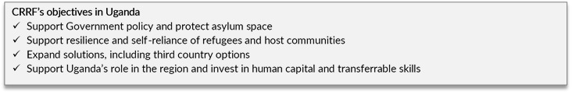

This document, originally endorsed by Uganda’s CRRF Steering Group on 31 January 2018 and its updated version endorsed on 11 April 2019, sets out the vision for the practical application of CRRF in Uganda and provides strategic guidance on its implementation led by the State. The National Plan of Action articulates the CRRF pillars of engagement, identifies stakeholders and principles of partnership, CRRF coordination structures, outlines the practical application of the CRRF, and identifies short- and longer-term priority areas of support to meet the ongoing needs to refugees and hosting communities.

## **CRRF Pillars of Engagement in Uganda**

At the Leaders’ Summit in September 2016, Uganda pledged 1) to continue its settlement approach, 2) to provide access to education and formal employment to some 120,000 newly arrived refugees in 2016, and 3) to sustain and work on the Refugee and Host Population Empowerment (ReHoPE) framework.

Thus, the CRRF in Uganda encompasses five mutually reinforcing pillars and covers support provided to refugees, host communities, the government and the countries of origin, as outlined by the global CRRF objectives: (1) Admission and Rights, (2) Emergency Response and Ongoing Needs, (3) Resilience and Self-reliance, (4) Expanded Solutions and (5) Voluntary Repatriation. The five pillars of engagement are meant to ensure protection throughout the cycle of displacement.

*Figure 4: Five Pillars of Engagement*

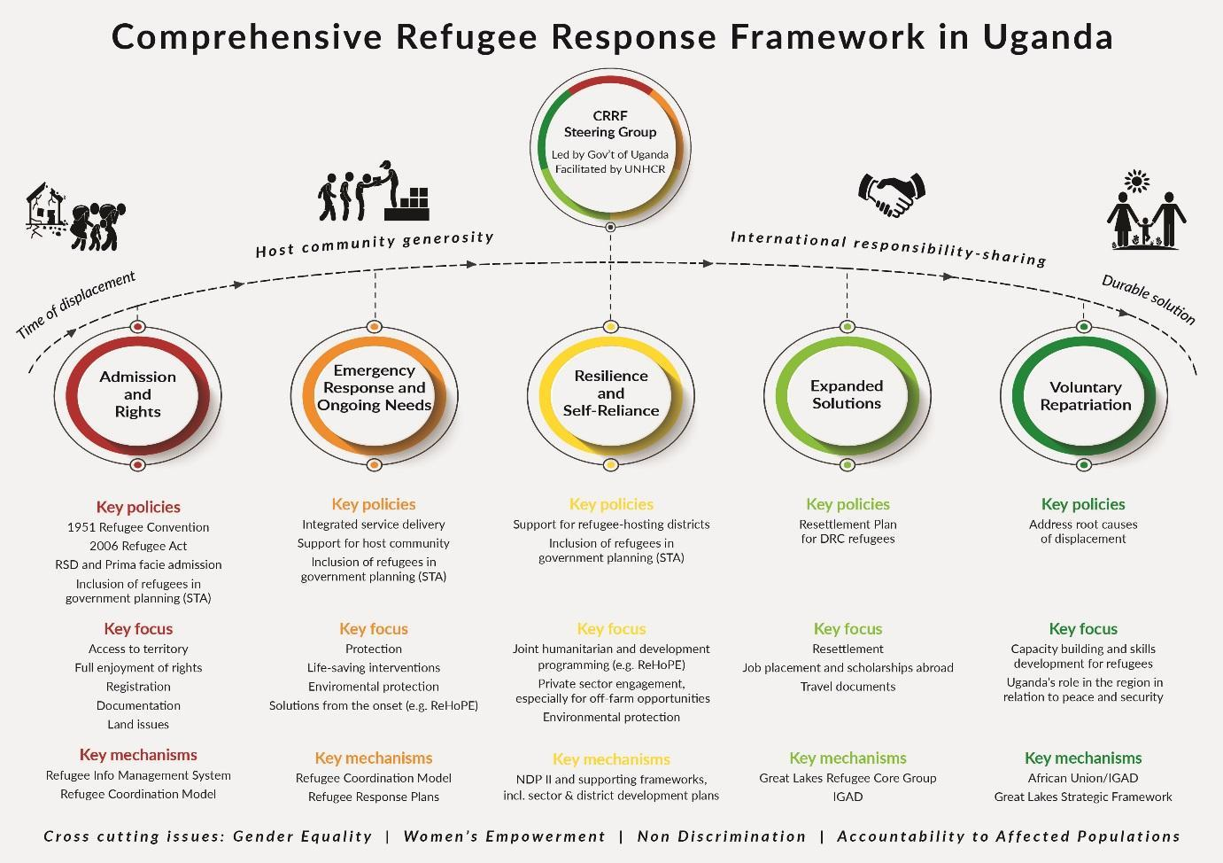

## **National and International Frameworks: A Long History of Self Reliance**

Uganda’s progressive approach started in **1951**, when the Government of Uganda signed the **Convention relating to the status of Refugees and later its 1967 Protocol**, committing to protect persons fleeing from persecution. The commitment was renewed in **1969** with **the OAU Convention Governing the Specific Aspects of Refugee Problems in Africa** (referred to as “OAU Convention”), granting *prima facie* refugee status to refugees fleeing from conflicts. These Conventions and Uganda’s open border policy are crucial for the protection of refugees and full enjoyment of their rights, ensuring access to the country and avoiding the risks related to repatriation and refusal of entry.

Self-reliance strategies for refugees began in Uganda as early as 1999. In 2006, the Parliament passed the **Refugee Act 2006**, followed by its **2010 Refugee Regulations**. Consistent with the Refugee Convention and Protocol, Uganda’s legal framework avails refugees access to key rights, including freedom of movement and the right to work, as well as access to Uganda’s social services. The Refugee Act unquestionably constitutes the most progressive refugee law in Africa, enabling the Uganda settlement approach and access to basic services on par with nationals, a progressive protection model where refugees are welcomed, registered, allocated land and provided with documents.

The Government of Uganda introduced the **Settlement Transformation Agenda (STA)**[19] in 2015, which operationalizes the national legal framework and aims to achieve self-reliance and bring social development to Ugandan nationals in refugee hosting areas through six main objectives: 1) Land management, 2) Sustainable Livelihoods, 3) Governance and rule of law, 4) Peaceful co-existence, 5) Environmental protection, and 6) Community infrastructure.

*Figure 5: An overview of international and national frameworks in Uganda.*

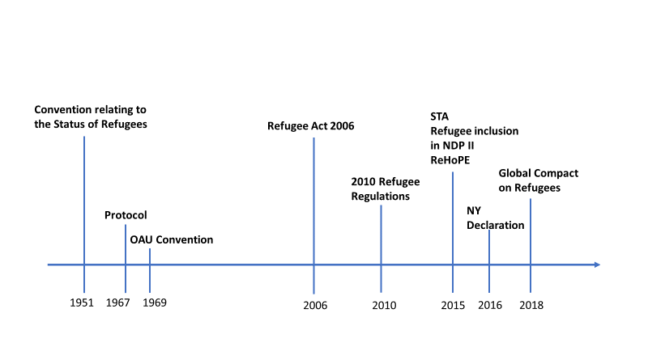

Leaving no-one behind in line with the **2030 Agenda for Sustainable Development and the Sustainable Development Goals (SDGs)**, and in recognition of Uganda’s firm commitment to peace and security in the region and the protracted nature of displacement, the Government of Uganda took a bold decision to include refugee management and protection within its own domestic planning framework. The ***NDP II 2015/16 -2019/20*** include refugees into its national development planning by annexing the ***Settlement Transformation Agenda (STA***). In 2017, the Kampala Declaration further reaffirms Uganda’s continued commitment to protection and solutions, and to promote refugee self-reliance and their inclusion in the country's development planning through a comprehensive approach. Refugee inclusion into NDP II paved the road for comprehensive responses to address the needs of both refugees and Ugandan nationals living in host communities.

Efforts to support Uganda’s STA were mobilized as early as in 2015 including through a strategic framework called **Refugee and Host Population Empowerment (ReHoPE)**[20]. With a soft loan of USD 50 million from the World Bank, the Government of Uganda started the 5-year Development Response to Displacement Impact Project (DRDIP) to improve access to social services, expand economic opportunities and enhance environmental management for Ugandan nationals and refugees in refugee hosting areas. In addition, Uganda meets the criteria for soft loans under the World Bank’s IDA 18 refugee sub-window dedicated to support the development of low-income countries hosting large numbers of refugees.

These foundational building blocks predate and inspired the negotiations for the New York Declaration for Refugees and Migrants. They also predate the large-scale influx of South Sudanese who fled to Uganda for safety, which posed significant challenges to this nascent model, particularly in the emergency response requiring a prioritized focus on life-saving services. It is widely recognized that the presence of refugees can place overwhelming demand on the already overstretched capacity and resources of refugee-hosting districts, requiring support for enhancement to meet the needs of both the refugees and their hosts. It is also well recognized that refugees encounter additional shocks of violence, food insecurity, disease outbreaks before and after displacement. It is in this context that Uganda turned to the practical application of the CRRF to sustain and scale up the STA in time of acute influx.

The ultimate goal of the CRRF is strengthened cooperation and solidarity with refugees and host communities which is the ambition of the international community as a whole. Enhancing the capacities, funds and skills of the government, especially in refugee-hosting districts, including different authorities concerned at national and district levels, is therefore essential to implement the Global Compact on Refugees. This National Plan of Action intends to support the stabilization of the current emergency response while designing and coordinating predictable and sustainable responses to address the needs and rights of both refugees and host communities alike, using resilience strategies anchored in longer term development strategies. This entails a phased paradigm shift from a mainly humanitarian focus to developing integrated services for the long term for the benefit of both refugee and host communities and advancing socioeconomic growth and development in hosting areas. Further inclusion of refugees into key sectors in the next National Development Plan III creates the requisite and fundamental entry points for line ministries and development actors into Uganda’s refugee response, while providing the legal basis for district local governments to plan and consolidate the humanitarian provision of services into national service delivery systems.

# **CRRF ACHIEVEMENTS AND PROGRESS 2017-2018**

To sustain its current protection and response model in the face of significant influx and concurrent emergencies, fast tracking the application of the CRRF proved critical. It allowed space for both humanitarian coordination on life saving assistance, while engaging line ministries and other key stakeholders in a longer-term perspective on key sectoral challenges underpinning the settlement model. As a result, Uganda’s refugee response model has been sustained even in the face of concurrent emergencies and influx. Emergency needs of refugees have been met, and the hosting communities’ access to quality services has increased. Refugee rights, including the fundamental freedom of movement and access to integrated services remain intact and underpin the response model.

Uganda’s settlement approach, combined with the rights and freedoms granted, provides refugees with some of the best prospects for dignity and self-reliance found anywhere in the world, and creates a conducive environment for pursuing development-oriented planning for refugees and host communities.

Appreciating that refugees and their hosts are stabilizing and recovering from the shocks of new arrivals and displacement, life-saving needs have mostly been met and now greater focus by all stakeholders must be placed on longer-term interventions. Following the priorities set by the CRRF Steering Group, efforts are underway with comprehensive sector plans to bring refugees onto the development agenda for Uganda to improve the welfare for both – refugees and host communities.

Key CRRF achievements and progress to date, enabled through joint efforts by all CRRF stakeholders, include the following:

## **Meeting the needs of refugees and host communities and easing pressure on refugee-hosting districts**

Provision of protection for refugees is the realization of their rights which among others, includes access to health care, education, and other government services. Refugees enjoy the same right as Ugandans to benefit from government services for health and education. Strengthening these priority services through enhanced cooperation among humanitarian and development actors is a CRRF priority to ensure protection.

Momentum grows to ease pressure on refugee-hosting districts and to benefit refugees and host communities. The CRRF gave renewed and more prominent visibility to host communities, catalysing shifts in the geographical focus of Uganda’s refugee response from the settlement location to the area that is hosting them. Greater attention is now placed on the service needs of these districts by development and humanitarian actors alike. The application of CRRF encouraged the inclusion of refugees into national planning and implementation, empowering different line ministries to develop comprehensive sector response plans, which serve as addenda to include refugees into the current national sector development plans. These priority comprehensive sector plans include refugees into the Uganda’s national sector strategies in education and health.

* + 1. **Education**

Uganda’s [**Education Response Plan for Refugees and Host Communities (ERP)**](https://data2.unhcr.org/en/documents/details/65790)was launched on 14th September 2018 by the Hon. Janet Kataaha Museveni, First Lady and Minister of Education and Sports. The Plan – the first of its kind worldwide – represents a huge policy step forward for refugee education. It is the exemplary work of a multi-stakeholder approach with the Ministry of Education and Sports in the lead and has been developed with support from humanitarian and development partners.

The plan enables Uganda to clearly articulate how it will respond to refugees and their Ugandan hosts. Through its implementation, government ownership and its ability to coordinate interventions by the international community and identify priority gaps is greatly improved. As a refugee hosting country, Uganda can now honour its responsibility under the Global Compact on Refugees to clearly articulate where additional support is needed to ensure access to quality education for both refugee children and Ugandan children in refugee hosting areas. When fully funded, the plan will improve access to quality education for the half a million children and youth who live in refugee hosting areas – refugees and Ugandans alike.

The Government has committed to invest 1.5m USD from the Solidarity Summit in education, offsetting needs in the ERP. Additionally, through Uganda’s Development Response to Displacement Impacts Project (DRDIP), the government allocated additional resources to education for the benefit of Ugandan national in hosting communities. Education Cannot Wait (ECW) pledged 11m USD as seed funding for the first implementation year, in addition to other partners who are actively engaging the ERP Steering Committee to ensure that the education activities, including humanitarian efforts, are aligned with the ERP. The Ministry of Education and Sports (MoES) is mapping the current activities of the international community against the plan. A Secretariat has been set up in the MoES with the aim to coordinate the implementation of the ERP.

* + 1. **Health**

Health is also identified as an area in need of support in the Global Compact on Refugees. **Uganda’s** [**Health Sector Integrated Refugee Response Plan**](https://health.go.ug/content/health-sector-integrated-refugee-response-plan) **(HSIRRP)** was launched by the Prime Minister of Uganda, Rt. Hon. Dr. Ruhakana Rugunda on Friday 25th January 2019. The Plan was developed under the leadership of the Ministry of Health, with the support of development and humanitarian partners, to include refugees and host communities into the larger development service delivery on health in refugee-hosting districts.

Uganda’s HSIRRP is modelled along national health priorities through principles of strengthening health systems, integrated service provision and aid effectiveness. This is to leverage the in-country health resources for the mutual benefit of refugees and host communities through strengthening existing coordination and management structures, in view of efficient use of resources and sustainable development of the national health system. In the same mode as for education, there are plans to oversee the implementation of the HSIRRP through a Steering Committee and a Secretariat in the Ministry of Health.

* + 1. **Other areas of support**

With these key milestones achieved, in line with the areas of support identified in the Global Compact on Refugees, in addition to the Education and Health Response Plans for Refugees and Host Communities, the Government, supported by humanitarian and development actors, is developing two additional comprehensive sector plans which include the **Water and Environment Response Plan** as well as the **Jobs and Livelihoods Response Plan**, which will be launched in 2019.

With the impetus of CRRF, these Government-led plans enable Uganda to be well positioned to welcome greater responsibility sharing by making clear where concrete contributions are needed in support of a comprehensive response in line with commitments made in the Global Compact on Refugees.

## **National arrangements for greater burden- and responsibility-sharing - An unprecedented, novel common platform**

**Application of the CRRF created momentum for renewed whole of government ownership and leadership of the refugee response**. Under the leadership of the Government of Uganda, **CRRF provided an unprecedented, novel common platform**, allowing actors – both humanitarian and development – to come together and improve coordination for the support of refugees and the host communities. The CRRF Steering Group, established at the end of 2017, is a unique platform bringing together Government Ministries, Departments and Agencies, international bilateral and multilateral partners, international and local NGOs, the private sector, refugees and host communities. As a result, in addition to the OPM and the Ministry of Local Government, several line ministries, departments and agencies, including the National Planning Authority (NPA) and the Uganda Bureau of Statistics (UBOS), are now actively engaged in the refugee response. Following its inaugural sitting in October 2017, the CRRF Steering Group sat five times in 2018[21], strategically steering CRRF implementation in Uganda. A multi-stakeholder **Secretariat** in the OPM is fully capacitated to support the application of CRRF.[22]

Reaffirming the key role districts play in comprehensive responses, the CRRF Steering Group is chaired at the ministerial level by both the Office of the Prime Minister and the Ministry of Local Government (MoLG). This followed a Steering Group decision taken at the 3rd CRRF Steering Group (April 2018) and coincided with the presentation of **recommendations on strengthening coordination** across the humanitarian and development nexus to advance the inclusion of refugees into national service delivery and improve service delivery for both refugees and host communities.[23] Efforts to strengthen coordination are ongoing at national and local level, with concrete steps being taken to promote the role of line ministries as co-chairs to the humanitarian sector working groups[24]. At district level, district authorities are invited to co-chair the inter-agency coordination meetings and sector working group meetings at settlement level, and they are encouraged to include refugee issues on the agenda of monthly District Technical Planning Committee meetings. Additional measures shall be introduced in this Plan of Action (see section 5) to further improve coordination efforts of all relevant stakeholders working to achieve a comprehensive response.

With the establishment of the **Refugee Engagement Forum (REF)** in October 2018, the affected communities are now effectively represented at the CRRF Steering Group by leadership. The host community enjoys five representatives at the Steering Group meetings, which include two District Local Government Chairpersons and three District Chief Administrative Officers from refugee-hosting districts. Refugees enjoy two seats at the table and as of October 2018, a Refugee Engagement Forum was constituted bringing more than 75 refugees (two elected leaders from each settlement, youth representatives, and community leaders in Kampala) together to the national level. Two individuals were elected to represent the refugees at the quarterly Steering Group meetings for the duration of one year. While further efforts to increase their meaningful participation will be one of the key CRRF priorities in 2019, this is a first important step that empowers the affected community to have a voice and directly participate in decision-making.

Combined, these national arrangements brought humanitarian and development sector coordination mechanisms closer together to ensure efficiency of the CRRF application and coordination at both the national and sub-national level. With these arrangements, Uganda quickly built momentum to ease pressure on refugee-hosting districts to benefit refugees and host communities in key areas.

# **STAKEHOLDERS AND PARTNERSHIPS**

The Global Compact on Refugees emphasizes a multi-stakeholder and partnership approach. In Uganda, the CRRF is Government-led, spearheaded by the Office of the Prime Minister (OPM) and the Ministry of Local Government (MoLG), facilitated by UNHCR, and guided by the participation of a wide range of stakeholders. The Government is catalysing a ‘whole of government’ comprehensive response to refugees engaging relevant stakeholders including the United Nations, development and humanitarian partners, international financial institutions, international and national Non-Governmental Organizations (NGOs), academia, the private sector, refugees and host communities, and other members of civil society.

One objective of a comprehensive response is to broaden the range of actors engaged in the refugee response, both within the government and among other stakeholders concerned. The common aim, as set out in the 2030 Agenda and the SDGs, is not just to meet needs, but to reduce risk, vulnerability and overall levels of need and build resilience and self-reliance through enhanced cooperation including between humanitarian and development actors. Uganda’s National Plan of Action therefore recognizes that there is no other option for humanitarian and development stakeholders but working more closely together if the objectives of the SDGs and leave no one behind are to be met. At the same time, actors, in line with their joint Grand Bargain responsibilities, commit to work together more efficiently, transparently and harmoniously with new and existing partners, to support and strengthen the capacity of local and national responders on the frontline, including through the recruitment of local staff to the extent possible (i.e. localization agenda), improve the use of cash, increase flexible funding, and ensure effective participation of refugees and host communities in decisions which affect them.

The below outline reflects the current constituency of actors and may be subject to change as the application of the CRRF in Uganda evolves further.

## **Government**

The Government of Uganda leads the **CRRF Steering Group**, co-chaired by the Office of the Prime Minister and the Ministry of Local Government. Representation from the national authorities on the Steering Group include relevant Line Ministries, Departments and Agencies including the Ministry of Finance, Planning and Economic Development; Water and Environment; Education and Sports; Health; Gender, Labour and Social Development; Agriculture; Foreign Affairs; Internal Affairs; Lands, Housing and Urban Development; Works and Transport; Uganda Bureau of Statistics and National Planning Authority, all of whom will increasingly take stronger leadership roles in the preparedness and response to further influxes, while integrating preparedness for other hazards that may affect both hosts and refugees, as well as facilitating the integration of social services in refugee hosting districts through the District Local Governments. The Steering Group membership will be incrementally increased where necessary to involve all relevant actors.[25] This will allow the Steering Group to draw on the expertise of existing structures and coordination mechanisms when exercising its decision-making role, and to ensure that information flows to and from the CRRF Steering Group to the refugee hosting districts, Government Ministries, Departments and Agencies, donors, humanitarian/development agencies and national and international responders.

The CRRF Steering Group will be supported by the **CRRF Secretariat**, which – under the leadership of the Government of Uganda – steers the implementation of the CRRF. The Secretariat will pursue coherence among various components of the CRRF and engage with structures that are already in place, including the Government Development Coordination Structure, the emergency response for refugees co-led by OPM Department of Refugees and UNHCR and the Local Development Partners Coordination Structure, to ensure a more robust comprehensive response in the refugee-hosting districts.

The CRRF governance mechanisms will promote coordination between, and help strengthen, existing government and partner institutions towards a whole of government response to refugees. They should not replace or substitute for these existing institutions. The main national level institutions involved in supporting local government development planning are:

* **The Office of the Prime Minister** is responsible for coordination and implementation of Government Policies across Ministries, Departments and other Public Institutions as well as Government Programmes and Projects.[26] The OPM also coordinates the implementation of the National Development Plan and the development of capacities for the prevention, preparedness and response to natural and human induced disasters and refugees. Indeed, the Ugandan Constitution determines that the refugee mandate is under the Central Government (Article 189). Operationalized by the Refugee Act 2006, the refugee response coordination function is held by the OPM Department of Refugees.
* **The National Planning Authority** is responsible for overall guidance, technical support and mentoring Local Governments (LGs) throughout the local government development planning cycle; offering capacity building to LG players; as well as supporting LGs during plan implementation. The NPA mentors sector ministries, departments and agencies (MDAs). A sizeable portion of financing of the District Development Plan (DDP) is budgeted and channelled through the Sector Development Plans (SDPs).
* **Ministry of Finance, Planning and Economic Development (MoFPED)** is responsible for providing financial resources, technical guidance and mentoring on budgeting required to effectively execute the Second National Development Programme (NDP II), DDP and SDPs. Budget call circulars, issued by MoFPED, guide annual planning at both the central and local Government level. As refugees are further incorporated into NDP III, MoFPED will necessarily play a greater role.
* **Ministry of Local Government (MoLG)** is responsible for the guidance, coordination inspection, monitoring and coordination of Local Governments to ensure compliance with the provision of the Local Governments Act and other law to effectively execute LGDP processes. It is an additional entry-point for external partners.
* **Uganda Bureau of Statistics (UBOS)** is responsible for providing reliable data for planning, technical advice and capacity building in data collection and management.
* **Sector Ministries, Departments and Agencies (MDAs)** are responsible for receiving and integrating district sector priorities in their sector plans; offer technical advice, guidance and mentoring services required to effectively execute LGDPs; and support LGs in mobilizing finances for implementation of LGDPs. Sector Development Plans consist of sector policies, strategies and development interventions that address sectoral development challenges, potentials and priority investments.
* **District Local Governments (DLGs)** have a leadership role in terms of increasingly integrating refugees in district development plans and budget framework papers. They spearhead the integration of refugee services at the district level with guidance from NPA, OPM and relevant Line Ministries. This is supported by the DOR through liaising with the national, local and regional planning authorities for the purpose of ensuring that refugee concerns and related matters are taken into consideration in the initiation and formulation of sustainable development and environmental plans. They provide overall coordination of implementation of the CRRF at the district level. The Local Government Planning Guidelines (LGDPG)[27] guide the process of preparing Local Government Development Plans. The purpose of the Guidelines is “to facilitate LGs to prepare and align their development plan to the National Development Plan and the national aspirations as expressed in the National Vision”. NPA is reviewing these Guidelines to include planning guidance in refugee-hosting districts. **Local Government Institutions that are involved in the local government development planning function** include:
  + **District Council**, which is the District Planning Authority responsible for coordinating the production of Higher and Lower Local Government Plans;
  + **District Technical Planning Committee (DTPC)** responsible for coordinating and integrating all district sector development priorities and those of Lower Level Local Governments for presentation to the District Council;
  + **Lower Local Government Technical Planning Committees** responsible for coordinating the planning process in their areas of jurisdiction;
  + **District, urban and sub-county physical planning committees** that have physical planning mandates under the Physical Planning Act, 2010.

Beyond Government Institutions, the following stakeholders play a role in the local government development planning:

* + NGOs, CSOs, faith-based organization and community-based organizations that are required to participate in all stages of the planning cycle;
  + Private sector organizations and enterprise that are required to participate in all stages of the planning cycle; and
  + Citizens/communities that are required to participate in initial stages of the planning cycle, plan implementation and oversight.

## **The United Nations**

The New York Declaration called upon UNHCR to develop and initiate the application of the CRRF in roll-out countries in close coordination with relevant States, other UN agencies and stakeholders. UNHCR has supported the Government in developing the Framework in Uganda and will continue to work closely with the Government in the practical application of the CRRF, alongside other partners.

UN agencies contribute to the response to the refugee situation in Uganda and recognize their collective responsibility in leaving no one behind in line with the SDGs. The UN Country Team has started to include refugees in existing programs and new initiatives in order to meet the socio-economic needs of the refugee and host populations. The UN Resident Coordinator (UNRC) will continue to coordinate resident and non-resident UN agencies in Uganda under the development framework and ensure the UN’s development operations are aligned to national priorities.

## **Bilateral and Multilateral Partners and International Financial Institutions**

Bilateral and multilateral donors and bilateral development agencies are actively supporting the implementation of the Comprehensive Refugee Response in Uganda, both through humanitarian and development channels which serve complementary purposes as well as other partners to advance the CRRF as discussed above. The CRRF has created new entry points in the broader refugee response for development partners who have allocated additional funding to the benefit of refugee-hosting districts enabling the transition from a humanitarian towards a longer-term development response. This is being manifested, to some extent, in increased funding, programming and support to strengthen local government capacities; with further increase in support being contingent to ongoing improvements in transparency and accountability.[28]In addition, concrete efforts are underway within multilateral and bilateral partners to operationalize the humanitarian-development nexus; the European Union and its member states, for example, developed an Humanitarian-Development Action Plan to increase the effectiveness of their contributions to the CRRF roll-out.[29]

International Financial Institutions, in particular the World Bank, have been substantially involved in the refugee response in Uganda and support to host community through various initiatives, research, assessments and partnerships.

At global level, the Global Compact on Refugees introduces a Global Refugee Forum, planned for December 2019, which will take place every four years to announce concrete pledges and contributions towards its objectives and to consider opportunities, challenges and ways in which burden- and responsibility sharing can be enhanced. Looking ahead, the international community is asked to continue fulfilling its responsibility sharing commitments, including increased funding to refugee situations and host communities in a predictable and flexible manner, full alignment with local and national development priorities and with the involvement of relevant government offices. Full transparency about ongoing engagements will ensure efficient coordination and resource allocation.

## **National and International NGOs**

National and International NGOs are key stakeholders and have been actively engaged in the refugee response in Uganda. Collectively, they provide critical support to the CRRF implementation. Numerous NGOs carry forward humanitarian and longer-term development mandates providing essential support to national and local capacities, giving the CRRF a practical, national outlook. The Steering Group includes a representative from the International NGOs as well as a representative from the National NGOs, both of which have distinct, yet complementary coordination mechanisms.

## **Refugees**

Refugees are a critical stakeholder in all decisions which directly affect them. Each settlement benefits from refugee welfare councils (RWCs). To facilitate meaningful participation in decisions affecting them from the national level, a Refugee Engagement Forum (REF) has been established, building upon the RWCs, which reflects the diversity of the current demographics of refugees in Uganda as decided at the first CRRF Steering Group in October 2017, for OPM DOR and UNHCR to establish. This forum selected two individuals (one man and one woman), based on the call of the required intervention at the Steering Group, to ensure that the refugee representatives are informed by the collective, yet diverse voices of refugees in Uganda.

## **Host Communities**

Representatives of District Chairpersons (LCV) and Chief Administrative Officers (CAO) are a key part of the national Steering Group, representing local host communities, as an equally affected population. Community involvement must be emphasized to ensure that interventions are in line with community priorities and give ownership of the projects to the communities. Active engagement of host communities and refugees will also help ensure peaceful co-existence. Acknowledging that peaceful co-existence between refugees and host communities is majorly dependent on the extent to which there are disparities in access to basic services, the ultimate goal is for social service provision to be mainstreamed through the DLGs in order to improve equity, relevance and cost effectiveness, in ways that support refugees and host communities without distinction.

## **Private Sector**

The successful CRRF roll-out requires the innovation and active engagement of new partners and a lot of terrain remains to be discovered with the private sector. Private sector investment in support of refugees and host communities will be of critical importance. Specifically, the potential of working with private actors in terms of financial and in-kind support (e.g. through philanthropy), provision of technical expertise, and partnerships to enable connectivity, energy, and expanded employment opportunities for refugees and host communities, including through advocacy and investment, is recognized. This offers the opportunity to not only mobilise resources from alternative sources, but to move towards market-based approaches to increase the economic productivity of refugees and their hosts, building resilience and self-reliance. Enterprises and entrepreneurs are encouraged to establish businesses as well as micro, medium and small enterprises (MMSEs) and industries in host communities to enhance local employment opportunities, including for refugees. Participation of refugees in the local and district economy will be supported. Particular action will be taken to link qualified refugee youth with such employment opportunities, to enhance their social interaction with the wider Ugandan society.

## **Academia**

A global academic network will be established as foreseen by the Global Compact on Refugees to facilitate research, training and scholarship opportunities. To ensure an evidence-based application of activities within the CRRF, close collaboration with academia will be important throughout implementation. Academic expertise will also be required in the monitoring and evaluation of CRRF activities. Emphasis should be placed on national expertise and institutions in order to further strengthen the capacity of Ugandan academia to monitor, document, assess and evaluate progress and effectively validate their findings and recommendations towards delivering a more sustainable and comprehensive refugee response.

## **Regional Partnerships**

Uganda remains committed to ongoing regional processes, including the IGAD Nairobi process and Djibouti process on education, which are critical for the regional application of a comprehensive refugee response, addressing the needs of Somali and other refugees in the region. Indeed, this National Plan of Action plays an important role in the delivery of regional and national commitments made in the Nairobi Declaration and Plan of Action on Durable Solutions to Somali Refugees and Reintegration of Returnees in Somalia (adopted by IGAD Heads of State and Government in March 2017) as well as the Djibouti Declaration on Refugee Education in IGAD Member States and its Action Plan (December 2017).

# **COORDINATION**

To promote coordination between, and help strengthen, existing government and partner institutions, inclusive CRRF facilitation mechanisms led by the government – namely, a Steering Group and a Secretariat – have been setup. These structures build on existing institutional arrangements to the extent possible and are outlined below.

## **Key Existing Coordination Mechanisms for CRRF**

At highest level, the Government and Uganda’s partners hold semi-annual **National Partnership Forum (NPF)**, chaired by the Rt. Hon. Prime Minister. While this forum does not have a particular focus on the comprehensive refugee response, it is hoped that refugee protection and management and specifically implementation of the CRRF will be accorded critical focus. The 4th National Partnership Forum, held in February 2018, focused on “*Delivering a comprehensive multi-stakeholder response to the situation of refugees and host communities in Uganda*”. A commitment was made to include refugees into the next National Development Plan III. In line with the Terms of Reference of the Steering Group for the Comprehensive Refugee Response, the Steering Group will inform the NPF of progress on the CRRF, to ensure alignment with existing Government coordination mechanisms with partners. An expanded NPF including civil society and private sector enhances wider ownership and dialogue.

At sector level, the Government developed a **Sector Working Group** (SWG) approach to implement its National Development Plan. The Sector Working Group approach has been firmly adopted across Government as the basic building block to ensure coherent planning, consultation between related entities, engagement with external stakeholders and service providers, management of crosscutting issues, oversight by central agencies, and management of inter-sector linkages. The role of SWGs is regularly referred to by MoFPED, NPA, and OPM in the planning, budgeting and monitoring processes, guidelines and formats. SWGs (meet mostly quarterly) are responsible for producing the **Sector Development Plans (SDP)** and are the main fora for the sector-wide approach to planning and budgeting for the sector in furtherance of the implementation of the NDPII and service delivery. SWG tasks include:

* Formulation and Coordination of Sector Strategies for long, medium and short-term investment plans and budgets;
* Reviewing reports from Sector Technical Working Groups and evaluating their consistency with the objectives of Sector Development Plans;
* Development of indicators and monitoring and evaluating sector performance;
* Prioritization of expenditure within the available resources and mobilization of resources for funding identified financial gaps during the course of implementation of SDP projects and programs;
* Harmonization and monitoring and evaluation of Sector Policies and Programs; and
* Approval of Sector Development Plans (SDP).

There is a close relationship between Local Government Development Plans and the Sector Development Plans. For example, a big proportion of the financing of LGDPs is through conditional grants channelled via sector investment plans (roads, WASH, education, health, community services etc). Hence, the development priorities, policies and strategies in the SDPs exert a significant influence on priorities and strategies that can be selected by local government plans.

*Figure 6: Government Development Coordination Structure. Source: OPM*

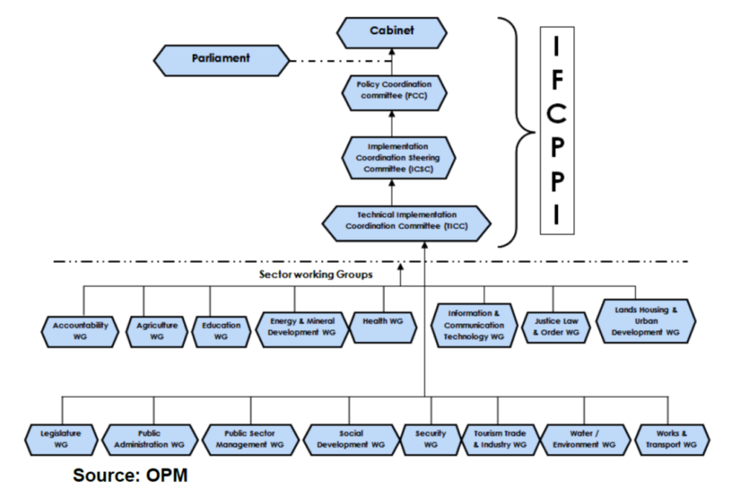

Most of the Sector Working Groups are relevant for the comprehensive refugee response, including Education, Water and Environment, Health, Lands, Housing and Urban Development, Social Development, Agriculture, and Justice Law and Order Sector (JLOS).[30] An assessment undertaken by OPM with support from Development Partners in 2017[31] of coordination practices in 15 sectors defined by Government indicates a wide range of progress; several SWGs (incl. Health, JLOS, Water & Environment, Education) have evolved effective coordination arrangements, with constructive engagement both within the sector and with a range of external stakeholders, and have established processes for joint planning, results-based monitoring and reviewing progress.

On the donor side, the **Local Development Partners’ Group (LDPG)** coordinates Development Partners’ engagement with the Government of Uganda on overall issues related to development cooperation at the policy, program and project levels. The objective of the LDPG is to promote effectiveness and harmonization of development assistance in support of national development goals and systems in Uganda. **Development Partner Technical Working Groups**, which report to the LDPG, cover a broad range of sectors including Education, Energy, Environment, Gender, Health, Land, Northern Uganda, Nutrition, Private Sector Development, Social Protection, and Water and Sanitation.

Following the refugee influx, the **Refugee Humanitarian Donor Partners Group** was established in late 2016, followed by the establishment of the **CRRF Development Partners Group (DPG)** in September 2017, recognizing the importance of coordination across development and humanitarian partners in support of the CRRF. While the Humanitarian Donor Partners Group deals with emergency operational issues, the CRRF DPG aims to provide donor partner coordination in support of the CRRF Steering Group’s and Secretariat’s objectives. Both report to the LDPG. The representation of LDPG members in the CRRF Steering Group (see: p. 18) enables effective information sharing between the CRRF Steering Group and Development Partners Group.

The **humanitarian coordination structure** is designed around four levels of coordination: 1) Leadership; 2) inter-agency at national level; 3) sectors at national level; and 4) field coordination structures at regional, district and settlement levels. The humanitarian refugee response in Uganda is co-led and coordinated by OPM and UNHCR, with broad participation of UN and NGO partners (national and international), in line with the **Refugee Coordination Model**. Key tools for strategy setting, partner coordination and planning, and resource mobilisation include the Uganda Refugee Response Plan (RRP) 2019-20, and the inter-agency contingency plans for specific refugee situations, as well as an inter-agency Business Continuity Plan in view of the risk of an Ebola outbreak. At the national level, inter-agency and inter-sector coordination meetings take place regularly and are co-chaired by OPM, the Ministry of Local Government and UNHCR. Sector-based coordination meetings, co-chaired by Line Ministries (most of the working groups), UNHCR, other UN agencies and/or INGOs, take place regularly with a varying frequency, mostly monthly. A similar structure exists in the field, both at District and settlement level, engaging the District Local Government (DLGs), UNHCR field staff, and partners. The meeting frequency is adjusted as needed, depending on the operational situation.

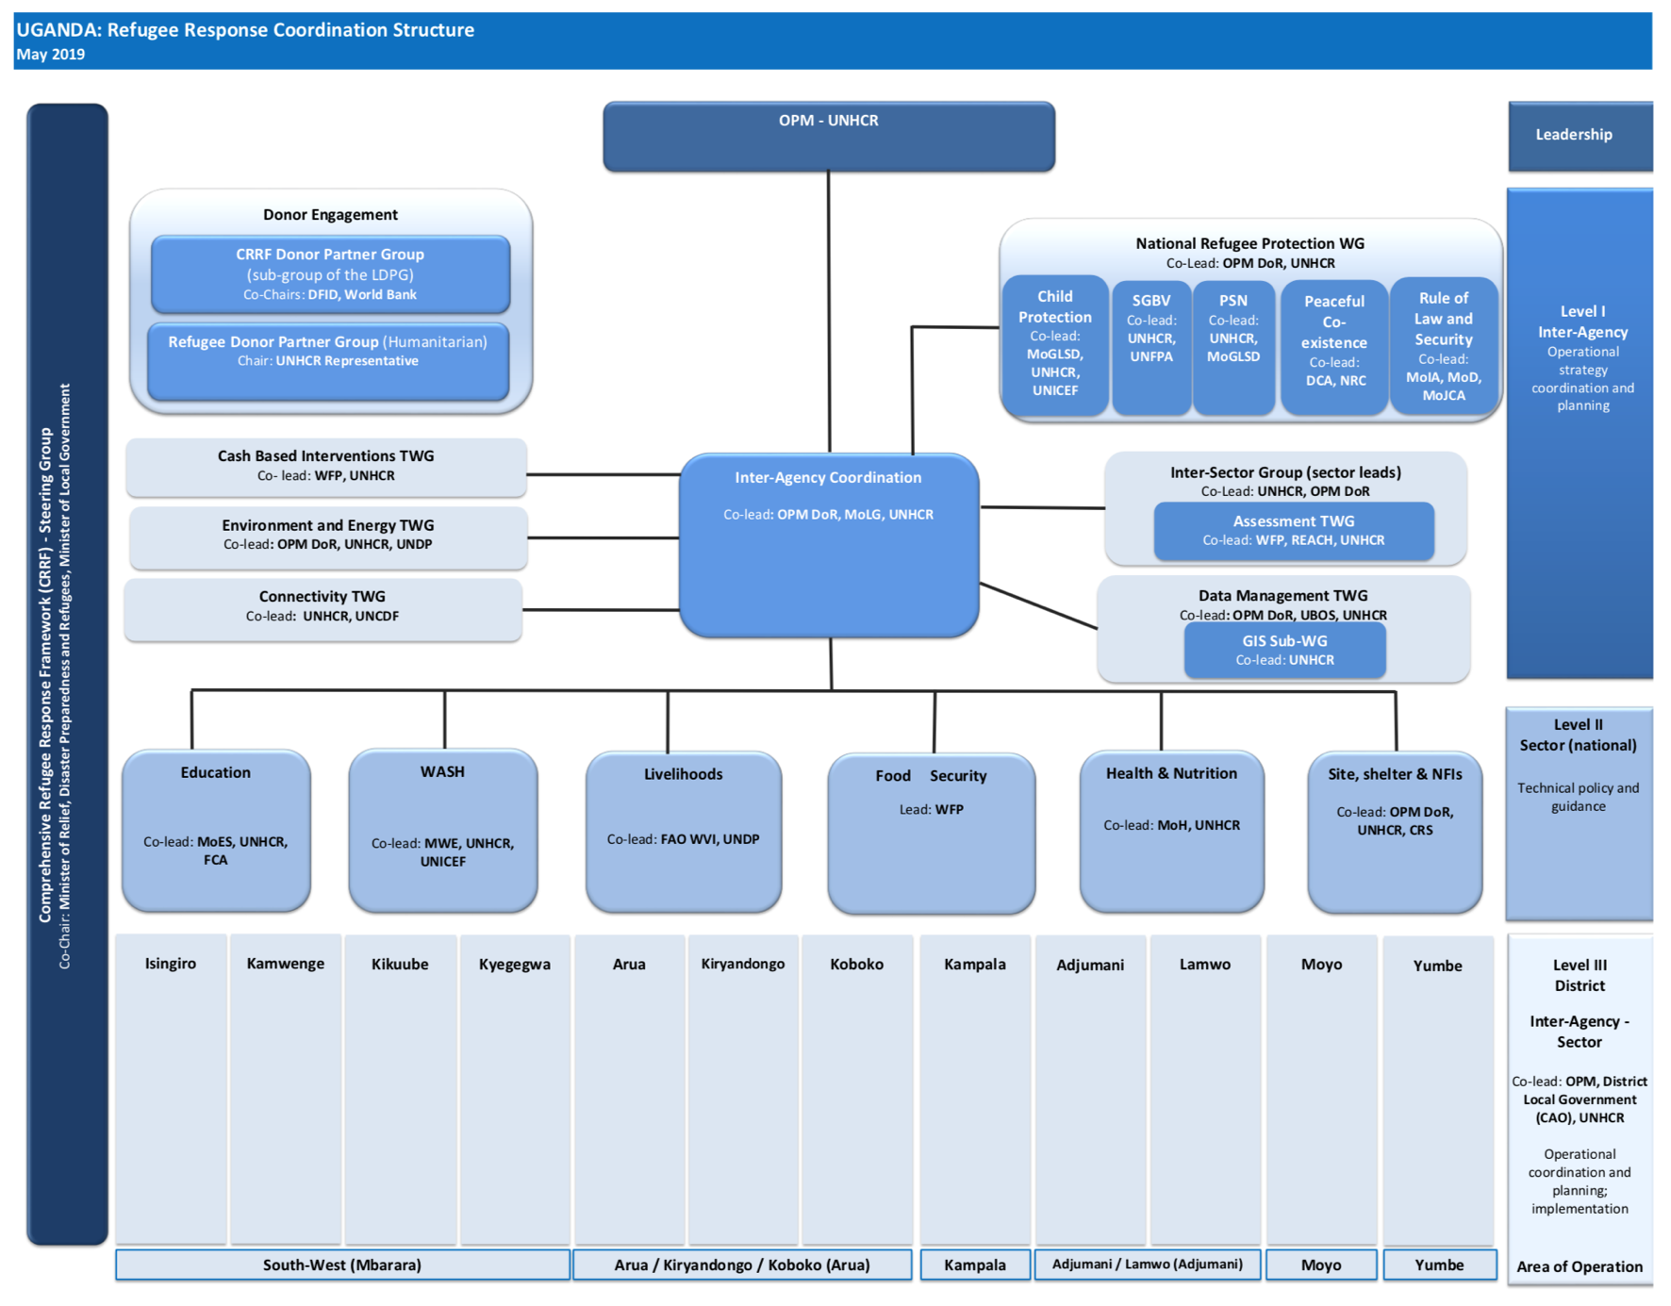*Figure 7: Refugee Response Coordination Structure (as of May 2019). Source: OPM/UNHCR.*

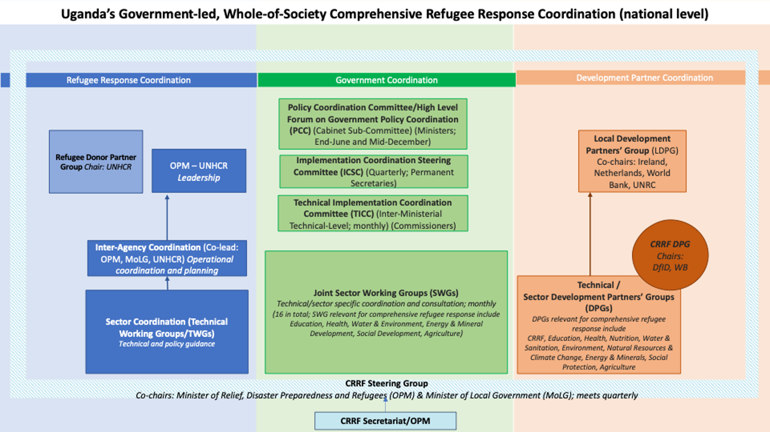In July 2018, recommendations were endorsed by the CRRF Steering Group, aimed at optimizing coordination within Uganda’s Comprehensive Refugee Response. The recommendations were intended to optimize coordination within the existing legal framework, focusing on strengthening existing coordination mechanisms rather than establishing new ones. While implementation of these recommendations is underway at central and district level, there is broad recognition that continued action is needed as reflected in the milestones in this National Plan of Action. In addition, looking ahead, it will also be important to further increase the cooperation between the Humanitarian DPG and the CRRF DPG.

*Figure 8: Overview of existing coordination structures at national level*

## **Steering Group for Comprehensive Refugee Response in Uganda**

The Steering Group for the Comprehensive Refugee Response, chaired by the Government, represents the views of key stakeholders involved in the refugee response. It guides and oversees the work of the CRRF Secretariat and ensures that it can function effectively. The CRRF Steering Group is the policy and decision-making body for the implementation of the CRRF.

The inaugural meeting of the Uganda Comprehensive Refugee Response Steering Group was chaired by the Minister of State for Relief, Disaster Preparedness and Refugees on the 12th of October 2017. The inaugural meeting adopted the Terms of Reference for the Steering Group (Annex 2) and decided on its composition based on the New York Declaration, while also taking the Uganda specific context into account. At the 3rd CRRF Steering Group meeting, held on 18 April 2018, Steering Group members agreed that, moving forward, meetings will be co-chaired by the Office of the Prime Minister and the Ministry of Local Government, acknowledging the central role of the Ministry of Local Government as the coordination Ministry for the Local Governments which host refugees.[32]

In terms of participation in the Comprehensive Refugee Response, the New York Declaration stipulates that:

“*The comprehensive refugee response framework will be developed and initiated by the Office of the United Nations High Commissioner for Refugees, in close coordination with relevant States, including host countries, and involving other relevant United Nations entities, for each situation involving large movements of refugees. A comprehensive refugee response should involve a multi-stakeholder approach, including national and local authorities, international organizations, international financial institutions, regional organizations, regional coordination and partnership mechanisms, civil society partners, including faith-based organizations and academia, the private sector, media and the refugees themselves*”.

The Uganda CRRF Steering Group is a multi-stakeholder forum, building on existing structures and coordination mechanisms where these exist, such as the National NGO Forum and the Local Development Partners’ Group. It currently consisting of 35 members constituted as below:

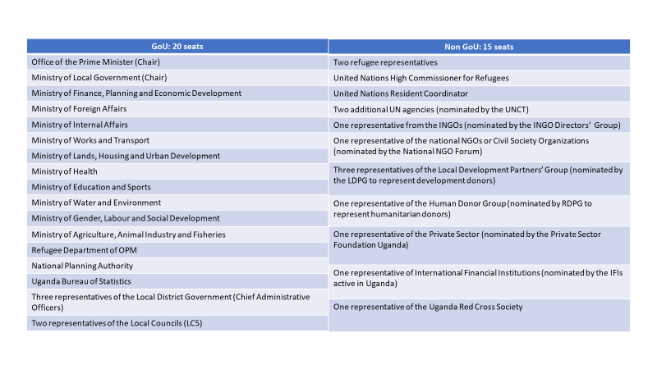

*Figure 9: Current Composition of the CRRF Steering Group.*

The Steering Group composition will likely be increased over time to involve other relevant actors including other Government Ministries or other international actors as required. In 2018, the Ministry of Agriculture, Animal Industry and Fisheries; the Uganda Bureau of Statistics (UBOS); and the Uganda Red Cross Society were officially added as Steering Group members. It is further proposed that other stakeholders can be invited to participate to specific meetings by the co-chairs following consultation with the Steering Group members.[33] Additional attendees that may be invited for future meetings should represent other parts of the Ugandan society (i.e. media, academia), regional entities, or actors not traditionally represented in fora discussing refugee issues.

The above listed ministries have each nominated a representative to the Steering Group to ensure consistency and facilitate decision-making. Representatives from DLGs as well as from donor partners have been nominated but might be subject of change to allow other refugee hosting-districts and donor partners to participate in the Steering Group. Representation on a rotational basis can be considered, and criteria shall be established for the selection of Local Government representatives to the Steering Group.[34]A CRRF Refugee Engagement Forum has been set up to facilitate broad refugee stakeholder engagement. Two refugee representatives (a woman and a man) were elected to represent the refugees at the CRRF Steering Group for the duration of one year.

## **Secretariat for Comprehensive Refugee Response in Uganda (OPM)**

The Comprehensive Refugee Response Secretariat is a technical body which works with a whole-of-Government approach and performs the task outlines in the Terms of Reference for the Secretariat approved by the CRRF Steering Group on the 12th of October 2017 (Annex 3). It implements the decisions of the CRRF Steering Group by aligning all stakeholders to this common direction.

In line with the agreed ToRs, the Secretariat supports coordinated planning, programming and resourcing of the CRRF roll-out in Uganda and ensures cross pillar information flow and linkages. In terms of the operational response, it will rely on existing coordination structures described above, and pursue coherence across the various structures. Lessons learned are documented through monitoring and evaluation as well as workshops and studies. The Secretariat ensures that statistics, data, assessments and findings relevant to the response are made available to all (for example census and household surveys, focus group discussions, beneficiary feedback, various mapping exercises); to advance evidence-based decision making. Through provision of technical and analytical support, the Secretariat assists the Steering Group as well as operational actors to pursue a more robust response. The Secretariat is also tasked with producing thematic and policy option papers based on analytical work in regard to emerging challenges and bottlenecks, identifying specific successes, best practices, gaps, constraints and solutions. The Secretariat also draws on experiences from other CRRF countries, building on cross-fertilization of good practices across the region. This includes supporting the countries’ engagement in the regional thematic meetings planned under the Nairobi Plan of Action (a meeting on education took place in 2018; a meeting on livelihoods took place in March 2019). It also helps preparing Uganda’s contribution to the annual reporting on the implantation of the Nairobi Plan of Action.

In addition to the above tasks, the Secretariat supports the Steering Group in the preparation of Steering Group meetings; in organizing different meetings/workshops/fora and stakeholder gatherings in Uganda to ensure information sharing and encouraging new partnerships. The Secretariat liaises with all actors including Line Ministries, humanitarian and development partners, the National Partnership Forum, District Local Governments and the beneficiaries.

The Secretariat is headed by a Director, the Under-Secretary of the Office of the Prime Minister. While the international community supports the Secretariat through secondment of staff[35], the majority of Secretariat staff is recruited by the Government. In addition to the core team, the Secretariat benefits from consultants and roves as needed to ensure close liaison with and rely on the expertise of other Government entities for specific tasks or functions, feeding into them when necessary. Thus, the Secretariat draws on the particular expertise of a Line Ministry or other Government entities, and members of the Secretariat are continuously liaising with other Government entities, humanitarian and development actors, private sector and all stakeholders and partners, in order to advance on both day-to-day tasks and specific deliverables.

To ensure the Secretariat is able to support coordinated planning and resourcing, new trust-funds or other funding mechanisms for the refugee response need to link to the CRRF Secretariat to ensure information flow and avoid duplications in the response. Based on the Steering Group’s priorities and to leverage the different mandates and expertise of all partners, the Secretariats’ membership in technical working groups is necessary.

*Figure 10: CRRF Secretariat Organigram.*

# **PRACTICAL APPLICATION OF THE COMPREHENSIVE REFUGEE RESPONSE FRAMEWORK**

The CRRF brings together a wide range of stakeholders in a harmonized and cohesive manner to more effectively coordinate predictable and sustainable responses to address the needs and rights of both refugees and host communities, promote the resilience and self-reliance of the entire population of the refugee hosting areas in Uganda and expand durable solutions – both in-country and in third countries. This entails a phased paradigm shift from a mainly humanitarian focus to developing integrated services in the long term for the benefit of both refugee and host communities and advancing socioeconomic growth and development in hosting areas. Further inclusion of refugees into key sectors in the next National Development Plan III creates the requisite and fundamental entry points for line ministries and development actors into Uganda’s refugee response, while providing the basis for district local governments to plan and consolidate the humanitarian provision of services into national service delivery systems.

**The CRRF aims to address the following challenges, among others[36]**:

* The presence of refugees places additional strain on local government services, infrastructure and the environment which are often already inadequate for Ugandans. Enhanced support to Uganda’s refugee-hosting districts is needed to ease the pressure and enable both refugees and the host community to enjoy access to quality social services and build their resilience and self-reliance.
* The unexpected and large influx of refugees has in some instances led to the establishment of parallel systems addressing the needs of refugees and host communities – local government services and humanitarian partners’ services. Competition for access to services and resources and inequalities between the quality of humanitarian and local government services can lead to resentment and conflict between refugees and their hosts. The transition to sustainable local government services that address the long-term needs of both refugees and host communities, with humanitarian assistance focused on providing lifesaving assistance for refugees, requires enhanced coordination, adequate resources and increased capacity of local governments.
* While the inclusion of refugees in the NDP II has paved the road for more comprehensive responses, efforts to ensure a more effective and sustainable longer-term response are hindered by the lack of a platform allowing Line Ministries, Departments and Agencies to meaningfully engage in the response and challenges regarding district level coordination and planning for refugees.
* It is widely recognized that several actors have scaled up support for both refugees and Ugandans, which is being manifested, to some extent, in increased funding and support to strengthen local government facilities. Insufficient data on funding, however, is leading to high risks of gaps, duplications, missed opportunities to leverage comparative advantages, and in some cases to inefficiencies as actors overstretch their capacities to try to fill gaps beyond their areas of core expertise. Numerous projects have their own parallel implementation structures rather than aiming to strengthen local government services and capacities. While Sector Response Plans exist (for now in education and health), many partners are not (yet) aligning their activities with these Government-led plans. In order to ensure effective implementation of the sector response plans developed under the leadership of Uganda’s Line Ministries, it will be critical that partners make visible their investments in refugee-hosting districts and align all activities with the plans.

## **Principles of Implementation**

Uganda’s National Plan of Action seeks to operationalize the international community’s commitment of burden- and responsibility sharing to better protect and assist refugees and support host communities as contemplated in the New York Declaration and the Global Compact on Refugees. The humanitarian principles of humanity, neutrality, impartiality and independence as well as the centrality of protection also guide the overall application of this Plan of Action.

National ownership is key to its success. In light of this, the practical application of the CRRF in Uganda takes into account the national realities, capacities and levels of development, and upholds national policies and priorities, while respecting international laws and standards. The following principles will guide the coordinated and comprehensive responses in Uganda. Building particularly on the Global Compact on Refugees and the New York Declaration, they also reflect other international commitments including those outlined in the Grand Bargain[37] as well as the ReHoPE principles:

* The CRRF is led by the Government of Uganda.
* Increased participation of national responders. To the extent possible, deliver assistance through appropriate national and local service providers, such as, NGOs, Uganda Red Cross (URCS), national systems for health, education, social services and child protection.
* Leverage comparative advantage of a diverse range of actors to work across the pillars and across the humanitarian/development nexus towards collective outcomes. Wherever possible, those efforts should reinforce and strengthen the capacities that already exist at national and local levels.
* Strengthen transparency and accountability of actors involved in the refugee response in line with international standards of transparency and accountability.
* Build on and strengthen existing coordination structures.
* Alignment with national, regional and district level development planning.
* Follow a rights-based approach that prioritizes security, social cohesion, equity, human rights, gender responsiveness, and children and women’s empowerment. Consistency with the rights and obligations of States under international law.
* Protect humanitarian principles which ensure the immediate delivery of life saving assistance.
* Prioritization and sequencing of assistance to be informed by joint assessments of needs, risks and impacts.
* Engage and empower the affected populations (refugees and local host community). Strong reliance on community-participatory approaches to ensure ownership of activities by the refugee and the host communities in line with the Grand Bargain[38], calling to ‘include people receiving aid in making decisions that affect their lives’.
* Gender mainstreaming through appropriate gender indicators, targets, and specific strategies to include women and girls.
* Mainstreaming of protection principles and environmental sustainability in all sectors.

## **Common messages for engagement and cooperation between CRRF Stakeholders**

The CRRF Communications and Outreach Strategy[39] was adopted by the CRRF Steering Group on 18thOctober 2018.[40]Forming an integral part of the CRRF, the Communications and Outreach Strategy strives to incentivize engagement and cooperation between CRRF stakeholders and to ensure a coherent ‘whole-of society’ approach in the refugee response, with refugees and refugee hosting communities being integral to every effort mobilized. The Strategy also aims to facilitate knowledge management including lessons learnt across the globe that can improve comprehensive refugee responses.

**Key Messages**

1. **Uganda’s refugee response model of welcoming our brothers and sisters in the hour of need remains intact**. It is not only the humane thing to do but it is the right thing to do.
2. **Uganda has a progressive refugee model**: Open borders, non-camp policies, integration of refugees, free movement, equal access to government-provided social services, a chance to work and land allocation for farming and shelter. This model is lauded as the most generous in the world.
3. **The task is too big for one country, one community or one sector. All hands together, everyone has a role to play.**

Immense support has been received from the partners towards Uganda’s refugee response. However, Uganda’s refugee response remains chronically underfunded**.** Without more support from the international community, and investments by existing and new partners including the private sector, Uganda’s ability to maintain this model is at risk.

## **Expected Results of Uganda’s Plan of Action in 2018-2020**

The first sentence of the Annex to the New York Declaration on Refugees and Migrants indicates a working definition for comprehensive approaches by recognizing that “*[t]he scale and nature of refugee displacement today requires us to act in a comprehensive and predictable manner in large-scale refugee movements. Through a comprehensive refugee response based on the principles of international cooperation and on burden- and responsibility-sharing, we are better able to protect and assist refugees and to support the host States and communities involved*.” The principles enshrined in the Convention Relating to the Status of Refugees (1951) and its Protocol (1967) defines the legal obligations and commitments.

The CRRF and the introduction of its programme of action in the Global Compact on Refugees suggests innovations for the way forward. All stakeholders in Uganda recognize with appreciation the importance and centrality of international cooperation and responsibility sharing to the refugee protection regime, especially in the context of Uganda. Fundamentally, this Plan of Action recognizes that individuals are agents of change, and that longer-term comprehensive approaches toward refugee response positively impact on the lives of refugees and the people in host communities.

In practical terms in the Ugandan context, the theory of change is that as a consequence of implementing comprehensive approaches in priority areas in need of support by the international community, and high-level coordination by the whole of government, multi-stakeholder approach, and across the humanitarian and development nexus, Uganda will be better able to achieve, inter alia, the objectives of the GCR and its CRRF.

This plan of action articulates expected results which supported by, high level coordination, can be achieved by all stakeholders, in particular in the remaining two-year window (2019-2020). This document serves as an updated revision of Uganda’s previous CRRF Road Map covering the period 2018-2020.[41]

Following the structure of the Global Compact on Refugees’ Programme of Action, Uganda prioritizes the following expected results in this timeframe:

|  |  |
| --- | --- |
| **UGANDA PLAN OF ACTION (2018-2020)** | |
|  | **By 2020, arrangements are firmly established for burden- and responsibility- sharing for the refugees hosted in Uganda to advance the prioritized areas where the Government has requested support to meet the needs.** |
| 1.1. | National Arrangements, at the central and District Local Government levels, are established and capacity built at both levels furthering the localization agenda. (Paragraphs 20, 37, 48 and 49 of the Global Compact on Refugees (GCR)) |
| 1.2. | Uganda developed comprehensive sector plans in education, health, jobs and livelihoods, and water and environment to make visible where requirements for support from the international community including investment, financing, material and technical assistance, are needed to meet the gaps. (21 GCR) |
| 1.3. | Sustained, coordinated support from the international community enables Uganda to coordinate its response to refugees and host communities across the CRRF pillars, benefitting both refugees and host communities. (Paragraphs 14, 15, 16, 22, 23, 24, 25, 26, 32 and 50 GCR) |
|  | **By 2020, Uganda is better positioned to address and inform long term interventions through improved preparedness and data collection at the reception and admission stage.** |
| 2.1. | Central Government and DLGs are supported for improved emergency preparedness, including through contingency planning, to strengthen Uganda’s comprehensive response. (Paragraphs 52 and 53 GCR) |
| 2.2. | Uganda’s settlement strategy is revised to prepare for current and future refugee influxes on gazetted land, drawing upon the lessons learned in the current context of Uganda’s settlement approach to hosting refugees. (Paragraphs 54 and 55 GCR) |
| 2.3. | Refugee registration data and other data such as socio-economic data of refugees and hosts is used systematically as a protection tool to identify needs of persons with specific needs and as a solutions tool to identify the skills of refugee populations to inform and improve current responses. (Paragraphs 45, 46, 47, 58, 59 and 60 GCR) |
| **3.** | **By 2020, Uganda is better able to meet the needs and support refugees and hosting communities by implementing the prioritized comprehensive sector plans.** |
| 3.1. | Uganda’s comprehensive sector plans in education, health, and water & environment are implemented to enable considerable advances in Uganda’s provision of basic social services to meet the needs of its nationals in refugee hosting districts and to progressively integrate refugees. (Paragraphs 64, 65, 66, 67; 68 & 69 (education), 72 & 73 (health), 78 & 79 (water & environment), and 84 GCR.) |
| 3.2. | Investments are made to strengthen access to justice to improve the security and safety of host community and refugees, especially of women and children, and other persons with specific needs, to prevent and respond to all forms of violence, including sexual exploitation and abuse, sexual- and gender-based violence and harmful practices. (Para. 74,75, 76, 82 and 83 GCR) |
| **4.** | **While recognizing that eliminating root causes is the most effective way to achieve solutions, by 2020, durable solutions for refugees are formulated and reinforced both within Uganda and in third countries.** |
| 4.1. | Without prejudice to eventual durable solutions that may become available, local solutions toward integration will be attained through implementation of the comprehensive plan for jobs and livelihoods which targets both refugees and hosting communities to improve resilience and self-reliance. (Paragraphs 70, 71, 84, 85 and 100 GCR) |
| 4.2. | Economic, social and cultural inclusion of refugees into key sectors in Uganda’s next National Development Plan III (July 2020 – June 2025) will further support local solutions, especially to facilitate access to age, disability- and gender responsive social and health care services for all. (Paragraph 100 GCR) |
| 4.3. | Resettlement targets are maintained with more countries sharing responsibility with Uganda through this avenue. (Paragraphs 90,91,92 and 93 GCR) |
| 4.4. | Complementary pathways to third countries are realized as a result of implementation of a clear strategy for this period of time. (Paragraphs 64,95 and 96 GCR) |

## **Reasoning behind the Expected Results**

* + 1. **By 2020, arrangements are firmly established for burden- and responsibility- sharing for the refugees hosted in Uganda to advance the prioritized areas where the Government has requested support to meet the needs.**

In order to ensure full realization of the principles of international solidarity and cooperation, Uganda’s Plan of Action articulates results to complete establishment of national arrangements within this timeframe to achieve more equitable and predictable burden- and responsibility-sharing with Uganda, as a refugee hosting country, and to support the search for solutions.

Since launching the effort to pilot the practical application of the CRRF in Uganda, the CRRF Steering Group and its Secretariat have been established and capacitated at the central levels. This arrangement has yielded two comprehensive sector plans in prioritized areas of support, namely Education and Health. Two additional priority areas in need of support remain - Jobs & Livelihoods and Water & Environment. Grouped around the pillars of the CRRF, these areas highlight where the international community may usefully channel support for a comprehensive and people-centred response to large refugee situations in Uganda in line with national priorities, strategies and policies. Implementation of the district coordination memo, which optimizes and improves coordination between key stakeholders at the local levels is critical and is supporting the DLGs to plan, budget and deliver services to refugees in support of these sector plans.

Additionally, success of the comprehensive sector plans relies on robust and well-functioning arrangements for burden- and responsibility-sharing, and a commitment on the part of the international community as a whole to providing concrete contributions to bring these arrangements to life, based on the principle of burden- and responsibility-sharing. All comprehensive plans are at early stages of implementation and critical for funding these plans are efforts by the international community to make visible where multilateral and bilateral interventions already address needs identified by the key line ministries to allow the government to articulate the gap and their priorities to mobilize increased funding. Resource tracking and mobilization will be monitored under this expected result, yet milestones tracking the actual implementation of the plans themselves will fall under the third expected result of meeting the needs of refugees and host community.

* + 1. **By 2020, Uganda is better positioned to address and inform long term interventions through improved preparedness and data collection at the reception and admission stage.**

The areas in need of support aim to ease the burden on Uganda as a host country and to benefit refugees and host community members. Preparedness, including contingency planning, strengthens comprehensive responses to large refugee situations, including over the medium term.

In the context of Uganda, preparedness plans must account for efficient mechanisms to strengthen Uganda’s out of camp policy, drive practical innovations that support the temporary provision of assistance using national delivery systems, and develop capacity to enable relevant authorities to put in place risk monitoring and preparedness measures in advance. Preparedness measures will take into account global, regional, sub-regional and national early warning and early action mechanisms, disaster risk reduction efforts, and measures to enhance evidence-based forecasting of future movements and emergencies.

In support of the government’s current strategy to manage arrivals, particularly in the context of the remaining emergency with arrivals from the DRC, an updated settlement strategy will be revised to prepare for current and future refugee influxes on gazetted land, drawing upon the lessons learned in the current context of Uganda’s settlement approach to hosting refugees.

Refugee registration systems and refugee registration data and statistics were validated and shared in November 2018 to improve the response by both development and humanitarian actors. Moving forward, registration will be used systematically as a *protection* tool to identify protection needs of individuals more effectively and a *solutions* tool by generating data relevant to designing solutions from the onset of arrivals by informing longer term development actors engaged in support of jobs and livelihoods interventions in Uganda for refugees and host communities.

* + 1. **By 2020, Uganda is better able to meet the needs and support refugees and hosting communities by implementing the prioritized comprehensive sector plans.**

Thorough management of a refugee situation is often predicated on the resilience of the host community. Uganda’s comprehensive sector plans facilitate the transition from humanitarian to development in key areas which advance Uganda’s current development goals in NDP II in education, health, and water and environment. Implementation of these three plans enable considerable advances in Uganda’s provision of basic social services to meet the needs of its nationals and to progressively integrate refugees by opening up entry points for development actors while allowing district local governments to plan, budget and coordinate implementation of the plans at the local level. Note that implementation of the Jobs and Livelihoods Plan is included under durable solutions (5.3.4.) below. For purposes of this expected result, the development of a comprehensive sector plan is grouped in with responsibility sharing (5.3.1.) in line with the Global Compact on Refugees determining that it is the responsibility of the refugee hosting country to make clear where concrete contributions are needed from the international community.

In addition to implementing these comprehensive sector plans, this Plan of Action prioritizes interventions to support access to justice, in particular for women and girls and persons with specific needs. Measures to ensure that refugee issues are included/mainstreamed in these key sectors in Uganda’s next National Development Plan (III) which will cover the period from July 2020- June 2025 are grouped into expected results on durable solutions (5.3.4).

* + 1. **While recognizing that eliminating root causes is the most effective way to achieve solutions, by 2020, durable solutions for refugees are formulated and reinforced both within Uganda and in third countries.**

Eliminating root causes is the most effective way to achieve solutions. At the same time, addressing the causes of refugee movements can take time. Uganda continues its diplomatic engagement in peace and security efforts in the region, including in the South Sudan conflict of playing an intermediary role in support of IGAD’s efforts to bring an end to the crisis, as well as its engagement in Somalia, are recognized as critical acts of diplomatic leadership by example.

The Global Compact on Refugees envisages a mix of solutions and adds to the traditional three durable solutions. Taking into account Uganda’s absorption capacity, level of development and demographic situation, in this two year period of time, Uganda’s National Plan of Action prioritizes the following desired results to advance durable solutions: a) advancement of “other local solutions”[42] toward integration to foster inclusive economic growth for host communities and refugees and promote economic opportunities, decent work, job creation and entrepreneurship programmes for host community members and refugees, including women, young adults, older persons and persons with disabilities; b) economic, social and cultural inclusion of refugees into National Development Plan III in key sectors as well as into District Development Plans is attained; c) maintained resettlement and d) complementary pathways made visible and promoted for admission to a third country. As a complement to resettlement, other pathways for the admission of persons with international protection needs can facilitate access to protection and/or solutions.

* 1. **Milestones Toward Achieving Comprehensive Approaches**

The refugee population in Uganda is as diverse as it is nuanced. Characteristics include 10 nationalities spread out in different districts, including in Kampala, with over 84 per cent being women and children. The shared goal must be to empower local actors to respond to refugee influxes in the immediate and longer term. As such, maintaining social cohesion, security and implementation of the Localization Agenda must be emphasized in all interventions.

The table below headlines the expected results and objectives articulated in Sections 5.3 and 5.4 over the three-year period implementing comprehensive approaches and offers milestones/deliverables against a timeline. As this is a revision to Uganda’s CRRF Road Map, 2018 milestone/deliverables remain to offer context. It is meant to capture and sustain constructive engagement and to inform vertical interventions within specific pillars and horizontal action across the pillars. The purpose of the chart below is to demonstrate milestones helpful for tracking progress toward expected results by 2020.

|  |  |  |
| --- | --- | --- |
| **PLAN OF ACTION FOR THE IMPLEMENTATION OF THE GLOBAL COMPACT ON REFUGEES AND ITS CRRF IN UGANDA (2018-2020)** | | |
| **EXPECTED RESULT 1: By 2020, arrangements are firmly established for burden- and responsibility- sharing for the refugees hosted in Uganda to advance the prioritized areas where the Government has requested support to meet the needs.** | | |
| **Intermediate result 1.1: National Arrangements, at the central and District Local Government levels, are established and capacity built at both levels furthering the localization agenda.** (Paragraphs 20, 37, 48 and 49 GCR) | | |
| **Milestone/Deliverables** | **Responsibility Centre** | **Timeline** |
| The CRRF Steering Group is fully operational to steer whole of government and multi-stakeholder response to refugees, which includes the voices of the host community and refugees. | *OPM, supported by UNHCR* | Q1 2018 |
| The CRRF Secretariat, as the technical support team for the Steering Group is fully capacitated and functioning. And tasked to carry forward its TORs and provides issues papers identifying challenges and solutions in key areas prioritized by the Steering Group. | *OPM, supported by UNHCR* | Q1 2018 |
| The affected population, represented by the local host communities and refugees, meaningfully participate in decision-making structure of the Steering Group. Where possible, equal participation (50% women) is ensured. The refugee engagement forum is established comprising refugee welfare leaders (RWCs) of each settlement. | *OPM/UNHCR* | Q2 2018 |
| Mechanisms are in place to collect and make good practices accessible to all stakeholders. | *CRRF Secretariat* | Q2 2018 |
| A Communication Strategy is developed to build a common understanding and vision of the CRRF at all levels, supporting its subsequent implementation. | *CRRF Secretariat* | Q3 2018 |
| An issues paper is adopted by the CRRF Steering Group to enhance coordination, in particular at district level, between OPM Refugee Department, relevant line ministries and refugee-hosting District Local Governments. Clarity on roles and responsibilities to optimize coordination. | *CRRF Secretariat* | Q3 2018 |
| Progress report of the practical implementation of CRRF is shared with the CRRF Steering Group. | *CRRF Secretariat* | Q1 2019 & Q1 2020 |
| The roll out of activities as enlisted in the approved CRRF Communications and Outreach Strategy Workplan to (i) showcase Uganda’s progressive policy and offset negative narratives about the refugee response in Uganda; (ii) to promote self-reliance of refugees and host communities; and (iii) to ensure international responsibility sharing – is achieved. | *All CRRF Stakeholders, facilitated by the CRRF Secretariat* | Q4 2020 |
| Facilitated by the CRRF Secretariat, the CRRF Steering Group meets quarterly to ensure continuous high-level, whole-of-government and multi-stakeholder steer on CRRF implementation. | *CRRF Secretariat* | Q1 2019 –  Q4 2020 |
| Steering Group membership is reviewed quarterly to ensure that critical additional Line Ministries, other international actors and national actors are included when necessary/appropriate. | *CRRF Steering Group, supported by the CRRF Secretariat* | Q1 2019 –  Q4 2020 |
| By the end of 2019, meaningful participation of the affected community in decision-making (i.e. in the CRRF Steering Group) is achieved through   * The Refugee Engagement Forum (REF) is fully constituted and operational (ToRs adopted); * Feedback/communication mechanisms are established to enable REF members to effectively engage, consult, inform and be informed by their peers*;* * Mechanisms are put in place to strengthen host communities’ participation (CAO/LC5) to ensure that the perspectives and interests of all refugee hosting districts are effectively represented. These include i.a. an effective information-sharing mechanism. District representatives agree on representation modalities (e.g. responsibilities, duration, feedback mechanisms to all districts affected, etc). |  |  |
| *OPM DOR / UNHCR, with INGO support* | Q2 2019  Q4 2019 |
| *MoLG, with support from partners* | Q4 2019 |
| By the end of 2019, recommendations endorsed in the district coordination issue paper to mirror CRRF coordination at district level are effectively implemented. To this end:   * Communication/Guidelines are issued to District Local Governments on the revised coordination arrangements * A task team is established to regularly implement/review/monitor coordination practice at district level and an annual progress report is issued with clear recommendations to reinforce coordination. This could include the establishment of enforcement mechanisms (rewards/sanctions regime for coordination performance). The first progress report is due in Q1 2020. * Guidelines are issued regulating partners’ entry / exit of a district and official handovers to ensure sustainability across the refugee hosting districts. |  |  |
| *OPM / MoLG / UNHCR* | Q2 2019 |
| *OPM (DOR & CRRF Secretariat) / MoLG / UNHCR / DLG representative* | Q2 2019 |
| *OPM / MoLG* | Q4 2019 |
| A joint agency impact assessment is conducted to measure the capacity of national local responders. Thereafter, an issue paper is developed to propose harmonised capacity strengthening initiatives, including common benchmarks for local and national responders to facilitate greater partnership and funding opportunities. | *NGO Bureau with support from Red Cross Society, OXFAM and other INGOS* | Q1 2020 |
| By the end of 2019, progress is made against proposed solutions outlined in the 2018 financing & localisation issue brief:   * Analysis of 2016 and 2017 financial flows in Uganda will be published to contribute to MoFPED’s building of a future financial tracking mechanism *(more details in Outcome 1.3)*. Recommendations will be presented to the SG and all stakeholders. | *Facilitated by the CRRF Secretariat, with support from OXFAM* | Q4 2019 |
| Line Ministries’ active engagement in the CRRF Steering Group has increased through:   * An SOP on line ministries’ engagement in the CRRF Steering Group and the CRRF Secretariat’s engagement with Line Ministries is developed and approved by the CRRF Steering Group. | *CRRF Secretariat /*  *Line Ministries* | Q4 2019 |
| The private sector is more actively engaged in Uganda’s comprehensive refugee response:   * A mapping of private sector engagement, including private-public partnerships, in Uganda’s refugee-hosting districts is concluded * Building on the mapping exercise, a Private Sector Engagement Strategy is finalized * An issue paper is released isolating necessary changes to the Regulatory Framework to incentivize business development | *CRRF Secretariat*  *CRRF Secretariat*  *OPM* | Q3 2019  Q42019  Q4 2020 |
| Uganda’s localized CRRF dashboard and M&E Strategy is circulated to track implementation and changes systematically and measure the effectiveness of the CRRF approach. | *CRRF Secretariat, in close cooperation with Line Ministries* | Q2 2019 |
| Annual monitoring reports are issued against the CRRF Dashboard. The first report is due in Q1 2020. | *CRRF Secretariat* | Q1 2020 |
| Performance monitoring and reporting of CRRF Dashboard indicators are mainstreamed into the Government Annual Performance Report (GAPR). | *OPM* | Q2 2020 |
| **Intermediate result1.2: Uganda developed comprehensive sector plans in education, health, jobs and livelihoods, and water and environment to make visible where requirements for support from the international community including investment, financing, material and technical assistance, are needed to meet the gaps.** The comprehensive sector plans to connect to sector plans in education, health, jobs and livelihoods and natural resource management and in NDP III. (Paragraph 21 GCR) | | |  |
| **Milestones/Deliverables** | **Responsibility Centre** | **Timeline** |
| Priority sectors identified/confirmed by the CRRF Steering Group and CRRF Secretariat tasked to develop sector-specific issue papers. | *CRRF Steering Group, facilitated by the CRRF Secretariat* | Q1 2018 |
| Joint assessments of needs and gaps for refugees and host communities in priority sectors led by or in close cooperation with relevant line ministries. Assessments are made available to all stakeholders through an online platform. | *CRRF Stakeholders* | Q1-4 2018 |
| Based on assessments, sector plans and financing strategies to identify key interventions aimed at longer-term sustainability in key sectors are developed, such as currently being developed for the education sector, and actors to implement and fund the initiatives are identified and activated. | *Line Ministries* | Q1-4 2018 |
| Integration of education for refugees into the National Education Sector Plan in line with the Djibouti Declaration on Refugee Education and its accompanying Plan of Action, and increased enrolment of refugee children including through the construction of additional school structures in refugee hosting areas and upgraded living quarters for teachers. | *Ministry of Education and Sports* | Q2-3 2018 |
| All field assessments related to education, health, water & environment, jobs & livelihoods and access to justice are uploaded by CRRF Stakeholders to the online portal (ugandarefugees.org). Sector Response Plans for Refugees and Host Communities are uploaded to the online portal and shared widely to ensure alignment of all activities and mobilize additional resources. | *All CRRF Stakeholders, supported by CRRF Secretariat* | Q4 2020 |
| Uganda’s knowledge management platform (Uganda CRRF online portal, ugandarefugees.org) is reviewed and modified to improve accountability of CRRF Stakeholders, and if necessary, additional knowledge management platform(s) are developed to ensure that stakeholders have access to relevant data analyses and information products to design needs-based interventions | *CRRF Secretariat* | Q4 2019 |
| An SOP is developed to streamline all assessments in refugee-hosting districts. The SOP will include an inventory of data requirements to enable UBOS to integrate the requirements into their annual planned surveys. | *UBOS / CRRF Secretariat* | Q4 2019 |
| **Health:** Uganda’s Health Sector Integrated Refugee Response Plan is launched as an addendum to the Health Sector Development Plan to integrate refugees. | *Ministry of Health* | Q1 2019 |
| **Jobs & Livelihoods:** Uganda’s Jobs and Livelihoods Plan for Refugees and Host Communities is developed and launched. | *MoGLSD/MAAIF/MEACA/ UBTEB, supported by CRRF Secretariat* | Q2 2019 |
| **Water & Environment**: Uganda’s comprehensive Water and Environment Response Plan for Refugees and Host Communities is developed/launched. Efforts are being made to ensure that cross-cutting issues are addressed (e.g. livelihoods, water for production, energy), including by ensuring that relevant Line Ministries are engaged in the development of the Water and Environment Response Plan for Refugees and Host Communities. | *Ministry of Water and Environment* | Q3 2019 |
| **Energy**:  Pending the approval from the CRRF Steering Group, the MEMD is added as a CRRF Steering Group member.  A concept note is developed to explore the possibility of developing an Energy Response Plan in refugee hosting districts. | *CRRF Steering Group Ministry of Energy and Mineral Development* | Q2 2019  Q4 2019 |
| Oversight/ implementation mechanisms, such as Steering Committees, chaired by the relevant Line Ministry/ies, comprising of representatives from Line Ministries, humanitarian and development partners, international and national NGOs, among others, are constituted and fully functioning to oversee the implementation of the comprehensive sector response plans. Support structures, such as Secretariats, are established as technical bodies. Where possible, Line Ministries will use existing mechanisms and fora to ensure sustainability and effectiveness (e.g. the MWE is exploring the possibility to formally establish a permanent sub-group on refugees of the Government Water and Environment Sector Working Group, while at the same time strengthening the capacity of the SWG Secretariat). The CRRF Secretariat will participate in meetings and engage closely with sector response plan support structures. | *Line Ministries with support from CRRF Secretariat* | Q1-4 2019 |
| **Intermediate result1.3: Sustained, coordinated support from the international community enables Uganda to coordinate its response to refugees and host communities across the CRRF pillars, benefitting both refugees and host communities.** (Paragraphs 14, 15, 16, 22, 23, 24, 25, 26, 32 and 50 GCR) | | |
| **Milestone/Deliverables** | **Responsibility Centre** | **Timeline** |
| A strategy outlining how to bring the comprehensive sector plans to life is developed, addressing issues of resource mobilization, funding modalities, tracking of investments and alignment of activities with the comprehensive sector plans. | *CRRF Secretariat in close cooperation with structures overseeing the implementation of the comprehensive plans (i.e. ERP, HSIRRP Steering Committees) and humanitarian and development partners* | Q4 2019 |
| Government formulates a request to activate temporary Support Platform(s) as contemplated in the Global Compact on Refugees (para 22-27) to enable context-specific support for refugees and host communities, e.g. by mobilizing assistance in support of comprehensive sector plans. ToR are developed for Support Platform(s). | *CRRF Steering Group Co-Chairs, supported by CRRF Secretariat* | Q4 2019 |
| The international community clearly communicates all ongoing and planned sector investments in refugee-hosting districts to the relevant oversight mechanisms in Line Ministries (i.e. ERP Steering Committee, HSIRRP Steering Committee etc) to ensure that international support to Uganda’s refugee response is aligned with the comprehensive sector plans and remaining gaps become clear (“off budget, but on plan”). | *LDPG/CRRF DPG/RDPG/SWGs on RCM & GoU and DP side* | Q1 2019-Q4 2020 |
| Building on the mapping of activities under the RRP as well as other ongoing mapping exercises (e.g. under the EU nexus action plan), a mapping of sector activities in refugee-hosting districts is concluded and made available on the CRRF Online Portal (ugandarefugees.org). *(see also under Expected Result 3, Outcome 1)* | *Line Ministries, with the support of CRRF DPG, facilitated by the CRRF Secretariat* | Q4 2019 |
| A financial tracking mechanism is developed to track humanitarian and development investments in the different sectors (education, health and water & environment) in refugee-hosting districts, informed by current financial tracking mechanisms on the humanitarian side and further building on existing GoU financial tracking tools (i.e. Uganda’s Aid Management Platform). | *MoFPED, with support from World Bank, in close coordination with Line Ministries and the CRRF Secretariat* | Q4 2019 |
| A progress report on CRRF in Uganda is completed in time to inform Uganda’s participation in the Global Refugee Forum (December 2019). Uganda’s Sector Response Plans for Refugees and Host Communities (education, health, water & environment, jobs & livelihoods) will inform stakeholder’ pledges during the Global Refugee Forum. | *CRRF Steering Group Co-Chairs, supported by CRRF Secretariat* | Q4 2019 |
| Donor partners have realized their commitment to make funding more flexible and predictable, with diminished earmarking and increased multi-year funding, including exploring a wider range of funding modalities, such as sector budget support, to ensure longer-term planning and engagement. | *LDPG/RDPG* | Q4 2020 |

|  |  |  |
| --- | --- | --- |
| **EXPECTED RESULT 2: By 2020, Uganda is better positioned to address and inform long term interventions through improved preparedness and data collection at the reception and admission stage.** | | |
| **Intermediate result2.1: Central Government and District Local Governments are supported for improved emergency preparedness, including through contingency planning, to strengthen Uganda’s comprehensive response.** (Paragraphs 52 and 53 GCR) | | |
| **Milestone/Deliverables** | **Responsibility Centre** | **Timeline** |
| All efforts to increase emergency preparedness are mapped. | *OPM DOR/UNHCR/World Bank* | Q4 2019 |
| Preparedness trainings are conducted with stakeholders. | *OPM/UNHCR/District Local Governments* | Q4 2020 |
| Concerted efforts on building capacity to address the chronic outbreaks of communicable diseases and malnutrition in refugee hosting areas. | *MoH, WHO, UNICEF, UNHCR, LDPG* | Q4 2020 |
| **Intermediate result2.2: Uganda’s settlement strategy is revised to prepare for current and future refugee influxes on gazetted land, drawing upon the lessons learned in the current context of Uganda’s settlement approach to hosting refugees**. (Paragraphs 54 and 55 GCR) | | |
| **Milestone/Deliverables** | **Responsibility Centre** | **Timeline** |
| Lessons learned and best practices are collected from the current context of Uganda’s settlement approach to hosting refugees to inform the Government’s approach on non-gazetted land. | *Settlement Task Force (OPM, MoLH&UD, UNHCR) in close coordination with relevant Line Ministries and District Local Governments* | Q4 2019 |
| The pilot phase of an Operational Settlement Strategy to meet the reception and immediate needs of an expected 50,000 arrivals from the DRC in three gazetted settlements is concluded and lessons learned are shared with the CRRF Steering Group. | *Settlement Task Force (OPM, MoLH&UD, UNHCR) in close coordination with relevant Line Ministries and District Local Governments* | Q4 2019 |
| The Government of Uganda produces an Action Plan based on the lessons learned from the pilots, and in consultations with the affected population (refugees and host communities), to generate a Land Management Guidance Note to inform all actors for future responses. | *Settlement Task Force* | Q2 2020 |
| An annex to the UNHCR emergency handbook is developed that speaks specifically to the urban and rural settlement context drawing on lessons learnt from Uganda. | *UNHCR* | Q4 2020 |
| Sensitization of refugees on land rights and acquisition is conducted. | *OPM/UNHCR* | Q4 2020 |
| **Intermediate result2.3: Refugee registration data and other data such as socio-economic data of refugees and hosts is used systematically as a protection tool to identify needs of persons with specific needs and as a solutions tool to identify the skills of refugee populations to inform and improve current responses.** (Paragraphs 45, 46, 47, 58, 59, 60 GCR) | | |
| **Milestone/Deliverables** | **Responsibility Centre** | **Timeline** |
| Validated refugee registration data and statistics are shared for a more effective response by both development and humanitarian actors. Review of how to better collect, manage and share host population data and statistics. | *OPM/UNHCR* | Q3 2018 |
| Monthly reports are generated and shared through the comprehensive refugee response online portal on protection for persons with specific needs. | *OPM/ UNHCR* | Q1 2019-Q4 2020 |
| An SOP is developed on data sharing arrangements to appropriately safeguard sensitive protection information of individual refugees. | *OPM/UNHCR* | Q3 2019 |
| Inclusion of refugees in national data and statistical collection processes to strengthen national data collection systems. | *UBOS* | Q4 2019 |
| As registration data now captures skills, livelihoods, education levels etc of the refugee population, this data, disaggregated by settlement, is shared with all stakeholders seeking to engage on solutions interventions. | *OPM/UNHCR* | Q1 2020 |

|  |  |  |
| --- | --- | --- |
| **Expected Result 3: By 2020, Uganda is better able to meet the needs and support refugees and hosting communities by implementing the prioritized comprehensive sector response plans.** | | |
| **Intermediate result3.1: Uganda’s comprehensive sector plans in education, health, and water & environment are implemented to enable considerable advances in Uganda’s provision of basic social services to meet the needs of its nationals in refugee hosting districts and to progressively integrate refugees.** (Paragraphs 64, 65, 66, 67; 68 & 69 (education), 72 & 73 (health), 78 &79 (water & environment), and 84 GCR.) | | |
| **Milestone/Deliverables** | **Responsibility Centre** | **Timeline** |
| Technical capacity is provided to Districts to produce sector specific response plans (*see also under Expected Result 1*). | *Line Ministries/MoLG, with support from development and humanitarian partners* | Q1-4 2019 |
| **Education**:   * The ERP Secretariat is established, with sufficient staff resource to oversee and steer implementation of the ERP, serve the Steering Committee and ensure effective coordination with stakeholders. A clear work plan developed and shared with partners. * Annual review of the ERP completed, outlining indicative results against first 18 months of implementation, and rolling update for 2019-2022 completed to establish revised priorities and targets. * The Education Sector Strategic Plan 2020 – 25 captures the needs of refugees and RHDs and incorporates elements of the ERP into the national education approach of Uganda. * Essential tools for monitoring, management and mobilisation of ERP developed and in use, including a comprehensive Monitoring and Evaluation Framework and Finance Tracking Tool. * District level ERPs developed and in use for all RHDs. These both to inform and be informed by the national ERP update process. | *ERP Steering Committee, UNHCR*  *ERP Secretariat, working with partners*  *Ministry of Education*  *ERP Secretariat*  *UNICEF and ERP Secretariat* | Q2 2019  Q2-3 2019  Q4 2019  Q2-3 2019  Q4 2019 |
| **Health**:   * A mapping of activities in the health sector (financial tracking) in refugee-hosting districts is concluded allowing the MoH to identify the gaps in the Health Sector Integrated Refugee Response Plan (HSIRRP) * By the end of 2019, refugee health facilities in settlements, including both existing and newly constructed, are accredited into Uganda’s national health system * District-level HSIRRP are developed under the leadership of the DHO and in close cooperation with the Settlement Health & Nutrition Working Group * Refugee issues are integrated/included in the next Health Sector Development Plan (HSDP) | *MoH*  *MoH, working with Districts/OPM*  *MoH*  *MoH* | Q3 2019  Q4 2019  Q1 2020  Q2 2020 |
| **Water and Environment**:   * A mapping of WASH activities in refugee-hosting districts is concluded. * Based on the Water & Environment Response Plan, gaps are identified and concept notes for projects are developed to address the gaps * The sector performance report 2019 includes a chapter on the status and progress of implementation of the Water and Environment Response Plan for Refugees and Host Communities * A Transition Strategy is developed articulating how to transition from / hand over humanitarian run water systems to the relevant authority, i.e. MWE or umbrella organizations. * A Climate Action Plan is developed * The National Forestry Authority (NFA), coordinating all actors engaged in tree planting, undertakes implementation of increased seedling production, bamboo plantation development, restoration of central forest reserves and provision of GIS support for forest planning and monitoring in refugee-hosting districts. At least 40,000 hectares of trees have been planted in refugee hosting districts in 2019. * A sustainable water infrastructure development plan is developed, based on the Water and Environment Response Plan for Refugees and Host Communities | *MWE, with support from CRRF Secretariat*  *MWE*  *MWE*  *MWE, supported by SWG/Humanitarian WASH Platform*  *MWE, WorkGrEEn, Environment & Climate Action DPG*  *NFA, DLGs*  *MWE, supported by KfW* | Q2 2019  Q42019  Q4 2019  Q4 2019  Q4 2019  Q4 2019  Q1 2020 |
| **Energy:**   * Standards for briquettes and charcoal are issued and shared with all CRRF stakeholders. * A Household Energy Guidance Note is developed for sustainable access to energy interventions in refugee-hosting districts. * Standards on cooking stoves are issued and shared with all CRRF stakeholders. * An institutional Energy Needs Assessment and costed plan is developed for all target health facilities and schools * An Access to Energy Study is concluded, informing future energy activities | *MEMD*  *MEMD, supported by WorkGrEEn*  *UNBS*  *MEMD*  *MEMD; conducted by GIZ under the EnDev Programme* | Q2 2019  Q2 2019  Q3 2019  Q4 2019  Q1 2020 |
| I**nfrastructure:**   * Plans to develop infrastructure in refugee-hosting districts and urban centres hosting refugees are made visible, including the Ministry of Lands, Housing and Urban Development’s plans for small scale infrastructure in eight refugee-hosting districts, to avoid duplication of efforts. * Regulatory frameworks for infrastructure across the sectors are shared with CRRF stakeholders and trainings conducted to ensure that all actors in the refugee response adhere to them. | *MoLH&UD*  *Line Ministries* | Q3 2019  Q4 2019 |
| **Intermediate result 3.2: Investments are made to strengthen access to justice to improve the security and safety of host community and refugees, especially of women and children, and other persons with specific needs, to prevent and respond to all forms of violence, including sexual exploitation and abuse, sexual- and gender-based violence and harmful practices.** (Paragraphs 74,75, 76, 82 and 83 GCR) | | |
| **Milestone/Deliverables** | **Responsibility Centre** | **Timeline** |
| Joint assessment of rule of law, access to justice and security needs and gaps for refugees and host communities is concluded (starting with two districts) and made available to all stakeholders through the CRRF online platform (ugandarefugee.org). Recommendations outlined in the report are implemented (beyond Q1 2019). | *JLOS, supported by UNDP, UNHCR* | Q1 2019 |
| Alignment of the refugee child protection SOPs with government guidelines and policies. | *JLOS - MoGLSD, OPM, UNICEF, UNHCR* | Q2 2019 |
| Training conducted to strengthen birth registration in settlements of all Child Protection actors to improve understanding of civil registration. | *NIRA, OPM supported by UNICEF* | Q4 2019 |
| A mapping exercise is concluded to make visible ongoing and planned activities in refugee-hosting districts to strengthen access to justice, in particular for women and children, including to prevent and respond to all forms of violence including sexual exploitation and abuse, sexual- and gender-based violence and harmful practices. | *JLOS, with support from CRRF Secretariat* | Q4 2019 |
| A capacity building strategy is developed based on the assessment of rule of law, access to justice and security needs of refugee and refugee hosting communities, to enhance the capacity of Justice Law and Order Actors, district-level authorities and informal justice actors, including the standardization of training manuals for key actors, to accelerate ongoing interventions by the JLOS Sector | *JLOS, supported by UNDP* | Q4 2019 |
| Legal assistance and psychosocial support for refugees and hosts supported through developing the capacity and coverage of legal aid and psychosocial support service providers and facilitating the establishment of a pool of interpreters to be used in courts and other JLOS service points. | *JLOS, supported by UNDP* | Q2 – Q4 2019 |
| Transition the current service delivery model for GBV and child protection into a government based sustainable protection system reaching down to the community level to foster links to the national protection system. Refugee concerns are integrated into the development of justice plans and strategies and existing strategies are reviewed to assess whether refugee concerns are addressed/incorporated therein. (See section 4.2 below for details on operationalizing inclusion of vulnerable refugees into Uganda’s current social protection policy and its programme of implementation.)  If need be, to address protection concerns, specific strategies/action plans are developed, e.g. to address issues of SGBV/VAC in the refugee context and made available to all stakeholders. The possibility to develop an Access to Justice Plan for Refugees and Host Communities is further explored. | *JLOS, supported by humanitarian and development partners (UNHCR, UNICEF, UN Women, UNFPA, INGOs etc)* | Q1 2020 |

|  |  |  |
| --- | --- | --- |
| **Expected Result 4: While recognizing that eliminating root causes is the most effective way to achieve solutions, by 2020, durable solutions are formulated and reinforced both within Uganda and in third countries.** | | |
| **Intermediate result4.1: Without prejudice to eventual durable solutions that may become available, local solutions toward integration will be attained through implementation of the comprehensive plan for jobs and livelihoods which targets both refugees and hosting communities to improve resilience and self-reliance.** (Paragraphs 70, 71, 84, 85 and 100 GCR) | | |
| **Milestone/Deliverables** | **Responsibility Centre** | **Timeline** |
| A Ministerial Declaration on jobs, livelihoods and self-reliance for refugees, returnees and host communities is adopted during the IGAD Inter-Ministerial meeting. | *IGAD Member States* | Q1 2019 |
| District-level Jobs and Livelihoods Response Plans for Refugees and Host Communities are developed in close cooperation with the DLG, representatives of the host community and refugees as well as the private sector. | *DLGs with support from CRRF Secretariat* | Q1 2020 |
| The Jobs & Livelihoods Response Plan is reviewed annually. | *JLRP Steering Committee* | Q4 2020 |
| A conducive enabling environment is fostered by addressing de facto barriers and the financial inclusion of refugees is met as a key component of achieving protection and long-term solutions. | *UNHCR, UNDP, WFP, UNCDF*  *and development partners* | Q4 2019 |
| **Intermediate result4.2: Economic, social and cultural inclusion of refugees into key sectors in Uganda’s next National Development Plan III (July 2020 – June 2025) will further support local solutions, especially to facilitate access to age, disability- and gender responsive social and health care services for all.** (Paragraph 100 of the GCR) | | |
| **Milestone/Deliverables** | **Responsibility Centre** | **Timeline** |
| An issue paper is finalized offering guidance of how to include refugees into National Development Plan III. | *NPA with support from the World Bank* | Q2 2019 |
| Refugees are formally included into The Uganda National Social Protection Policy and its Programme Plan of Interventions for the remainder of fiscal year period 2015/16 – 2019/20, based on the existing vulnerability criteria.  The vulnerability criteria and/or SOPs are developed to facilitate the inclusion of vulnerable refugees into programs focusing on resilience and self-reliance as needed.  Priority gaps in capacities and resources are identified to meet the needs of increased number of beneficiaries.  Resources are mobilized to meet priority gaps identified by government and partners.  Efforts which operationalize the inclusion of vulnerable refugees into Uganda’s programs are institutionalized into the next Social Development Sector Plan, Social Protection Policy and future Programme Plans (and the M&E framework) following NDP III covering fiscal years 2020/21- 2025/26. | *MoGLSD, World Bank, UNHCR* | Q3 2019  Q3 2019  Q4 2019  Q1 2020  Q2 2020 |
| Local Government Planning Guidelines are issued to provide for integration of refugee issues into District Development Plans. | *NPA with support from JICA* | Q3 2019 |
| Refugees are included into the national census for planning purposes. | *UBOS, OPM* | Q4 2019 |
| Refugee are factored in to the financial allocation formula and refugee numbers determine additional resources to district local governments for service delivery. | *MoFPED* | Q2 2020 |
| Refugees are included into key sectors in NDP III and DDP of refugee hosting districts. | *NPA/DLGs* | Q3 2020 |
| Refugees are included in Sector Strategies / Development Plans. | *Line Ministries, including MoES, MoH, MWE, MGL&SD, MAAIF* | Q3 2020 |
| **Intermediate result4.3: Resettlement targets increased and met with more countries sharing responsibility with Uganda through this avenue.** (Paragraphs 90,91,92 and 93 GCR) | | |
| **Milestone/Deliverables** | **Responsibility Centre** | **Timeline** |
| The number of refugees resettled from Uganda to third countries is maintained/increased compared to 2018 (5,478 refugees were submitted for resettlement in 2018). | *UNHCR, RDPG* | Q4 2019 / 2020 |
| The number of countries receiving resettled refugees from Uganda to share responsibility is maintained/increased compared to 2018 (Resettlement countries in 2018: USA, Norway, Canada Australia, Sweden, Netherlands, Finland and France) | *UNHCR, RDPG* | Q4 2019 / 2020 |
| **Outcome 4.4: Complementary pathways to third countries are realized as a result of implementation of a clear strategy for this period of time.** (Paragraphs 64,95 and 96 GCR) | | |
| **Milestone/Deliverables** | **Responsibility Centre** | **Timeline** |
| The outcome document from the Great Lakes Inter-Ministerial Meeting on durable solutions, which speaks to complementary pathways, is shared and made available through the online CRRF portal (ugandarefugees.org). | *CRRF Secretariat* | Q1 2019 |
| A strategy is developed amongst countries to build complementary pathways such as family reunification, work placements, and academic scholarships. | *UNHCR, RDPG* | Q3 2019 |

# **APPLICATION METHODOLOGY**

Following the selection of a particular challenge by the Steering Group, the Secretariat will prepare sector specific issue papers collecting existing assessments, identifying gaps and opportunities, and outlining the actors involved in the sector to inform the paper and make recommendations. The Secretariat will identify key questions for the upcoming Steering Group meetings that require decision-making at that level and will make recommendations to the Steering Group.

Across the five pillars, the gaps above are emerging based on the impacts of the refugee influx, many of which present common impediments toward the emergency delivery of assistance, stabilization progress and longer-term resilience and peaceful coexistence interventions. The Steering Group is a forum designed to address these impediments through improved coordination leveraging the comparative advantages of those around the representative table. Its Secretariat will advance work toward the expected results which are directed by the Steering Group focusing its support on specific issues.

* 1. **Monitoring and Evaluation**

Implementation of the CRRF National Plan of Action will be monitored against the CRRF Dashboard. Annual progress reports evaluating its implementation will be produced. While the overarching responsibility for monitoring and evaluation falls on the Steering Group, the Secretariat will complete the results framework and indicators, aligned to the global CRRF dashboard, to track progress and identify priority areas for reinforced efforts by the international community. The results framework will include indicators that are universal to all CRRF countries, as well as country-specific indicators anchored in the Ugandan context and national plans which build upon the monitoring mechanisms developed.

Annex 1 – Terms of Reference - Steering Group

**Terms of Reference**

**Steering Group for the Comprehensive Refugee Response Framework in Uganda**

(As Adopted in Kampala at the Steering Group Meeting 12 October 2017 and revised following the 3rd Steering Group meeting held on 18 April 2018)

**Purpose**

Under the leadership of the Government of Uganda, the Steering Group for the Comprehensive Refugee Response Framework (CRRF) will represent the views of key stakeholders involved the refugee response. It will guide and oversee the work of the CRRF Secretariat and ensure that it can function effectively. The CRRF Steering Group is the policy- and decision-making body for the implementation of CRRF. It will inform and advice on the Comprehensive Refugee Response in support of Uganda’s contribution to the Global Compact for Refugees (scheduled to be adopted by UN General Assembly in 2018).

**Context**

Uganda has already established exemplary policies and plans in response to the needs of refugees and host populations as prescribed by the CRRF. Refugees have been incorporated into the second National Development Plan (NDP II) through the Settlement Transformative Agenda (STA), and the rights of refugees have been incorporated into domestic law through the 2006 Refugee Act and the 2010 Regulations. These efforts predate the CRRF. In the Ugandan context, the CRRF is in principle already being applied under five themes:

1. Admission and Rights;
2. Emergency and ongoing needs;
3. Resilience and self-reliance;
4. Expanded solutions (including access to third country solutions), and
5. Voluntary repatriation (including investing in human capital and transferrable skills and supporting conditions in countries of origin).

The Uganda Solidarity Summit on Refugees held in June 2017 adopted the “Kampala Declaration on Refugees” which underlined that the magnitude and challenges of the refugee situation in Uganda calls for a multifaceted comprehensive refugee response. The Declaration called upon UNHCR to continue developing, in consultation with the Government and relevant partners, modalities for the enhanced application of the CRRF as a contribution to the Global Compact for Refugees, which will be put forward by the United Nations High Commissioner for Refugees as requested by the New York Declaration.

The focus for the Comprehensive Refugee Response will be the main refugee hosting districts, as this is where the operational implementation of the response, in close alignment with District Development Plans (DDPs), will be undertaken.

**Tasks**

The CRRF Steering Group will set the overall strategic direction for the implementation of CRRF in Uganda, supported by the technical and analytical work of the CRRF Secretariat. The Steering Group will be the policy and decision-making platform. Detailed functions include:

***Strategic Direction and Implementation***

* Ensure that all stakeholders share a common vision for what the CRRF is trying to achieve
* Ensure a strategic short, medium and long-term plan is in place which enables concrete interventions by public and private sector, development and humanitarian actors to have tangible impact on the lives of refugees and the communities which host them
* By engaging with the range of stakeholder involved, ensure coherence and alignment of policy and planning to avoid duplication or gaps and to maximise the impact of contributing resources.

***Policy and Advocacy***

* Guide the review and implementation of the CRRF in alignment with national priorities
* Advocate for support to the CRRF implementation in Uganda including further policy development and adjustment, as necessary
* Guide Uganda’s implementation of related key frameworks such as the IGAD Plan of Action for the Nairobi Declaration on Somali Refugees
* Serve as a forum for the consideration of issues that may impede the implementation of CRRF in Uganda and propose ways to address such obstacles

***Financing***

* The Steering Group should be informed of the financial situation in regard to the refugee response as well as resource requirements as expressed through established Government and other mechanisms (i.e. district development plans, national development plans, sector strategies, inter-agency refugee response plans etc)
* The steering Group will support monitoring of the use of funds within the established mechanism for financial tracking under the leadership of the Government, in particular in relation to the Open/ Multi-donor Solidarity Basket Account of the Office of the Prime Minister.

***Facilitate, task and oversee the CRRF Secretariat***

* Ensure office space and administrative support is provided for the CRRF Sec. (PS OPM)
* Ensure the CRRF Secretariat is adequately resourced with competent officers with appropriate profiles
* Approve TORs for the CRRF Secretariat
* Review and approve the CRRF Secretariat’s annual work plans in line with the TOR
* Review and guide proposals from the CRRF Secretariat on the technical and analytical work to be undertaken, including objectives, indicators and National Plan of Action.
* Monitor status and progress on CRRF plans and provide recommendation
* Monitor status and progress on funding for a comprehensive refugee response and provide recommendation
* Review analytical products undertaken by the CRRF Secretariat and/or other actors and provide recommendations for CRRF implementation

**Leadership, Membership and Coordination**

The CRRF Steering Group will be chaired by the Government. Steering Group meetings will be co-chaired by the Minister of Disaster Preparedness and Refugees (OPM) and the Minister of Local Government, or by the respective Permanent Secretaries.[43]

The CRRF Steering Group will include the Commissioner for Refugees, key ministries, Local District representatives, other high-level representatives (Heads) from Government, UN, IFIs, development partners, INGOs/NGOs, CSOs and/or private sector. Other non-traditional actors in the refugee response will be encouraged to join in the future. The CRRF Steering Group shall meet at least quarterly and as deemed necessary by the chair.

The Steering Group will inform the National Partnership Forum (NPF) of progress on the CRRF, to ensure alignment with existing Government coordination mechanisms with partners. An expanded NPF including civil society and private sector could enhance wider ownership and dialogue.

The CRRF Steering Group will guide Uganda’s contribution to the development of a Global Compact for Refugees, scheduled to be adopted by the UN general assembly in September 2018. The Steering Group shall review purpose, activities and operational arrangements for the CRRF Secretariat beyond 2018. As per UNHCR’s global mandate to develop and initiate modalities for the application of the CRRF to a range of specific refugee situations, the CRRF Steering Group will benefit from technical support by UNHCR. UNHCR will also ensure that the Steering Group is informed about the global channels and discussions in regard to the roll-out of the Comprehensive Refugee Response globally, to help inform Uganda’s inputs into the Global Compact for Refugees.

Adopted in Kampala at the 1st CRRF Steering Group Meeting 12 October 2017 and revised following the 3rd CRRF Steering Group meeting held on 18 April 2018

Annex 2 – Terms of Reference – Secretariat

**Terms of Reference**

**Secretariat for the Comprehensive Refugee Response Framework in Uganda**

(Adopted by the CRRF Steering Group in Kampala on 12 October 2017)

**Purpose**

The Secretariat for the Comprehensive Refugee Response Framework (CRRF) in Uganda, under the leadership of the Government of Uganda, will be aligned with Government structures and will promote and support a more robust and coherent refugee response in the country, inclusive of key stakeholders. The Secretariat will support coordinated programming and resourcing for a comprehensive refugee response. It will provide technical and analytical support to enable evidence-based decision-making and will recommend courses of action to the CRRF Steering Group, which in turn will guide and task the Secretariat.

The Secretariat will pursue coherence among various components of the CRRF and engage with structures that are already in place (including nationally-led frameworks and initiatives such as the Settlement Transformative Agenda (STA) and the Refugee and Host Population Empowerment (ReHoPE) initiative as well as the emergency response for refugees co-led by OPM and UNHCR, to ensure a more robust comprehensive response in the refugee hosting districts. These districts will be the focus for the operational implementation of a comprehensive refugee response, in close alignment with District Development Plans (DDPs).

The Secretariat will also be the knowledge and information hub on matters relating to the overall application of CRRF in Uganda, and the follow up on the Uganda Solidarity Summit on Refugees of June 2017.

**Context**

Uganda has already established exemplary policies and plans in response to the needs of refugees and host populations as prescribed by the CRRF. Refugees have been incorporated into the second National Development Plan (NDP II) through the STA, and the rights of refugees have been incorporated into domestic law through the 2006 Refugee Act and the 2010 Regulations. These efforts predate the CRRF.

In the Ugandan context, a comprehensive refugee response is in principle already being applied under five themes:

1. Admission and Rights;
2. Emergency and ongoing needs;
3. Resilience and self-reliance;
4. Expanded solutions (including access to third country solutions), and
5. Voluntary repatriation (including investing in human capital and transferrable skills and supporting conditions in countries of origin).

The Secretariat will play a technical role in supporting these five themes to ensure an even more robust and comprehensive response to the needs of refugees and host communities.

During the Uganda Solidarity Summit on Refugees held in June 2017, the Government of Uganda adopted the “Kampala Declaration on Refugees” which underlined that the magnitude and challenges of the refugee situation in Uganda calls for a multifaceted comprehensive refugee response. The Declaration called upon UNHCR to continue developing, in consultation with the Government and relevant partners, modalities for the enhanced application of the CRRF as a contribution to the Global Compact for Refugees, which will be put forward by the United Nations High Commissioner for Refugees as requested by the New York Declaration.

In Uganda, multi-stakeholder support to the refugee response has already been mobilized through the UNHCR Refugee Coordination Model and the regional Refugee Response Plans, as well as through the ReHoPE strategy. ReHoPE is designed to serve both refugees and host communities through an area-based approach in refugee hosting districts. As such ReHoPE will serve as one of the key building blocks for engaging development actors, primarily in terms of resilience and self-reliance, and addressing the humanitarian-development nexus. A UN multi-donor trust fund is being established as a mechanism to contribute additional funds to priorities particularly in this area, in line with the objectives of the New Way of Working initiative.

**Tasks**

Detailed functions and deliverables include:

1. **Support to planning and monitoring of comprehensive refugee response.**
   * Based on strategic guidance from the Steering Group and in close consultation with stakeholders, develop a road map and monitor and track progress.
   * Articulate and annually review the short and longer-term objectives for the CRRF in Uganda
   * Identify areas of priority response and develop a CRRF road map for Uganda (to be validated by the Steering Group), based on consultations with refugees and host communities and the draft road map proposed at the multi-stakeholder CRRF workshop in June 2017
   * Informed by the indicators for progress identified for the CRRF globally, develop indicators and baselines to measure progress on CRRF in Uganda
   * Track progress by liaising with relevant existing coordination structures, platforms and bodies, and report to the Steering Group regularly.
2. **Analytical work in support of implementation of a comprehensive refugee response.**
   * Propose and consolidate analytical work (such as sector and district gap analysis) to be undertaken by CRRF stakeholders, based on comparative advantages and expertise
   * Review and recommend how refugee data and statistics can be better analysed and shared for a more effective response by both development and humanitarian actors, with an impact on all themes of the CRRF; review how to better collect, manage and share host population data and statistics
   * Analyse issues related to awareness of refugee rights and propose measures to address the gaps identified
   * Based on UNHCR and OPM Department of Refugees review of roles and responsibilities (in line with the Refugee Coordination Model, the 2006 Refugee Act and the 2010 Regulations); propose areas where DLGs and development actors need to engage earlier for sustainability
   * Support the development of planning guidelines for districts, including STA planning, and identify capacity building needs of line ministries and district local governments
   * Advise on coherence between STA and ReHoPE programming and other refugee-related programming and promote coherence and complementarity of approaches with key stakeholder groups.
   * Gather and analyse learning from previous skilling experience in Uganda and in Northern Uganda and for women and youth in particular and provide recommendations to stakeholders.
3. **Knowledge management in support of the implementation of a comprehensive refugee response, in close consultation with stakeholders**
   * Aligning with existing mechanisms and platforms, create an online depository of relevant strategies, assessments and reports relating to the various themes of the CRRF
   * Document and disseminate best practices in Uganda for each of the CRRF themes
   * Document lessons learned to inform the global CRRF implementation and the development of a Global Compact for Refugees (September 2018)
   * Introduce relevant learning, tools and practices from regional or global level for consideration in the Ugandan context.
4. **Support the established mechanism (under Ministry of Finance) to track resources available for a comprehensive refugee response in Uganda, and assisted in the monitoring and tracking of progress, in close consultation with stakeholders**
   * Regularly review the requirements for a comprehensive refugee response in Uganda and recommend revisions or further analysis needed
   * Map and track resources available for refugee hosting districts and the refugee response, including keeping records of, and follow up on pledges made in relation to the Uganda Solidarity Summit on Refugees held in June 2017.
   * Should a multi-donor trust fund to support the refugee response be established, the MDTF secretariat will be hosted by the CRRF secretariat to avoid the creation of parallel structures. The administrative and organisational arrangements for a potential trust fund will follow established UN guidelines for such a fund. The CRRF Secretariat will support the coordination of the refugee response by advising on priority needs and gaps to avoid a duplication of efforts
5. **Advise on needed advocacy, engagement and information-sharing in support of the implementation of a comprehensive refugee response**
   * Develop a stakeholder engagement strategy for 2017, including refugees and host communities, particularly women and youth; to be updated on an annual basis and submitted to the Steering Group for endorsement
   * Advise on the needed support for the refugee hosting districts from existing development programmes, multilateral banks, academia, civil society, refugee interest groups and from private sector and identify and document synergies with programming undertaken by these stakeholders.

**6. Support to the CRRF Steering Group**

* + Provide technical advice and recommendations to the Steering Group on CRRF implementation, and undertake any tasks assigned by the Steering Group.

**Leadership, Membership, Coordination and Reporting**

The Secretariat will support the Steering Group in contributing to the Comprehensive Refugee Response, which will inform the Global Compact (scheduled to be adopted by the UN General Assembly in September 2018). The purpose, activities and operational arrangements for the Steering Group beyond 2018 shall be reviewed by the Steering Group.

The Secretariat will be located in the Office of the Prime Minister and will be led by a Head of Secretariat. The Secretariat shall develop and maintain an active work plan and submit this to the CRRF Steering Group for endorsement. The Secretariat will further report to the Steering Group through regular technical reports and recommendations.

The Secretariat will aim to include senior technical staff, through a multi-partnership approach, to support the agreed objectives of the work plan. The Secretariat may also solicit or accept offers of analytical or technical support from other actors. UNHCR will provide support on various technical and administrative aspects of the Secretariat’s work, as well as time-bound resourcing of some key posts and functions. Contributions from other partners to the refugee response are welcome. Should a UN multi-donor trust fund (MDTF) be established to support the refugee response in Uganda, the MDTF secretariat unit will be part of the CRRF Secretariat, supported by UNHCR and the Office of the Resident Coordinator.

The Secretariat will closely liaise with the various coordination fora for development and humanitarian action at both national and district level to ensure effective and appropriate information-sharing and to avoid duplication in current or planned activities. The Secretariat shall request updates from such fora in relation to a comprehensive refugee response

1. The Global Compact on Refugees was affirmed by the UN General Assembly on 17 December 2018. An overwhelming number of States, 181, voted in favor of the compact. affirming the compact. The US and Hungary opposed the UNGA Resolution containing the Global Compact on Refugees. Eritrea, Liberia and Libya abstained from the vote.
2. Approximately 85 percent of refugees live in developing countries, according to UNHCR statistics, <https://www.unhcr.org/figures-at-a-glance.html>.
3. The New York Declaration for Refugees and Migrants was adopted by all 193 Member States of the United Nations in September 2016. Annex 1 is the Comprehensive Refugee Response Framework (CRRF).
4. See press release “OPM and UNHCR complete countrywide biometric refugee verification exercise”: <https://data2.unhcr.org/en/documents/details/66545>.
5. According to the Human Development Index (HDI) Ranking 2018, Uganda is positioned at 162 out of 189 countries and territories, <http://hdr.undp.org/en/2018-update>.
6. A CRRF Steering Group and CRRF Secretariat were officially established in October 2017 during the inaugural meeting of the CRRF Steering Group. Efforts are underway to further strengthen coordination at central and district level. See also section 2 below.
7. Uganda has launched comprehensive sector response plans for refugees and host communities with regard to Education and Health and is currently developing comprehensive plans for water & environment as well as jobs & livelihoods. See also section 2 below.
8. 2018 marked the year of the largest resettlement submission ever achieved out of Uganda, and the largest in Africa. Eight resettlement countries accepted to receive refugees from Uganda. In addition, in 2018, Canada, USA and Ireland have offered complementary pathways for refugees in Uganda.
9. The following stakeholder consultation meetings took place: Ministries, Departments and Agencies (18 December 2018), CRRF Donor Partner Group (3 December 2018), Humanitarian Donor Partners Group (28 November 2018); Gender Donor Partner Group (6 December 2018), UN Country Team (24 January 2019), INGO Refugee Coordination Meeting (29 November 2018 & 24 January 2019), Humanitarian Platform Steering Committee Meeting (National NGOs) (5 December 2018), National Protection Working Group (31 January 2019), Refugees & Host Communities, Private Sector Foundation, KCCA.
10. Since the establishment of the CRRF Steering Group in October 2017, the Ministry of Agriculture, Animal Industry and Fisheries (MAAIF), the Uganda Bureau of Statistics (UBOS), and the Uganda Red Cross Society have become Steering Group members.
11. See press release “OPM and UNHCR complete countrywide biometric refugee verification exercise”: https://data2.unhcr.org/en/documents/details/66545.
12. According to statistics received from Office of the Prime Minister.
13. See https://www.un.org/development/desa/dpad/wp-content/uploads/sites/45/publication/ldc_list.pdf.
14. See <https://www.unhcr.org/afr/statistics/unhcrstats/5b27be547/unhcr-global-trends-2017.html>.
15. See Uganda Country Refugee Response Plan: The integrated response plan for refugees from South Sudan, Burundi and the Democratic Republic of the Congo; January 2019 – December 2020.
16. A study published in November 2017 states that six of the ten poorest districts per capita are in Northern Uganda. See study by USAID/Frederick S. Pardee Center for International Futures, Estimating District GDP in Uganda, November 2017, <https://pardee.du.edu/sites/default/files/Estimating%20District%20GDP%20in%20Uganda%20.pdf>.
17. Building on Uganda’s experience in rolling out the CRRF, the Global Compact on Refugees is an international agreement, affirmed by the UN General Assembly in December 2018, to forge a stronger, fairer response to large refugee movements. It is a commitment by the international community to provide greater support for those fleeing and for the countries that take them in order to improve the lives of refugees and their host communities.
18. The Leaders’ summit on Refugees, co-hosted by the US, the UN Secretary General, Ethiopia, Canada, Mexico, Germany, Sweden and Jordan, took place on 20 September 2016, following the UN Summit on Refugees and Migrants on 19 September 2016.
19. The Settlement Transformation Agenda Project 2016 – 2021, Office Of The Prime Minister, 2016.
20. ReHoPE is a joint UN and World Bank strategy to support the STA, which addresses the needs for sustainable livelihoods, infrastructure and integration of social services of both refugees and host communities.
21. CRRF Steering Group meetings in 2018: 2nd meeting on 31st January 2018, 3rd meeting on 18th April 2018, 4th meeting on 3rd July 2018, 5th meeting on 17th October and Extraordinary meeting on 14th November 2018.
22. The CRRF Secretariat is supported by UNHCR, UNICEF, UNDP, WFP, BZM, DFID and INGOs (Action Against Hunger, CARE, Danish Church Aid, Danish Refugee Council, Finnish Church Aid, Food for the Hungry, Humanity & Inclusion, Norwegian Refugee Council, Plan International, Save the Children and War Child Holland).
23. The CRRF Secretariat facilitated the development of an issue paper, offering concrete recommendations to improve coordination at central and district level. Recommendations were endorsed at the 4th CRRF Steering Group meeting, and implementation is underway.
24. To date, the WASH platform, Health & Nutrition Working Group, Education in Emergency Working Group are co-chaired by the respective Line Ministries; other working groups, such as the Livelihoods Working Group, works in close cooperation with the respective Line Ministries.
25. In 2018, the Ministry of Agriculture, Animal Industry and Fisheries, the Uganda Bureau of Statistics and the Uganda Red Cross Society were added to the Steering Group. The Ministry of Energy and Mineral Development was invited to attend the 5th CRRF Steering Group meeting (October 2018) as well as the extraordinary Steering Group meeting in November 2018.
26. Article 108 of the Constitution of Uganda.
27. <https://nutrition.opm.go.ug/wp-content/uploads/2017/04/Local-Govt-Development-Planning-Guidelines.pdf>.
28. While note exhaustive, examples include additional support from Germany to refugee hosting communities (EUR 15 million) according to a new bilateral development cooperation agreement signed on 16 November 2018; additional GBP 210 million from the UK, announced in October 2018, in support of Uganda’s comprehensive refugee response; support by the Netherlands as part of their new Global Strategic Partnership with the World Bank, International Finance Cooperation, UNHCR, UNICEF and ILO for “Inclusive Hobs and Education for forcibly displaced persons and host communities”; the EU increased its EU Trust Fund (EUTF) funding to over 65 million Euro from an initial 10 million to respond to the refugee influx and benefit refugees and host communities; Norway put additional funding to a World Bank Trust Fund to advance CRRF goals in Uganda; Denmark, as emphasized in its new country programme (2018-2022), supports equitable economic development and peaceful co-existence in Northern Uganda, including for refugees and refugee-hosting communities; and USAID is engaging in refugee response for the first time in Uganda beyond food security, exploring opportunities for livelihoods programming, education and through its “Power Africa” programme. The World Bank is also providing additional support of USD 268 million through the IDA18 sub-window to support host communities and refugees.
29. See <https://cdn1-eeas.fpfis.tech.ec.europa.eu/cdn/farfuture/ddRKlXll1Yx6GzHJX3v3E8M90iVljr7zcCRF70rnDMs/mtime:1550739447/sites/eeas/files/eu_nexus_action_plan.pdf>.
30. For more information see CRRF issue paper on coordination, endorsed by the CRRF Steering Group at the 4th meeting in July 2018.
31. Strengthening the Coordination Function at the Office of the Prime Minister and Sector Working Groups, Office of the Prime Minister, Final Report, April 2017, available at: <https://www.ldpg.or.ug/wp-content/uploads/2017/05/SWG_OPM-Coordination-Assessment_3-May17.pdf>.
32. Amended following the 3rd Steering Group meeting held on 18 April 2018.
33. The Ministry of Energy and Mineral Development was invited to attend the 5th CRRF Steering Group meeting (October 2018) and the extraordinary Steering Group meeting in November 2018.
34. As of January 2019, the host community is represented by Adjumani, Isingiro and Kiryandongo (CAO) and Yumbe and Kamwenge (LC5). The LDPG is represented by DfID, USAID and Germany.
35. UNHCR, BMZ, DFID and INGOs (Action Africa Help, CARE International, Danish Church Aid, Danish Refugee Council, Finn Church Aid, Humanity & Inclusion, Norwegian Refugee Council, Plan International, Save the Children and War Child Holland) are seconding international staff into the CRRF Secretariat. UNICEF pay the salary of a national staff. UNDP and WFP are currently supporting the Secretariat through consultants.
36. While this is not an exhaustive list, it serves as providing an overview about some of the most pertinent challenges, which are aimed to be addressed through the implementation of the CRRF. Several challenges were identified during the ReHoPE stocktaking exercise. A Stocktake Report was published in November 2017.
37. Grand Bargain – A Shared Commitment to Better Serve People in Need, May 2016, https://www.agendaforhumanity.org/initiatives/3861.
38. Commitment 6 of the Grand Bargain.
39. See <https://reliefweb.int/report/uganda/communications-and-outreach-strategy-201820-comprehensive-refugee-response-framework>.
40. The Strategy was formulated through a consultative process with a task force that comprised of communication experts from key CRRF partners. These included the Office of the Prime Minister, Line Ministries, INGOs, UN Agencies, and other key stakeholders. The Strategy is now in the implementation stage. The consultation meetings were facilitated by Oxfam – one of our partners from the INGO fraternity.
41. Please see above where justifications for revisions are explained.
42. See paragraph 100 in the Global Compact on Refugees.
43. The co-chairing arrangement between OPM and MoLG was agreed at the 3rd meeting of the CRRF Steering Group meeting held on 18 April 2018, acknowledging the central role of the Ministry of Local Government as the coordination ministry for the Local Governments which host refugees.