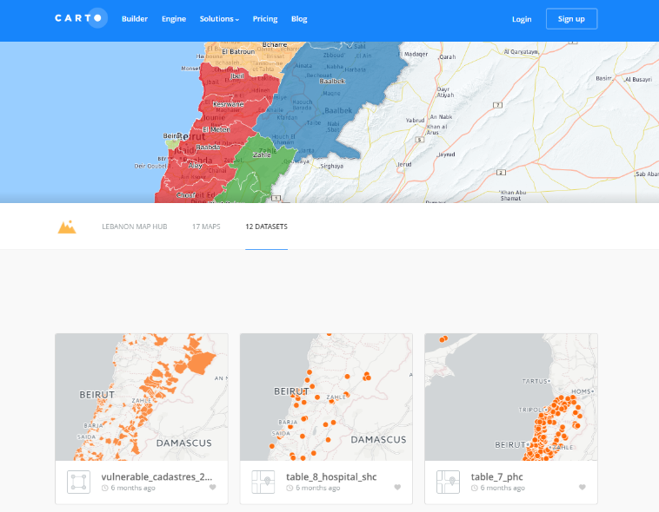
Map layers
For dynamic layers, go to Map Hub.
To download the dataset,
- Select a map
- Click download (bottom right)
- Select preferred file format (CSV, SHP, KML, etc.)

Available maps/datasets
Dataset | Data source | Updates
Municipalities | Minister of Interior | As per updates from Minister of Interior
Localities | Partners | As per updates for missing locations from partners
SDCs | MoSA | As per updated list shared by MoSA
Hospitals (SHCs) | Health sector | As per updates on new contracted hospitals from Health sector
PHCs | MoPH | As per updates on new sites from MoPH and partners
Schools | MEHE | As per updates on new schools from MEHE
Informal settlements | IAMP project | Updated data released every month; full sweep every 3 months (each sweep includes 3-4 additional indicators e.g. Access to healthcare)
Collective shelters | Partners | As per updates from partners in the field

The same Excel datasets are also available on the IM Dropbox.

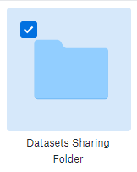

We have also created a new folder to share layers compiled from all agencies. Email datasets to sader@unhcr.org.

