Zambia
- January 2020
Zambia received 716 new arrivals during the month of January. 449 came from the Democratic Republic of the Congo (DRC), 249 from Burundi, and 18 from other states. |  | A total of 260 refugee and host community farmers (subtotal of 50) in Mantapala settlement were provided with agriculturally productive assets, enabling cultivation during the 2019/2020 farming season. |  |  |  |  | Resettlement Registration Forms (RRFs) of 62 cases (comprising 239 individuals) were completed for review for possible acceptance into the Finnish quota.
Total population of concern AS OF 31 january 2020: 86,772 individuals; 28,494 HouseHolds  Countries of Origin  **Other Nationalities include : Congo Brazzaville, Eritrea, Ethiopia, Kenya, Liberia, Namibia, Nigeria, State of Palestine, Sierra Leone, South Africa, South Sudan, Sudan, Syrian Arab Republic, Turkey, Uganda, Ukraine, Zimbabwe. |  |  |  |  | funding (as of 31 January 2020)  USD 19,800,016  UNHCR’s 2020 requirements for the Zambia operation:
UNHCR PRESENCE  Staff:  53 National  17 International  24 Affiliate  Offices:  1 Representation Office in Lusaka  2 Field Offices in Solwezi and Kawambwa  1 Field Unit in Kaoma | 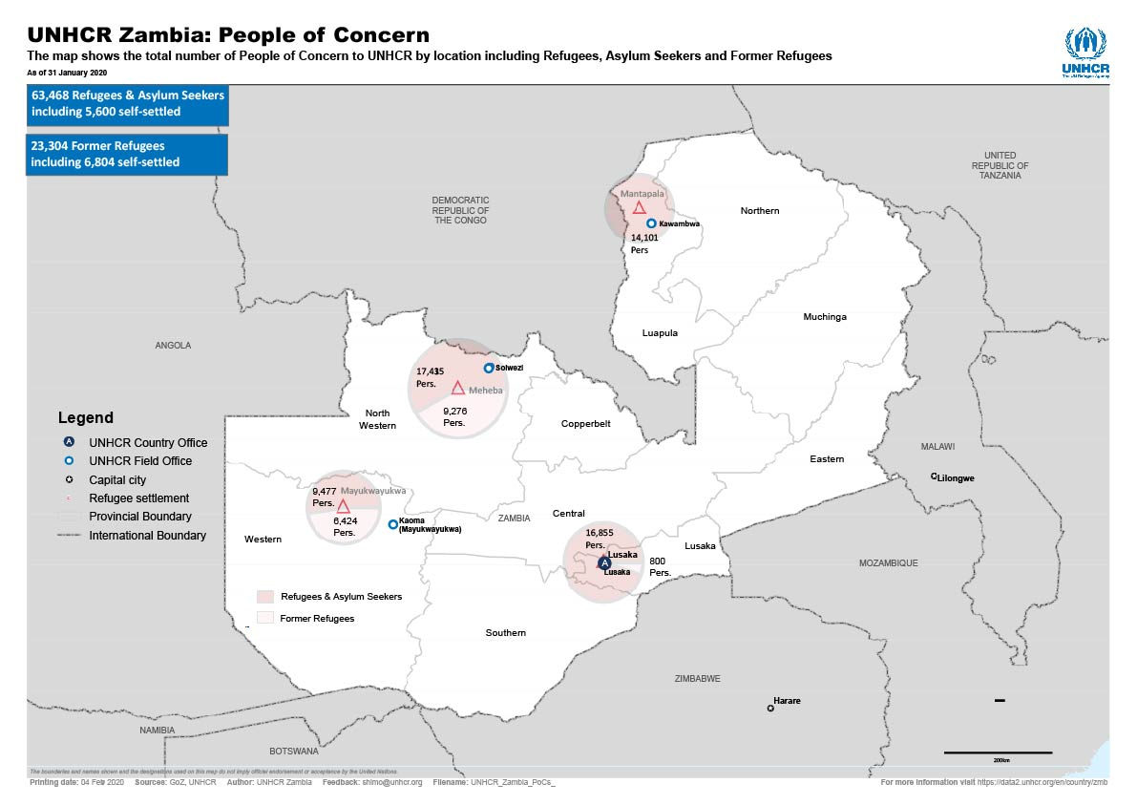

Working with Partners

- UNHCR, the UN Refugee Agency, works closely with the Office of the Commissioner for Refugees (COR) in the Ministry of Home Affairs and key government line ministries.
- It also works in partnership with the United Nations Country Team (UNCT) and NGOs, such as Action Africa Help, Plan International, Caritas Czech Republic, CARE International and World Vision Zambia.
- Most of the NGOs and UN agencies provide support to Congolese refugees, the majority of whom live in Mantapala Settlement, in northern Zambia.
- Together with the government, UNHCR also provides basic social support to persons of concern in the older refugee settlements of Meheba and Mayukwayukwa, in Western and North Western provinces, respectively.

Main Activities

Protection
- Zambia received a total of 716 new arrivals in January 2020. 449 came from the Democratic Republic of the Congo (DRC), 249 from Burundi and 18 are of other nationalities. The number of Burundian arrivals constitutes a steady increase, with 249 Burundians newly registered in January, the majority of which in Lusaka. This increase could be attributed to latent registration. Of the 449 newly registered Congolese, 313 arrived prior to 2020, continuing the trend of arrivals presenting themselves for registration some months after arriving in the country. In December 2019, Zambia registered 538 new arrivals. 2019 saw a total of 7,914 new arrivals through various entry points, the majority of which consisted of Congolese, followed by Burundians.
- UNHCR organized the Roundtable on the Urban Refugee Programme together with the Ministry of Home Affairs and NGOs working in the urban context, on the implementation of UNHCR’s 2009 Urban Refugee Policy, community-based protection, access to services and inclusion into national systems, enhancement of partnerships and data gathering. The outcome of the roundtable serves to improve the delivery of services and define areas in need of advocacy, mapping, and information to enable evidence-based programming. Challenges identified include the encampment policy, documentation, outreach, and obstacles to inclusion into national services. Zambia participated in the global survey on the implementation of the Policy in 2012 and the Building Communities of Practice for Urban Refugees initiative in 2015.
- In Mantapala settlement, UNHCR and Child line staff continue to operate at the Protection Help Desks offering counselling, receiving request of different Core Relief Items and providing advice on diverse protection matters.
- UNHCR and Care International held a meeting with the refugee leaders in the Mantapala settlement to sensitize and roll out the “Zero Tolerance Village Alliance” Project (ZTVA), a community-based model which employs community members to monitor and combat SGBV in the settlement, funded by the Population Council. It will be rolled out in Mantapala starting from January to September 2020. After the meeting, Stakeholders Forum members were elected to assist mobilizing beneficiaries and thereby spearhead its implementation.
- In Meheba Refugee Settlement, UNHCR, together with the Ministry of Community Development and Social Services (MCDSS), convened a multi-functional team (MFT) meeting to approve the list of appointed guardians of unaccompanied children to collect CBI on behalf of the children until the unaccompanied are eligible to collect cash on their own at the age of 16 years old. The MFT approved a total of 20 children through ten households.
- In Mayukwayukwa Refugee Settlement, MCDSS completed the introduction of prevention of Sexual Exploitation and Abuse (PSEA) monitoring and supervision to key leaders in the settlement.

Education
- The two schools in Mantapala settlement were certified as examination to 7th Grade, which will enable them to be included in district plans and receive support from the Ministry of General Education. The official approval as examination centres was one of the key priorities for the Area-Based Action Plan on Education adopted in 2019 for the implementation of the Government National Roadmap on Comprehensive Refugee Responses and was enabled through the joint efforts of UNHCR, UNICEF and the District Education Office. The total number of pupils of the two schools counted 5,247 by the end of 2019.
- MCDSS conducted assessments for 90 (46 boys and 44 girls) school-attending children that need school support in Mayukwayukwa Refugee Settlement.

Health
- During the period under review, a total 7,186 patients (consisting of 6,045 refugees and 1,141 hosts) visited the Outpatient Department at Mantapala Settlement Rural Health Post. Malaria was the leading illness with 3,217 cases, followed by respiratory tract infections and diarrhoea. A phase of Universal Child Immunization was rolled out during which more than 3000 children under five were vaccinated against various diseases. Mantapala health post received an international consignment of pharmaceuticals from UNHCR as well as donations of assorted reproductive health supplies from UNICEF and UNFPA. There was an SGBV screening training for 12 participants drawn from Mantapala health clinic.
- Population Council of South Africa held an SGBV Screening Training for clinical and protection staff from St Paul Mission Hospital from Nchelenge District, Mantapala Health Post, and MCDSS.

Food Security and Nutrition
- In Mantapala Settlement, food rations were provided to Congolese refugees.
- In Mayukwayukwa Settlement, demonstrative plots have been created for all farming-related activities. These will act as teaching aids on vegetable production, field crops (soybeans, groundnuts and maize) as well as livestock.

Water and Sanitation
- A total of 51 boreholes in Mantapala settlement continue to supply 31.88 litres per person per day exceeding the sphere standard of 20 litres per person per day.
- UNICEF, through Norwegian Church Aid and World Vision International, is constructing latrines for all households which do not have decent toilets in the Mantapala settlement.

Shelter and NFIs
- Care International trained 60 households in Mantapala Settlement in brickmaking, using brickmaking machines. After training, the households were empowered with building materials and are now producing bricks for sell to contractors in the settlement to raise funds for their households.
- UNHCR has continued to supply and support mounting of Refugee Housing Units in Lusaka, Meheba, Mantapala and Mayukwayukwa settlements. In January, nine RHUs were supplied and mounted in Mayukwayukwa Refugee Settlement. Two RHUs were allocated to a single mother with her four children, and the remaining seven were allocated to new arrivals that had been staying at the transit centre but moved to make room for others.

Camp Coordination and Camp Management
- The refugee response is led and coordinated by the Government of the Republic of Zambia in order to achieve the United Nations (UN) Sustainable Development Goals (SDGs), Zambia’ Seventh National Development Plan (SNDP) and the Comprehensive Refugee Response Framework (CRRF). Under the Refugee Act (Government Of Zambia Act No. 1 Of 2017), COR, within the Ministry of Home Affairs, is mandated to deal with refugee matters. Thus, Zambia has since 2018 adopted the mainstreaming approach, which requires that the line ministries of Agriculture, Health, Education and Community services (which previously were engaged under separate Project Partnership Agreements (PPAs)) contribute to key sectors under COR. Coordination of the different sectors and partners is managed through bi-monthly and monthly interagency meetings at field and country level, respectively. This interaction is further strengthened through sectoral and bilateral stakeholder interactions. UNHCR is the primary interlocutor and lead agency for all refugee matters. To respond to the Congolese refugee emergency in a holistic and co-ordinated manner, the Government of the Republic of Zambia has installed an Inter-Ministerial Committee (IMC) composed of key line ministries. The Committee remains active even post-emergency.

Access to Energy
- Refugees in all three settlements continue to rely on firewood, candles, solar panels and battery powered energy for lighting and related domestic use.
- 20 Mayukwayukwa Refugee Settlement community members (18 Congolese, two Angolan; six of which male and 14 female) were empowered with energy-saving stoves. These stoves will help to educate the communities on the dangers of deforestation and the resultant need to save the forests.

Community Empowerment and Self-Reliance
- A total of 260 refugee and host community farmers (50 host) in Mantapala Settlement (154 supported by UNHCR through Caritas Czech Republic and 106 supported by World Vision) were provided with agricultural productive assets enabling them to undertake cultivation during this 2019/ 2020 rain-fed farming season. A further 16 households sourced maize seed using their own resources and were supported with top dressing and basal fertilizers by World Vision Zambia.
- 49 households were supported by World Vision with cash grants of USD 207 to facilitate their engagement in small scale businesses (start-up/expansion) in Mantapala Settlement.

- A solar-powered cold storage was installed in Mantapala Settlement’s Block Eight market, providing community members trading in perishable goods with an opportunity to preserve their produce and reduce on losses. The cold storage will be managed by the community.
- UNHCR, through Caritas Czech Republic, has this past January supported the development and expansion of the rice value-chain in Meheba Settlement through the installation of Machines which enable polishing, grading and packaging of rice produced by the population.
- In Meheba Settlement, UNHCR has engaged Madison Finance (Mfinance) to support financial inclusion through capacity building of mobile money agents. Five entrepreneurs were assisted to open agency accounts with Mfinance and will receive trainings (on mobile money agency) and mobile phones from the financial institution.
- 40 youths (20 in Meheba Settlement, 20 in Mayukwayukwa Settlement) supported in 2019, completed their vocational skills training at Mongu and Solwezi Trade Schools. While some of the youths have received productive assets to enable them to engage in business, others have sought internship opportunities within and outside of the province.

Durable Solutions
- The confirmed Resettlement Quota for Zambia for 2020 counts 200 individuals to be submitted to Finland. As of 31 January 2020, Resettlement Registration Forms (RRFs) of 62 cases, comprising 239 individuals, were completed for review for possible acceptance into the Finnish quota. Given the limited resettlement quota, UNHCR will promote complementary pathways for refugees in Zambia. The mapping of refugees with university degree certification and English/French language proficiency is ongoing. To this end, a list of 51 refugees with university qualifications has been generated from the ProGres v4 database for vetting and possible consideration under the UNHCR pilot project on DHRM Temporary Assignment/employment of refugees. In addition, 71 DAFI (Albert Einstein German Academic Refugee Initiative) scholars, as well as 12 candidates holding the UNESCO Global Qualification passports are to be screened for possible consideration for study visa initiatives and scholarships among other legal pathways for solutions.
External / Donors Relations

UNHCR is grateful for the critical support provided by donors which have contributed to the Zambia operation in 2020 with special thanks to: the United States of America, Japan, Czech Republic and the United Nations Trust Fund for Human Security; and to all donors giving unearmarked and softly earmarked funds, including Algeria, Argentina, Australia, Austria, Azerbaijan, Belgium, Canada, Costa Rica, Denmark, Estonia, Germany, Iceland, Indonesia, Ireland, Kuwait, Malta, Monaco, Montenegro, Netherlands, New Zealand, Norway, Peru, Philippines, Qatar, Republic of Korea, Russian Federation, Saudi Arabia, Serbia, Singapore, Slovakia, Sri Lanka, Sweden, Switzerland, Thailand, United Arab Emirates, United Kingdom, Uruguay, along with private donors from Australia, Republic of Korea, and Spain.

CONTACTS
Pierrine Aylara, Representative, Zambia,
aylara@unhcr.org, Tel : +260 977862000/1, Cell +260 977471613

Kelvin Shimoh, Public Information Associate, Zambia
shimo@unhcr.org, Tel: +26097786200/01, Cell +260979585832

LINKS:
Regional portal | https://data2.unhcr.org/en/country/zmb
https://twitter.com/unhcrzambia | https://www.facebook.com/UnhcrZambia/

