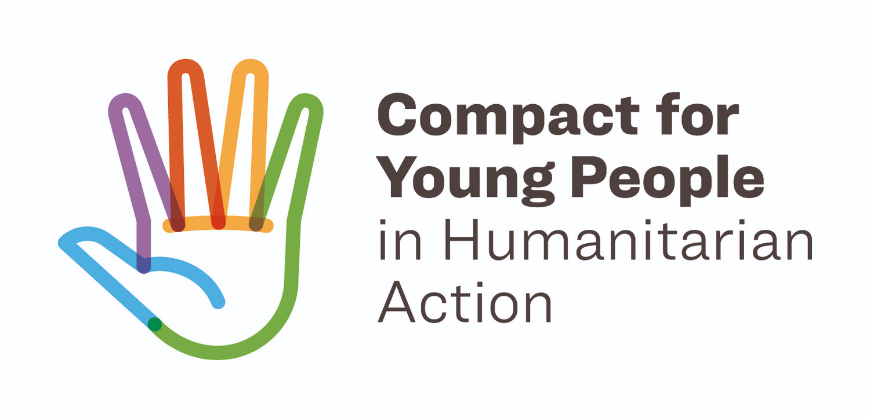

Za’atari Level - Compact for Young People in Humanitarian Action Workshop

Location: NRC Premises, village 10 in Za’atari Camp
Date: 10th of September 2019
Time: 10am-3pm
Purpose: To introduce and train youth focal points from the different working groups present in Za’atari camp on the “Compact for Young People in Humanitarian Action”, how to navigate the guidelines, and to discuss ways forward on how to advocate for the youth agenda under the Compact across the working groups under the different sectors.
Facilitator: Bothaina Qamar, Chair of YTF Za’atari camp level.
Minute Taker: Joanna
Organizations present: UNFPA, NRC, IMC, IRD, UNICEF, Save the Children, RI, UNHCR, IFH, JHASI. (see Annex for details)
Workshop Agenda: (See Annex for details)

The Compact is a global call to prioritise the needs and rights of young women and men, girls and boys in humanitarian action. This paper provides a general documentation for the discussion and reflections that took place in the workshop that targeted members of the Youth Task Force in Zaatari Camp in addition to active members in different working groups at the camp level. The paper does not provide a comprehensive report for the workshop content including the introduction to the Compact, and the guidelines on engaging youth in humanitarian settings. For further details, please refer to the Workshop PowerPoint, version 4 of the Compact Guidelines, the Compact ToRs, and the Igniting Hope Report.

Discussions and reflections:

The workshop is timely as the JRPP process started under the leadership of MOPIC and Humanitarian actors. It is important for humanitarian actors and humanitarian coordination systems to engage with The Compact for Young People in Humanitarian Action. The Compact provides the dedicated space and the necessary framework for Members to ensure that the priorities, needs and rights of young women and young men, girls and boys affected by disaster, conflict, forced displacement and other humanitarian crises, are addressed; and that young people are informed, consulted, and meaningfully engaged throughout all stages of humanitarian action. Compact Members acknowledge that young people have the skills, capacity and resources to prevent, prepare for, respond to and recover from humanitarian situations, and that supporting and working with them will help improve humanitarian effectiveness and efficiency and strengthen resilience of communities.

The Global Commitments under the COMPACT are:
- Make humanitarian programmes contribute to protection, health, development of young women, young men, girls, boys
- Support systematic engagement and partnership with youth in all phases of humanitarian action, especially decision-making and budget allocations
- Strengthen young people’s capacities to be effective humanitarian actors, and support local youth-led initiatives and organizations in humanitarian response. This includes young refugees and internally displaced persons living in informal urban settlements and slums
- Increase resources to address the needs and priorities of adolescents and youth affected by humanitarian crises and
- use the new gender and age marker for better tracking and reporting
- Generate and systematically use age- and sex- disaggregated data

Based on that the participants were trained on how to navigate the output under the Services Key Action. The guidelines are an easy-to-use programming tool for all humanitarian aid workers at country level for working with and for adolescents (10-19 years) and youth (15-24 years). The document includes sections on young people definition, principles for working with and for young people in humanitarian settings, what is meaningful participation, and Adolescents & Youth across the Humanitarian Programme Cycle and Sector-specific entry points.

Principles for working with and for young people in humanitarian settings:
When working in humanitarian settings, there are 10 principles included in the guidelines which all humanitarian aid staff at country level must follow when working with and for young people. The principles are: 1) Do No Harm, 2) Positive development approach, 3) Meaningful Participation, 4) Giving away power), 5) Solidarity, 6) Equity, Non-discrimination and Inclusion, 7) Sustainability, 8) Commitment, 9) Zero tolerance of sexual exploitation and abuse, 10) Accountability. The below bullet points are reflections that came up during group work on the 10 principles:

- To stand in solidarity with young people means that we move away from charity actions or approaches and work from a rights-approach and see them as equal partners;
- The age and gender of youth must be taken into consideration in all programs, projects or services and that they need to be age and gender appropriate. The maturity of a young person is not always equivalent to his or her age, which derives from culture, past experiences, socio-economic backgrounds etc;
- Youth are not homogenous group and there are many intersectionality that needs to be taken into consideration. One size fits all programming dose not respond to youth differences in terms of gender, social and economic background, disability, sexual orientation …etc
- In order to do no harm, we need to work with the families of young people as well in order to not cause any tension or conflicts within the family. Also to positively engage with parents on issues of development concerning their children.
- Services need to be both youth-friendly but also take into consideration the different needs of young people; geographical location, socio-economic background, culture, disability, sex, gender and sexual identity etc. Service can be only focusing on young people such as youth centers, or youth health friendly clinics or part of the general services that are provided for the public.
- In order to be sustainable, projects and programs and services need to be connected with opportunities.
- In order for organizations to “give away power” to young people, this needs to be combined with a process of capacity building and on “Evolving Capacities” bases.

Meaningful Participation (Please refer to page 11 in the Compact Guidelines)

- Meaningful participation can enables young people to: acquire knowledge and skills, build competencies, and extend aspirations and gain confidence. Also it Promotes youth’s capacity for civic engagement, collective organization, and tolerance and respect for others
- There are many good examples for active youth participation in the camp including youth led spaces, youth focused consultation, youth Action participatory research groups, youth committees, and other examples.
- In order for youth to participate, it needs to be systematic and prepared for and should not be ad hoc for the sake of participation as a concept. Organizations should have structures to promote and facilitate youth participation in order for it to be sustained. YTF needs to work toward systematic engagement of young people in the meetings.
- The usual practice of engaging with young people is limited to set project log-frames and plans that in many cases cannot accommodate the innovative ideas the young people would suggest. This is a big challenge to youth participation and youth-led initiatives in the camps;
- The current legal status for Syrians does not allow the formulation of youth led organizations or starting youth led COOP’s which can enhance youth active engagement in their communities.
- The guidelines provider a parameter that measure the modes of participation and they can vary from no participation at all “Tokonistic” to consultative, collaborative and youth led participation. Engaging and consulting with young people is a key for any effective programming that works with youth. In humanitarian settings modes of participation can vary based on context. What is important is to try to engage with youth to better understand their needs, assets and aspirations vs our program objectives, resources and crisis status.

Adolescents & Youth across the Humanitarian Programme Cycleand Sector-specific entry points. (Please refer to page 15 and 24 in the Compact Guidelines)

This Section provides guidance, tips, and concrete examples across all sectors, structured around the Humanitarian Programme Cycle (HPC). The HPC was agreed upon by the Inter Agency Standing Committee (IASC) in 2013 to improve upon the Consolidated Appeals Process (CAP). It refers to a series of actions to help prepare for, manage and deliver humanitarian response. It consists of five interrelated elements and three key enablers, i.e. coordination, information management and overall preparedness, as shown below.

The guidelines major focus is to provide programming tips for age-appropriate, adolescent & youth-responsive programming across different sector-specific entry points. Indicative assessment questions, priority actions, key indicators, and links to tested tools are offered for young people and agencies working in various sectors. Below are some reflections from the workshop:

- Overall participants found that the guidelines are easy to navigate and the fact that they can be adaptable to local context gives a space of flexibility.
- In the Humanitarian Programme Cycle which is included the Compact Guidelines adolescents and youth need to be involved across the whole cycle and not in a specific element.
- A project or program or a sector that did not involve youth participation from the start can later on involve more youth participation and that is why the Compact Interagency Guidelines includes a parameter on the different modes of participation.
- A limitation was pointed out that the guidelines do not address in the “health Section” the medicine, such as vaccination, screening etc
- Humanitarian actors should strive towards adolescent-led participation as much as possible, but it does not have to be the case every time we work with young people. Sometimes, for example, consultative participation is enough.
- Trained youth focal points can play an active role in advocating for youth focused programming, age- sex desegregated data, and youth active engagement and participation.

Specific Reflections on the Compact related to the Za’atari Camp context:

- YTF resembles a great example on the COMPACT implementation, also organizations shared their different practices of engaging on youth issues weather through youth specific assessments and surveys, youth committees, youth targeted programming, and supporting youth led initiatives at the camp level. Yet there is always a room for improvement.
- Under protection and education work youth are addressed however other sectors might need more effort to adopt the Compact such as Shelter, and WASH. This requires regular capacity building on the Compact for members in different sectors.
- When working with young people in Za’atari, we do work on the key action areas (Services, Participation, Capacity, Resources, and Data) stated in the Compact Guidelines but challenges exists in key areas under resources and data in particular;
- A special focus on the need to understand mental health services and programming that targets youth. YTF needs to work closely with mental health task force that is recently formed.
- In conclusion, the workshop opened the space for the participants from different sectors to dig deeper into how to provide young people specialized services by each sector. Moreover, the workshop allowed the participants to embrace their diverse mandates, while also linking their cross cutting activities/efforts/mandates toward a collective responsiveness for the youth in Za’atari camp.

Action points:
- UNFPA to send the Igniting Hope report to the participants along with other documents related to the Compact;
- The YTF chairs to send an email for management and supervisors of the participants as an introductory email and ask for their consistent participation and what is expected if they want to contribute to the Compact agenda in Za’atari;
- The YTF chairs to coordinate with the participants which working group they would be interested in attending;
- The participants to contact respective working groups they will attend for the different sectors in order to have a better understanding what is being done on the youth component.
- Create a roadmap for the YTF for the next steps for the Compact in Za’atari which will be discussed in the next YTF meeting.
- JRP process – and the importance of it.

Annex 1: Participants

 | Name: | Organization
1. | Bothaina Qamar | UNFPA, YTF Chair
2. | Joanna Broumana | UNFPA
3. | Dina Ala’eddin | NRC, Co-Chair
4. | Dr. Yakoob Majdoubeh | IMC/Health
5. | Manar Al-Basti | IRD
6. | Wejdan Harahsheh | IRD
7. | Reema Abu Ghazaleh | UNICEF
8. | Sylvia Skerry | UNICEF
9. | Yazan Shahrouri | Save the Children
10. | Sarah Al Halawani | RI
11. | Hani Alnaser | UNHCR
12. | Ali Al-Tawiq | UNHCR/CMC
13. | Nadeen Mayyas | IFH/Protection
14. | Razan Al-Nabulsi | IFH/ADTF
15. | Ghada Ali Al-Said | JHASI//Health
16. | Amal Tawalbeh | JHASI//Health

Annex 2: Workshop Agenda

Compact for Young People in Humanitarian Action
Workshop Agenda – Za’atari Camp Level
10th of September 2019

Time | Activity
9.30 to 10.00 | Registration and coffee/tea
10.00 to 10.30 | Introduction and Ice Breaker
10.30 to 11.30 | Introducing the Compact for Young People in Humanitarian Action
11.30 to 12.00 | COFFEE AND TEA
12.00 to 12.30 | Introduction to the Compact Guidelines of working with and for young people in humanitarian action
12.30 – 1.30 | Group work on implementing the guidelines with existing camp coordination structure
1.30 – 2.00 | Lunch
2.00 – 2.45 | Road map for the YTF and youth FP’s rolling out the Compact at the camp level
2.45 – 3.00 | Wrap Up

