“ActivityInfo - Protection Referrals Database” Reporting Guide - 2019
National Protection Working Group

This document details the steps required sector partners to be able to report on the Protection Referrals Database on ActivityInfo. For any clarification needed about this document please contact the Protection Sector Focal Points Rasha Akil (akil@unhcr.org) or Tamara Stupalova (stupalov@unhcr.org)

HOW TO GET ACCESS TO THE SECTOR REPORTING DATABASE:
In order to get access to the 2018 Protection Referral’s Database on ActivityInfo, please contact the Protection Focal Points Rasha Akil (akil@unhcr.org) or Cyrille Ble (ble@unhcr.org).

- START ACTIVITY INFO:
To start the program, type the following web address: www.activityinfo.org

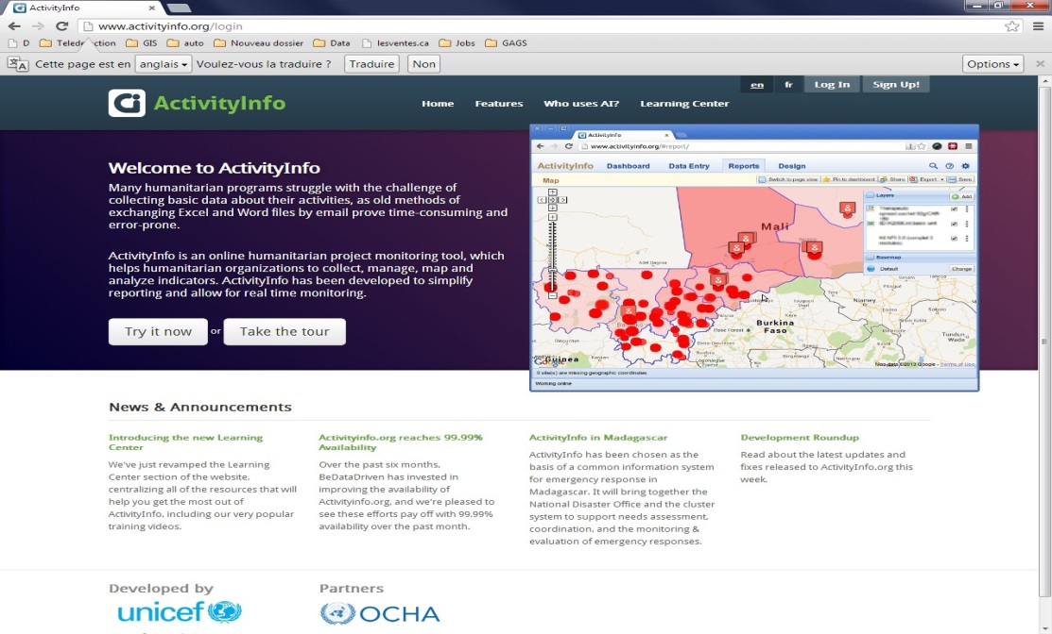

- CREATING A NEW SITE:
Once logged in follow the steps as shown below:
- Click on the DATA ENTRY tab.
- Open the LCRP-2019-R Protection database by clicking on the little arrow to the left.
22
- Select the relevant Form.
- Click on NEW SUBMISSION.
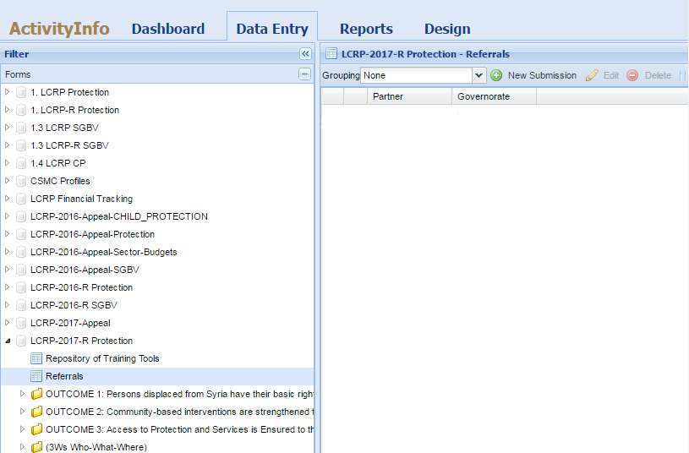

- Click on Intervention Details. 4) Click on Comments: Add any comment, if any.
- Select the Partner Agency 5) Click on Save.

- Click on Site - Select Governorate

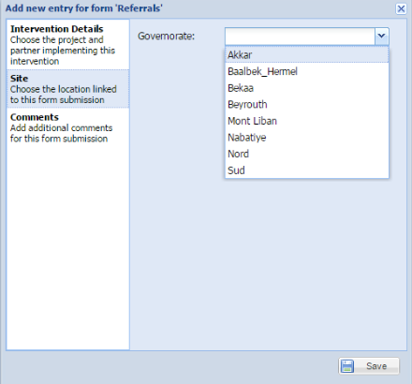
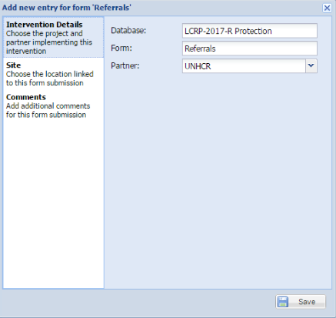

- REPORTING ON REFERRALS:

- Select the relevant form that you created as per the guidelines above.
- Select the Site.

- Click on ‘Monthly Reports’ Tab to access the indicator and reporting table.
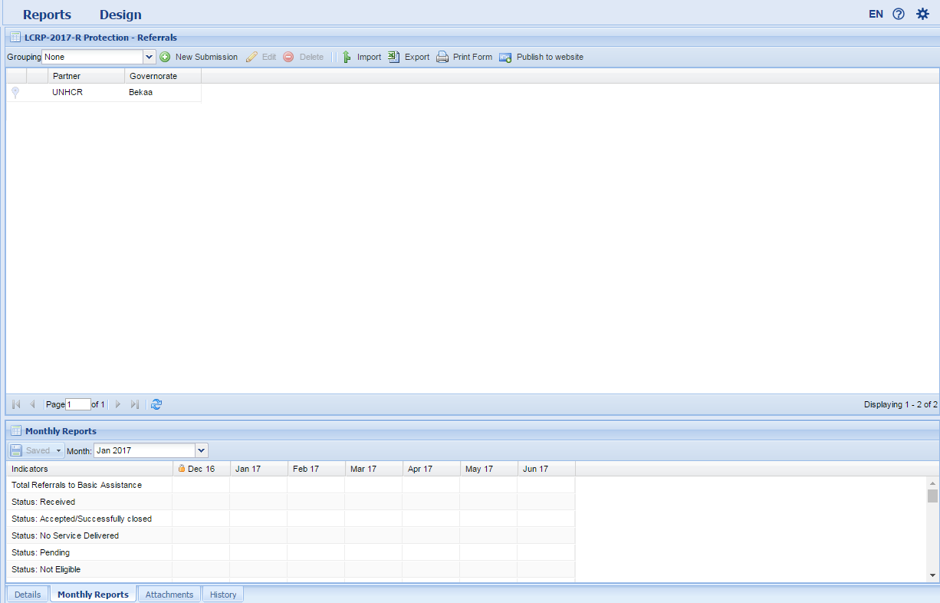

- Enter the referrals made per Sector per reporting period (refer to below figure):
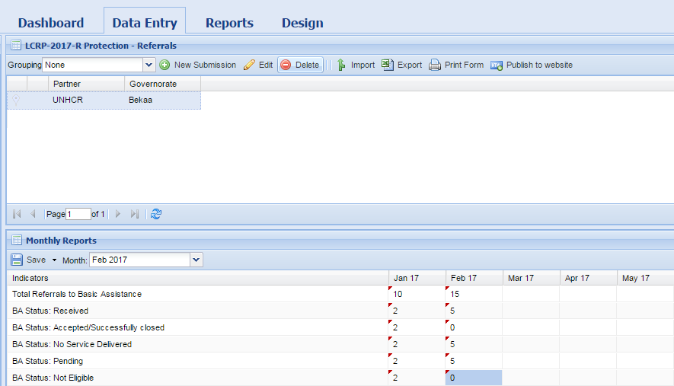

- Each sector has 5 required disaggregation/status’:
- Received;
- Accepted/Successfully Closed;
- No Service Delivered;
- Not Eligible;
- No feedback received
Please note that the total referrals made per sector should be equal to the relevant disaggregation.

- Press Save.

