****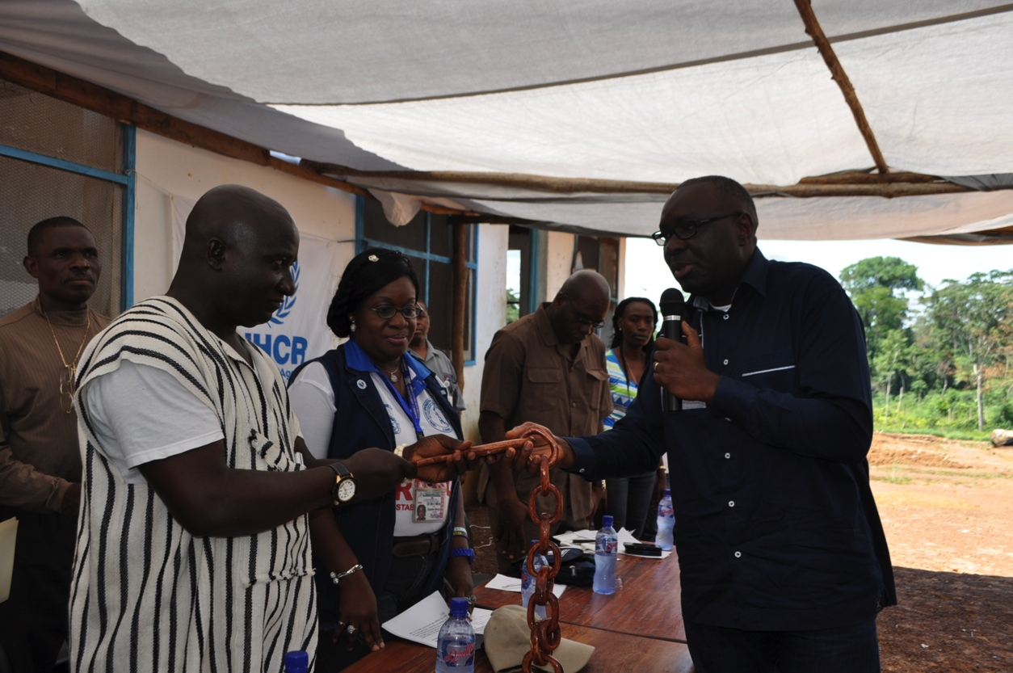

**The UNHCR Representative Khassim Diagne handed over the symbolic key to Solo Refugee Camp to County Superintendent Peter Solo, signifying the turning over of 85 acres of land back to the Government and the local community.**

**PROTECTION SITUATION REPORT**

**Covering the period: March 01-31 2014**

**EXECUTIVE SUMMARY:**

River Gee County saw a surge in Ivorian refugee population by 546 following the *refoulement* of 14 Ivorian registered refugees on 17 February and the attacks on Forces Republicaines de Côte d'Ivoire (FRCI) by rebels in Grabo and Fete villages in Côte d’Ivoire near the border with Liberia on 23 February. The two events have had a chilling effect on the number of potential returnees in Maryland County. Notwithstanding, the month of March has marked a number of important milestones pointing towards a steady progress in finding a durable solution for the Ivorian refugees in Liberia. UNHCR has facilitated the safe return of 3,280 Ivorian refugees, bringing the total number of the Ivorian returnees in the first quarter of the year to 8,648. The third meeting of the Tripartite Commission for Voluntary Repatriation of Ivorian Refugees was held in Abidjan, Côte d’Ivoire from 27 to 28 March. The Solo Refugee Camp, once home to some 6,000 Ivorian refugees at its peak was officially closed on 21 March. Overall, the refugee population has seen their rights respected and no cases of *refoulement* have been reported. Out of the 14 Ivorian registered refugees who were refouled and detained in Côte d’Ivoire, 6 were released on 3 March by the Ivoirian authorities in Abidjan and returned to Liberia. Memorandum of Understanding between LRRRC and the office of the Coordinator of Public Defenders of Liberia came into effect with the aim of enhancing legal representation in courts for those who come into conflict with the law which, in turn, is expected to boost refugees’ confidence in the rule of law in Liberia. On 8 March, refugees and other persons of concern joined celebration of International Women’s Day under the global theme “*Equality for Women is Progress for All*” and the national theme “*Mentoring for Transformation*.” The outbreak of Ebola in Guinea and Liberia late this month raised a serious public health concern in the West Africa region and may have an impact on the voluntary repatriation in coming months. UNHCR Liberia is developing preparedness and response plans in the event of the disease occurring in camps and host communities.

1. **Persons of Concern**

Liberia is currently hosting 45,674 refugees, asylum seekers, and other persons of concern. The Ivorian refugee population decreased by 2,654 individuals from 46,267 at the end of February 2014 to 43,613 at the end of March 2014, mainly due to the ongoing facilitated voluntary repatriation activities. The breakdown of Ivorian population by locations is as below.

|  |  |  |  |
| --- | --- | --- | --- |
| **County** | **Population** | **Location** | **Population** |
| **Nimba** | **9,485** | Bahn Refugee Camp | 7,082 |
| Communities | 2,403 |
| **Grand Gedeh** | **20,174** | PTP Refugee Camp | 15,240 |
| Communities | 4,934 |
| **River Gee** | **1,815** | Communities | 1,815 |
| **Maryland** | **11,552** | Little Wlebo Refugee Camp | 9,961 |
| Communities | 1,591 |
| **Montserrado** | **587** | Communities | 587 |
| **Grand Total** | | | **43,613** |

1. **Registration**

River Gee County saw a surge in Ivorian refugee population by 546 following the attacks on FRCI in Grabo and Fete villages in Côte d’Ivoire near the border with Liberia on 23 February. From 4 to 19 March 2014, UNHCR and LRRRC in collaboration with the Bureau of Immigration and Naturalization (BIN) and local authorities wrist banded, screened and registered new arrivals in Kronokon and Nyaaken villages, River Gee County. A total of 549 new arrivals, 375 individuals in 98 families in Koronkon and 174 in 56 families in Nyaaken were wrist banded and screened out of which 546 individuals (294 Female and 252 Male) in 148 households were recognized as refugees. A total of 3 individuals in 2 households were rejected as they were found to be Liberians. It is worth noting that more than 75 percent of the new arrivals were previously repatriated to Côte d’Ivoire. The majority of the new arrivals cited fear of further attack by the rebels and fear of harassment, intimidation and arrest by the FRCI as reasons for seeking asylum in Liberia. UNHCR cross-checks the identity documents of asylum-seekers, such as an Ivorian National Identification Card and a Voluntary Repatriation Form as much as possible so as to ascertain their identity. The majority of the new arrivals expressed their intent to return to Côte d’Ivoire once conditions that led to their forced displacement no longer exist.

Though *prima facie* recognition is maintained for Ivorian nationals, the new arrivals were interviewed before their final registration taking into account improvements of the political situation in Côte d’Ivoire.

In Monrovia, 8 Malians in 3 households were registered as asylum-seekers. They first sought asylum in Niger. The onward movement to Liberia was attributed to lack of food.

1. **Refugee Status Determination (RSD)**

Neither Asylum nor Appeal Committee sat in this month.

1. **Access to Asylum/Border Monitoring**

UNHCR intensified border monitoring since the attacks by the rebels and following reports of new arrivals crossing to Liberia. On 19 March 2014, UNHCR in collaboration with LRRRC carried out a border monitoring exercise following reports of 45 new arrivals in Yobloken by the Bureau of Immigration and Naturalization. The team did not find any new arrivals at Yobloken, but were informed that the new arrivals were staying in Baniyaken and Yoken villages which are not accessible by car or motorbike, and were about two hours walking distance from Yobloken. On 20 March 2014, a joint UNHCR and LRRRC team also visited Geeplaken, Yagbaken, Tuwoloke, Parken, Youwarken and Saklyken villages in River Gee County. This special monitoring mission was as a result of constant reports by the locals and LRRRC that there are a few new arrivals stranded in these localities who have sought refuge in Liberia following the recent attacks on Fete and Grabo in Côte d’Ivoire.

1. **Protection Highlights (Achievements and Challenges)**

**6 Ivorian registered refugees who were refouled to Côte d’Ivoire on 17 February were released by the Ivorian authorities and returned to Liberia:** 6 refugees, who were refouled to and detained in Côte d’Ivoire on 17 February 2014, were released on 3 March 2014 by the Ivoirian authorities in Abidjan. Those released are part of 21 individuals refouled to Côte d’Ivoire for alleged mercenary activities. Information from Côte d’Ivoire revealed that no charges have been confirmed against the 6 refugees and they were given the right to leave the detention Center (Direction de la Surveillance du Territoire). UNHCR Côte d’Ivoire and Liberia arranged the travel of the refugees to Liberia and they were reunited with their families in Little Wlebo Refugee Camp.

**The third meeting of the Tripartite Commission held in Abidjan, Côte d’Ivoire** **from 27 to 28 March 2014:** The Tripartite Commission for the Voluntary Repatriation of Ivorian refugees, which comprises the Governments of Côte d’Ivoire and Liberia, as well as UNHCR, expressed satisfaction over the significant progress made in the implementation of the provisions contained in the Tripartite Agreement which was signed in August 2011 in Abidjan. The Agreement, which sets out the framework for voluntary repatriation, is regularly reviewed through a tripartite mechanism during which achievements and challenges are discussed.

The Commission endorsed the recommendations of the third meeting of the Technical Working Group centred on medical screening before repatriation; strengthening of information sharing to enable refugees make informed decisions to voluntarily return; accelerating returns; and regularization of the civil documents issued to returning refugees. In the area of security challenges, UNHCR expressed concern in relation to the recent incidents at the border and reminded the two Governments of the necessity to take all the appropriate measures to ensure an enabling security environment in the areas of return in order not to slow down the momentum on voluntary repatriation. UNHCR also reminded the two Governments of their commitment to respect international protection principles in particular the cardinal principle of *non-refoulement*, to which all the parties agreed. The final communique was signed by the Deputy Secretary-General of the Ministry of State, Ministry of Foreign Affairs of Côte d’Ivoire, Mr. Djerou Robert Ly; Deputy Minister of Internal Affairs of Liberia, Mr. Varney A. Sirleaf; and the UNHCR Representative in Côte d’Ivoire, Mr. Mohamed Toure.

**Closure of Solo Refugee Camp in Grand Gedeh County:** On 21 March 2014, UNHCR held a handover ceremony to mark the official closure of the Solo Refugee Camp in Grand Gedeh County. The Solo Refugee Camp was established on 21 April 2011, and at its peak hosted about 6,000 Ivorian refugees, 3,000 of whom voluntarily repatriated, and the others relocated to the PTP Refugee Camp. At the handover ceremony witnessed by Government of Liberia and UN officials, local authorities and members of the host community, the UNHCR Representative, Khassim Diagne symbolically handed over the key of the Refugee Camp, signifying the turning over of 85 acres of land back to the Government of Liberia and the local community. This was done in appreciation to the Liberian Government and people for hosting Ivorian refugees over the past 3 years.

UNHCR and partners also handed over assets which included a primary school, clinic, Norwegian Refugee Council and LRRRC offices, police posts and barracks, warehouse and distribution halls. Other assets included 4 hand pumps, 27 latrines, 9 bathhouses and 3 laundry slabs. In addition, UNHCR provided 91 houses with 3 bundles of zinc per house and other assorted construction material to the residents of Solo Town community. The Solo Refugee Camp was the third Ivorian refugee camp closed in the County and in Liberia over the past 2 years.

**A 45-year-old Ivorian male refugee was found dead on Mamba Point beach:** On 2 March 2014, a 45-year-old Ivorian male refugee was found dead on Mamba Point beach close to the UNHCR Branch Office. LRRRC, UNHCR and SEARCH were called on the scene of the police’s investigation. While the preliminary examination indicated no foul play, the peculiar circumstance of his death raised physical security concern among Ivorian refugees who associated his death with perceived insecurity in Liberia. On 7 March 2014, the Executive Director of LRRRC and UNHCR’s Country Representative met the refugee representatives to discuss the incident. The Executive Director of LRRRC expressed her deepest condolences and assured the refugee representatives that the Government of Liberia is committed to providing security to all refugees in the country. The Executive Director stated that the contents of the police report will be shared with them once concluded, and advised them to put in writing the sources of insecurity to help the Government to address them. In urban areas, where a relationship with refugees can get easily tense over incidents that affect them, UNHCR continued its communication efforts to establish a constructive dialogue and positive partnership with refugees in urban areas.

1. **Protection Monitoring**
2. **Monitoring of Detention Centers**

A UNHCR and LRRRC protection team conducted monitoring of prison and detention centers in Maryland and River Gee Counties. Currently, there is one male refugee (Secondary school Teacher) in detention at Harper Central Prison, who is an alleged rape suspect. He has been transferred to the 4th Judicial Circuit Court in Maryland by the Harper Magisterial Court. The case is expected to proceed to the Grand Jury Room where an indictment will be prepared in next term of court in May 2014. In Nimba, 3 refugees charged with arson and statutory rape are presently incarcerated in Sanniquellie Prison Compound. 9 registered refugees are still detained in the Monrovia Central Prison. Out of the 9, 7 were arrested in July 2012 and are charged for multiple offenses including, mercenarism, rape, arson and murder, etc. 2 are detained without charge since March 2013.

1. **Refugee Women and Children**

Refugee community joined International Women’s Day celebrated under the global theme “Equality for Women is Progress for All” and the national theme “Mentoring for Transformation.” In the Bahn Refugee Camp, outstanding 16 Traditional Birth Attendance contributing to the community received gift items which included hand bags, metal bucket wrappers and cash. In the Little Wlebo Refugee Camp, two female students from the secondary and primary schools were honored for their high academic performance and received gifts.

1. **Durable Solutions**

**Voluntary Repatriation of Ivorian refugees:** UNHCR facilitated safe return of 3,280 individuals in March, bringing the total number of the Ivorian returnees in the first quarter of the year to 8,648. 2 repatriations were facilitated from the Bahn Refugee Camp and 4 repatriations were facilitated from the border communities in Nimba to Côte d’Ivoire. The refugees were transported from all border towns to the two major crossing points; Buutuo using canoes to cross the Cestos River and the Loguatuo land border. In Grand Gedeh, UNHCR facilitated return of 248 individuals from the communities. *Refoulement* of 14 Ivorian registered refugees on 17 February and the attacks on FRCI in Grabo and Fete villages in Côte d’Ivoire near the border with Liberia on 23 February have had a chilling effect on the number of potential returnees, mainly from Maryland County. Only 12 individuals in 5 families from the Little Wlebo Refugee Camp were voluntarily repatriated to Guiglo, Yopougon, Nero and Bakoubli in Côte d’Ivoire. However, voluntary repatriation registration is on-going in communities and the refugee camp.

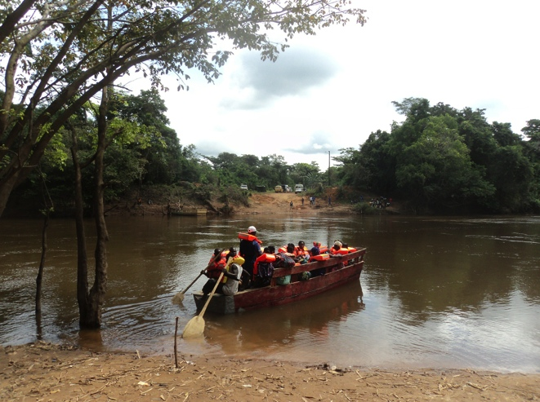

**A canoue carrying repatriating Ivorian refugees to Ivorian side of the Cestos River in Nimba County**

**Resettlement:** 7 potential resettlement cases were identified in Nimba County. The cases identified were profiled and physical files were opened for resettlement referral.

1. **Access to Education**

**Ivorian national exams:** The authorities in Abidjan have declined UNHCR's request for the administration of the Ivorian national exams (CEPE, BEPC and Baccalauréat) in the refugee camps hosting Ivoirian refugees. The issue was again discussed during the third meeting of the Tripartite Commission and the signatory parties agreed *to continue the discussion in order to find appropriate solution which will take into account the interest of the refugee students*. UNHCR is liaising with UNICEF and education partners to how best document the learning achievements of refugee students that could be recognized by the Ivorian authorities upon return to Côte d’Ivoire.

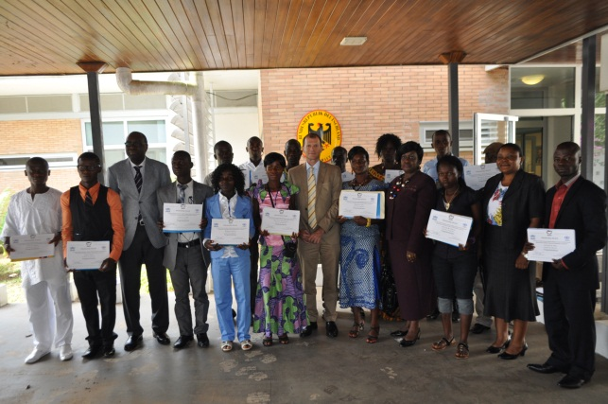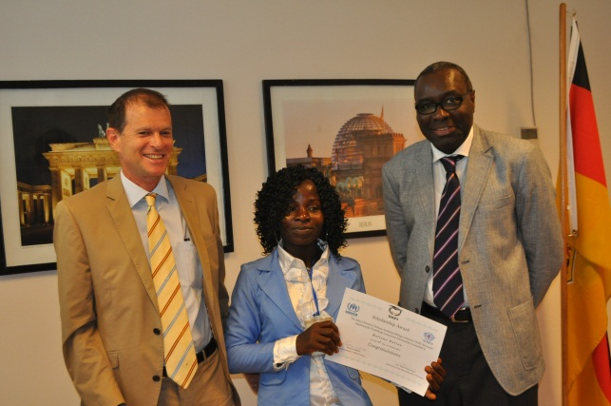**Tertiary Education – DAFI Scholarship Award Ceremony:** The Federal Republic of Germany, through its embassy in Monrovia, on 18 March awarded scholarships to 15 Ivorian refugees to pursue higher education in various tertiary institutions in Liberia. The second batch of 18 refugees is being identified for the 2014 - 2015 academic year.

**DAFI scholarship students in the German Embassy**

**H.E. Ralph Timmermann, Ambassador of the Federal Republic of Germany and UNHCR Representative awarded a certificate of scholarship to a female refugee student**

1. **Livelihood/Self-reliance**

In the Bahn Refugee Camp, Finnish Church Aid (FCA) has started a vocational training center named “Live Skill Training Center” for out-of-school children and adolescents aged between 12 to 26 years. The Training Center offers one year training in 5 areas; hairdressing; tailoring; carpentry; masonry; and mechanics and in total 160 children and adolescents were enrolled.

In the PTP Refugee Camp, an operational partner, IBIS donated start-up kit materials to the third cycle graduates of both soap-making and hair dressing groups. Additionally, IBIS also provided 5 days Training of Trainers (TOT) on drug and substance abuse; human rights and sexual abuse; and gender base violence. A total of 30 individuals participated in the training in the PTP Refugee Camp. In other developments, UNHCR/ADRA agriculture activities under the livelihood the project carried out initial harvest of vegetables from its production site in the PTP Refugee Camp. 4 filled wheel barrows of cucumbers were harvested from the site. Cabbages and other items are nearing harvest.

UNHCR is spearheading the formation of a committee which will be comprised of ADRA, NRC, Central Leadership, LRRRC and representation from the farmers. The committee, after its formation will be in charge of drafting TORs to properly assist the farmers to manage proceeds and also establish links with potential buyers in Zwedru and also look into the issue of other related issues to the project for sustainability.

In Montserrado County, Gloria Group Inc. held a graduation ceremony on 2 March for 16 Ivorian refugees (4 males, 12 females) who have completed a vocational training on tailoring and cosmetology/hairdressing. 9 (4 males, 5 females) completed tailoring and 7 (all females) did cosmetology/hairdressing. The graduating trainees were awarded certificate and starter kits.

1. **Invocation of Cessation Clauses for Liberian Refugees**

The “ceased circumstances” cessation clause came into effect for Liberian refugees, who fled their country as a result of the civil war from 1989 to 2003. The cessation clause meant that refugee status for this group of refugees formally ceased by 30 June 2012. Against this background, UNHCR supported the Government of Liberia to form a mobile team to undertake passport vetting missions for Liberian refugees opting for local integration in ECOWAS countries of asylum. The delegation was composed of 3 government agencies, namely, the Ministry of Foreign Affairs (MFA), the Bureau of Immigration and Naturalization (BIN) and the Liberian Refugee Repatriation and Resettlement Commission (LRRRC).

From September 2012 to December 2013, the Liberian delegation undertook a total of 11 passport vetting missions to 9 countries of asylum (Cote d’Ivoire, the Gambia, Ghana, Guinea, Guinea-Bissau, Mali, Nigeria, Senegal and Sierra Leone), during which a total of 7,696 applicants (89%) were approved, while some 910 applicants (11%) were considered as “red coded” cases, thus putting on hold the processing for Liberian ECOWAS passports for that group.

As of 31 March 2014, 4,700 passports were issued to UNHCR Liberia, out of which 3,730 passports have been delivered to the countries of asylum. 2,865 passports are pending issuance.



***Refugee women’s economic participation: Ivorian refugee woman contributes to Liberian youth empowerment***

**The Liberian economy is relatively stable with robust growth, but prevailing unemployment - particularly among youths - remains a major challenge. The most recent Labor Force Survey (2010) showed high rates of vulnerable employment in Liberia, especially in rural area (86%) and among female (87%)*. Under such an economic condition, securing gainful employment is a daunting task for refugees in Liberia.**

**The Gloria Group Inc. was established in 2011 by an Ivorian refugee woman, Ms. Irene Kpor, with support from UNHCR. The motto of the Group is “Togetherness we empower youth”. Ms. Kpor used to own a Tailor shop in Côte d’Ivoire. Since 2002 when she was forced to flee to Liberia, she struggled to re-establish her tailoring business in her country of asylum. She has gradually expanded the training business and had contract with UNMIL and Child Fund under UNHCR’s partnership in past years. This year, she is planning to train Liberian youths in the community where the Gloria Group Inc. is located. Attaining such a success while being a single female head of household of 11, she is now a role model of urban refugees. During the graduation ceremony, UNHCR urged the graduating trainees to follow her path and establish their own business, maximizing the skills and knowledge they acquired through the vocational training.**

**\* World Bank. Liberia Overview. Last updated on October 2013.http://www.worldbank.org/en/country/liberia/overview**



**Compilation/ Protection Reports from:**

**FO Salepea & Harper/SO Zwedru/BO Monrovia**

**UNHCR Liberia**